Chapter 1: Physics and Measurement

Conceptual Questions

Q2.3 If the mean velocity of an object is zero within a time interval, what can you say about the displacement of the object within that time interval?

ANS: Zero.

Q2.9 Dua kereta bergerak dalam arah yang sama di sepanjang lebuhraya yang lurus. Pada suatu ketika, halaju kereta A lebih besar daripada kerata B. Adakah ini bermakna pecutan A adalah lebih besar daripada pecutan B? Terangkan.

JAWAPAN
No:

Q2.11 Pertimbangkan kombinasi tanda dan nilai bagi halaju dan pecutan berikut yang merujuk kepada pergerakan suatu kerata sepanjang paksi-x dalam 1-D.

Halaju | pecutan
a. positif | Positif
b. positif | Negative
c. positif | Sifar
d. negative | Positif
e. negative | Netatif
f. positif | Sifar
g. sifar | Positif
h. sifar | Negative

Perihalkan apa pergerakan yang dilakukan oleh kerata tersebut dalam setiap kes. Anggap kereta tersebut bergerak dalam arah timur-barat, dengan arah timur diambil sebagai arah positif.

Q2.15 Seorang pelajar berada di atas bumbung suatu bangunan setinggi h. Dia membaling senbiji bola ke atas dengan kelajuan v_{i}, kemudian membaling lagi sebiji bola ke arah bawah dengan kelajuan v_{i} yang sama. Bagaimanakah halaju akhir kedua-dua bola dibandingkan satu sama lain?

MASALAH-MASALAH

Position, Velocity, and Speed

3. The position versus time for a certain particle moving along the x axis is shown in Figure P2.3. Find the average velocity in the time intervals (a) 0 to 2 s, (b) 0 to 4 s, (c) 2 s to 4 s, (d) 4 s to 7 s, (e) 0 to 8 s.

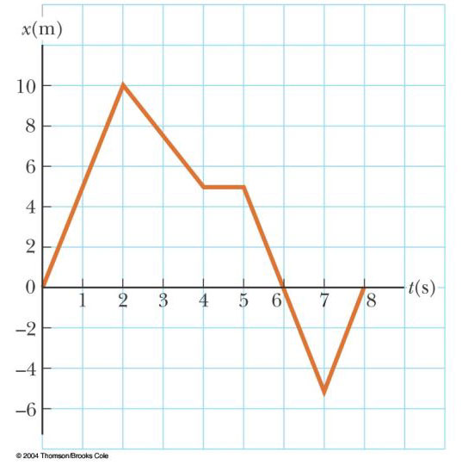

Figure P2.3 Problems 3

(a) (b)
(c) (d)
(e)

5. A person walks first at a constant speed of 5.00 m/s along a straight line from point A to point B and then back along the line from B to A at a constant speed of 3.00 m/s. What is (a) her average speed over the entire trip? (b) her average velocity over the entire trip?

(a) 3.75m/s
(b)

Instantaneous Velocity and Speed

7. A position-time graph for a particle moving along the x axis is shown in Figure P2.7. (a) Find the average velocity in the time interval t = 1.50 s to t = 4.00 s. (b) Determine the instantaneous velocity at t = 2.00 s by measuring the slope of the tangent line shown in the graph. (c) At what value of t is the velocity zero?

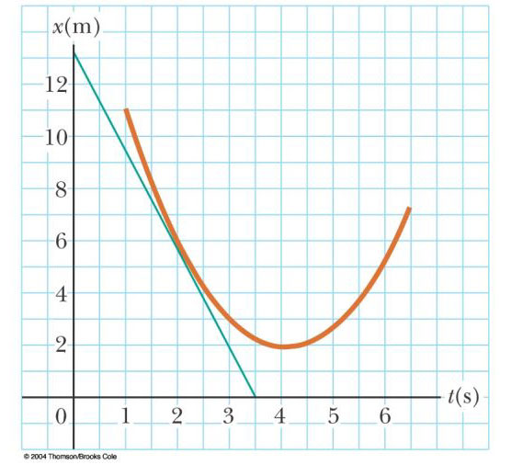

Figure P2.7

(a) -2.4 m/s (b)-3.8 m/s
(c) 4s

Acceleration

15. A particle moves along the x axis according to the equation x = 2.00 + 3.00 t – 1.00 t², where x is in meters and t is in seconds. At t = 3.00 s, find (a) the position of the particle, (b) its velocity, and (c) its acceleration.
(a) 2.00 m
(b) -3.00 m/s
(c) -2.00 m/s²

One-Dimensional Motion with Constant Acceleration

21. An object moving with uniform acceleration has a velocity of 12.0 cm/s in the positive x direction when its x coordinate is 3.00 cm. If its x coordinate 2.00 s later is –5.00 cm, what is its acceleration?

27. A jet plane lands with a speed of 100 m/s and can accelerate at a maximum rate of –5.00 m/s² as it comes to rest. (a) From the instant the plane touches the runway, what is the minimum time interval needed before it can come to rest? (b) Can this plane land on a small tropical island airport where the runway is 0.800 km long?

(a) .

(b) .

31. For many years Colonel John P. Stapp, USAF, held the world’s land speed record. On March 19, 1954, he rode a rocket-propelled sled that moved down a track at 632 mi/h. He and the sled were safely brought to rest in 1.40 s. Determine (a) the negative acceleration he experienced and (b) the distance he traveled during this negative acceleration.
(a)
(b)

Section 2.6 Freely Falling Objects

43. A student throws a set of keys vertically upward to her sorority sister, who is in a window 4.00 m above. The keys are caught 1.50 s later by the sister's outstretched hand. (a) With what initial velocity were the keys thrown? (b) What was the velocity of the keys just before they were caught?
(a) .
(b)

47. A baseball is hit so that it travels straight upward after being struck by the bat. A fan observes that it takes 3.00 s for the ball to reach its maximum height. Find (a) its initial velocity and (b) the height it reaches.

(a) 29.4m/s.
(b) 44.1m

49. A daring ranch hand sitting on a tree limb wishes to drop vertically onto a horse galloping under the tree. The constant speed of the horse is 10.0 m/s, and the distance from the limb to the saddle is 3.00 m. (a) What must be the horizontal distance between the saddle and limb when the ranch hand makes his move? (b) How long is he in the air?

(a) .
(b)

Section 2.7 Kinematic Equations Derived from Calculus

53. Automotive engineers refer to the time rate of change of acceleration as the "jerk." If an object moves in one dimension such that its jerk J is constant, (a) determine expressions for its acceleration a_{x}(t), velocity v_{x}(t), and position x(t), given that its initial acceleration, speed, and position are a_{xi} , v_{xi}, and x_{i} , respectively. (b) Show that

.

(a) ,
.

Additional Problems

65. Setting a new world record in a 100-m race, Maggie and Judy cross the finish line in a dead heat, both taking 10.2 s. Accelerating uniformly, Maggie took 2.00 s and Judy 3.00 s to attain maximum speed, which they maintained for the rest of the race. (a) What was the acceleration of each sprinter? (b) What were their respective maximum speeds? (c) Which sprinter was ahead at the 6.00-s mark, and by how much?

(a)

(b)

(c) Maggie is ahead by .

69. An inquisitive physics student and mountain climber climbs a 50.0-m cliff that overhangs a calm pool of water. He throws two stones vertically downward, 1.00 s apart, and observes that they cause a single splash. The first stone has an initial speed of 2.00 m/s. (a) How long after release of the first stone do the two stones hit the water? (b) What initial velocity must the second stone have if they are to hit simultaneously? (c) What is the speed of each stone at the instant the two hit the water?

(a) after the first stone is thrown.
(b) downward
(c) downward
downward

73. Kathy Kool buys a sports car that can accelerate at the rate of 4.90 m/s². She decides to test the car by racing with another speedster, Stan Speedy. Both start from rest, but experienced Stan leaves the starting line 1.00 s before Kathy. If Stan moves with a constant acceleration of 3.50 m/s² and Kathy maintains an acceleration of 4.90 m/s², find (a) the time at which Kathy overtakes Stan, (b) the distance she travels before she catches him, and (c) the speeds of both cars at the instant she overtakes him.

(a)
(b) 73.0 m
(c) 26.7 m/s22.6 m/s

75. Two objects, A and B, are connected by a rigid rod that has a length L. The objects slide along perpendicular guide rails, as shown in Figure P2.75. If A slides to the left with a constant speed v, find the velocity of B when α = 60.0°.
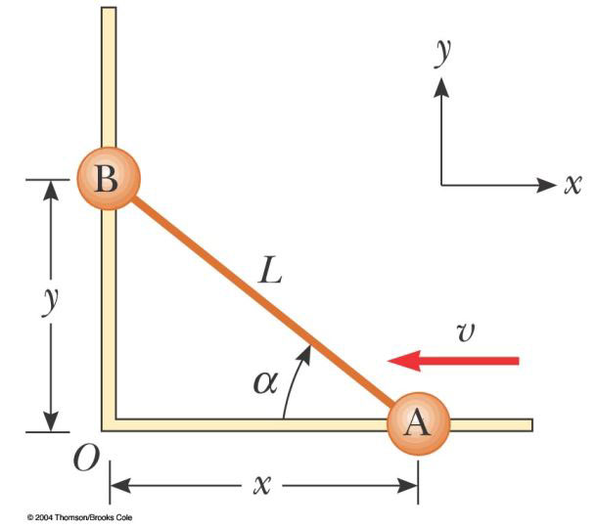

Figure P2
ANS=

