Bab 3 Pergerakan dalam 2-D

SOALAN-SOALAN

Q4.2. If you know the position vectors of a particle at two points along its path and also know the time it took to move from one point to the other, can you determine the particle’s instantaneous velocity? Its average velocity? Explain.

ANS. No, you cannot determine the instantaneous velocity. Yes, you can determine the average velocity. The points could be widely separated. In this case, you can only determine the average velocity, which is
.

Q4.6 A spacecraft drifts through space at a constant velocity. Suddenly a gas leak in the side of the spacecraft gives it a constant acceleration in a direction perpendicular to its velocity. The orientation of the spacecraft does not change, so that the acceleration remains perpendicular to the original direction of the velocity. What is the shape of the path followed by the spacecraft in the situation?
ANS: A parabola.

Q4.12
A projectile is launched at some angle to the horizontal with some initial speed v_{i}, and air resistance is negligible. Is the projectile a free falling body? What is its acceleration in the vertical direction? What is its acceleration in the horizontal direction?

ANS The projectile is in free fall. Its vertical component of acceleration is the downward acceleration of gravity. Its horizontal component of acceleration is zero.

Q4.18
Explain whether or not the following particles have an acceleration: (a) a particle moving in a straight line with constant
speed and (b) a particle moving around a curve with constant speed

ANS
(a) no (b)yes

Masalah-masalah

1. A motorist drives south at 20.0 m/s for 3.00 min, then turns west and travels at 25.0 m/s for 2.00 min, and finally travels northwest at 30.0 m/s for 1.00 min. For this 6.00-min trip, find (a) the total vector displacement, (b) the average speed, and (c) the average velocity. Let the positive x axis point east.
P4.1 | (a) | FIG. P4.1

(b)

(c)

7. A fish swimming in a horizontal plane has velocity at a point in the ocean where the position relative to a certain rock is . After the fish swims with constant acceleration for 20.0 s, its velocity is . (a) What are the components of the acceleration? (b) What is the direction of the acceleration with respect to unit vector ? (c) If the fish maintains constant acceleration, where is it at t = 25.0 s, and in what direction is it moving?

Solution and

(a)

(b)

(c) At

11. In a local bar, a customer slides an empty beer mug down the counter for a refill. The bartender is momentarily distracted and does not see the mug, which slides off the counter and strikes the floor 1.40 m from the base of the counter. If the height of the counter is 0.860 m, (a) with what velocity did the mug leave the counter, and (b) what was the direction of the mug's velocity just before it hit the floor?

P4.11 (a) The mug leaves the counter horizontally with a velocity (say). If time t elapses before it hits the ground, then since there is no horizontal acceleration, , i.e.,  In the same time it falls a distance of 0.860 m with acceleration downward of . Then | FIG. P4.11

.

Thus,

.

(b) The vertical velocity component with which it hits the floor is

.

Hence, the angle θ at which the mug strikes the floor is given by

.

15. A projectile is fired in such a way that its horizontal range is equal to three times its maximum height. What is the angle of projection?
Solution ; ; ,
so
or
thus .

19. A place-kicker must kick a football from a point 36.0 m (about 40 yards) from the goal, and half the crowd hopes the ball will clear the crossbar, which is 3.05 m high. When kicked, the ball leaves the ground with a speed of 20.0 m/s at an angle of 53.0° to the horizontal. (a) By how much does the ball clear or fall short of clearing the crossbar? (b) Does the ball approach the crossbar while still rising or while falling?

Solution (a) We use the trajectory equation:

.

With

, , and

we find

.

The ball clears the bar by

.

(b) The time the ball takes to reach the maximum height is

.

The time to travel 36.0 m horizontally is

.

Since .

27. The athlete shown in Figure P4.27 rotates a 1.00-kg discus along a circular path of radius 1.06 m. The maximum speed of the discus is 20.0 m/s. Determine the magnitude of the maximum radial acceleration of the discus.
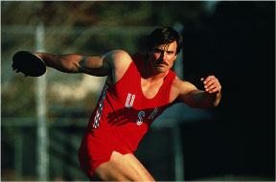Figure P4.27
Solution
The mass is unnecessary information.

33. A train slows down as it rounds a sharp horizontal turn, slowing from 90.0 km/h to 50.0 km/h in the 15.0 s that it takes to round the bend. The radius of the curve is 150 m. Compute the acceleration at the moment the train speed reaches 50.0 km/h. Assume it continues to slow down at this time at the same rate.

P4.33 | We assume the train is still slowing down at the instant in question.  at an angle of | FIG. P4.33

41. A river has a steady speed of 0.500 m/s. A student swims upstream a distance of 1.00 km and swims back to the starting point. If the student can swim at a speed of 1.20 m/s in still water, how long does the trip take? Compare this with the time the trip would take if the water were still.

Solution Total time in still water .

Total time = time upstream plus time downstream:

Therefore, .

45. A science student is riding on a flatcar of a train traveling along a straight horizontal track at a constant speed of 10.0 m/s. The student throws a ball into the air along a path that he judges to make an initial angle of 60.0° with the horizontal and to be in line with the track. The student's professor, who is standing on the ground nearby, observes the ball to rise vertically. How high does she see the ball rise?

P4.45 | Identify the student as the S’ observer and the professor as the S observer. For the initial motion in S’, we have  .  Let u represent the speed of S’ relative to S. Then because there is no x-motion in S, we can write so that . Hence the ball is thrown backwards in S’. Then,  .  Using we find  . | FIG. P4.45

The motion of the ball as seen by the student in S’ is shown in diagram (b). The view of the professor in S is shown in diagram (c).

51. Barry Bonds hits a home run so that the baseball just clears the top row of bleachers, 21.0 m high, located 130 m from home plate. The ball is hit at an angle of 35.0° to the horizontal, and air resistance is negligible. Find (a) the initial speed of the ball, (b) the time at which the ball reaches the cheap seats, and (c) the velocity components and the speed of the ball when it passes over the top row. Assume the ball is hit at a height of 1.00 m above the ground.

P4.51 Refer to the sketch:  (b) ; substitution yields .  ; substitution yields  .  Solving the above gives .  (a) | FIG. P4.51

(c) ,

At ,

59. Your grandfather is copilot of a bomber, flying horizontally over level terrain, with a speed of 275 m/s relative to the ground, at an altitude of 3 000 m. (a) The bombardier releases one bomb. How far will it travel horizontally between its release and its impact on the ground? Neglect the effects of air resistance. (b) Firing from the people on the ground suddenly incapacitates the bombardier before he can call, “Bombs away!” Consequently, the pilot maintains the plane’s original course, altitude, and speed through a storm of flak. Where will the plane be when the bomb hits the ground? (c) The plane has a telescopic bomb sight set so that the bomb hits the target seen in the sight at the time of release. At what angle from the vertical was the bomb sight set?

Solution (a) ;  Combine the equations eliminating t:  .  From this, | FIG. P4.59

thus .

(b) The plane has the same velocity as the bomb in the x direction. Therefore, the plane will be when it hits the ground.

(c) When φ is measured from the vertical,

therefore, .
61. A hawk is flying horizontally at 10.0 m/s in a straight line, 200 m above the ground. A mouse it has been carrying struggles free from its grasp. The hawk continues on its path at the same speed for 2.00 seconds before attempting to retrieve its prey. To accomplish the retrieval, it dives in a straight line at constant speed and recaptures the mouse 3.00 m above the ground. (a) Assuming no air resistance, find the diving speed of the hawk. (b) What angle did the hawk make with the horizontal during its descent? (c) For how long did the mouse "enjoy" free fall?

Solution (a) From Part (c), the raptor dives for undergoing displacement 197 m downward and forward.  (b)  (c) , | FIG. P4.61

63. A car is parked on a steep incline overlooking the ocean, where the incline makes an angle of 37.0° below the horizontal. The negligent driver leaves the car in neutral, and the parking brakes are defective. Starting from rest at t = 0, the car rolls down the incline with a constant acceleration of 4.00 m/s², traveling 50.0 m to the edge of a vertical cliff. The cliff is 30.0 m above the ocean. Find (a) the speed of the car when it reaches the edge of the cliff and the time at which it arrives there, (b) the velocity of the car when it lands in the ocean, (c) the total time interval that the car is in motion, and (d) the position of the car when it lands in the ocean, relative to the base of the cliff.

Solution (a) While on the incline | FIG. P4.63

(b) Initial free-flight conditions give us

and

since

(c) ;

(d)

67. A skier leaves the ramp of a ski jump with a velocity of 10.0 m/s, 15.0° above the horizontal, as in Figure P4.67. The slope is inclined at 50.0°, and air resistance is negligible. Find (a) the distance from the ramp to where the jumper lands and (b) the velocity components just before the landing. (How do you think the results might be affected if air resistance were included? Note that jumpers lean forward in the shape of an airfoil, with their hands at their sides, to increase their distance. Why does this work?)

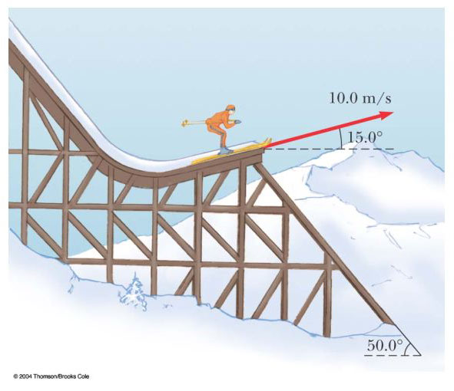
Solution (a) ,  and  .  Solving, and .  (b) Since , | FIG. P4.67

Air resistance would decrease the values of the range and maximum height. As an airfoil, he can get some lift and increase his distance.

