Bab 4 Hukum-hukum Gerakan

SOALAN-SOALAN

Q5.4 In the motion picture It Happened One
Night (Columbia Pictures, 1934), Clark Gable is
standing inside a stationary bus in front of
Claudette Colbert, who is seated. The bus suddenly starts moving forward and Clark falls into Claudette's lap. Why did this happen?

Q5.7
A rubber ball is dropped onto the floor. What force causes the ball to bounce?

Q5.10 A weightlifter stands on a bathroom
scale. He pumps a barbell up and down. What
happens to the reading on the bathroom scale as
this is done? What if he is strong enough to ctually
throw the barbell upward? How does the reading
on the scale vary now?

Q5.14 Identify the action-reaction pairs in the
following situation: a man takes a step; a snowball
hits a girl in the back; a baseball player catches a
ball; a gust of wind strikes a window

Masalah-masalah

3. A 3.00-kg object undergoes an acceleration given by . Find the resultant force acting on it and the magnitude of the resultant force.

5. To model a spacecraft, a toy rocket engine is securely fastened to a large puck, which can glide with negligible friction over a horizontal surface, taken as the xy plane. The 4.00-kg puck has a velocity of at one instant. Eight seconds later, its velocity is to be . Assuming the rocket engine exerts a constant horizontal force, find (a) the components of the force and (b) its magnitude.
,

7. An electron of mass 9.11 × 10^{–31} kg has an initial speed of 3.00 × 10⁵ m/s. It travels in a straight line, and its speed increases to 7.00 × 10⁵ m/s in a distance of 5.00 cm. Assuming its acceleration is constant, (a) determine the force exerted on the electron and (b) compare this force with the weight of the electron, which we neglected.

(a)
(b)

11. Two forces F₁ and F₂ act on a 5.00-kg object. If F₁ = 20.0 N and F₂ = 15.0 N, find the accelerations in (a) and (b) of Figure P5.11.
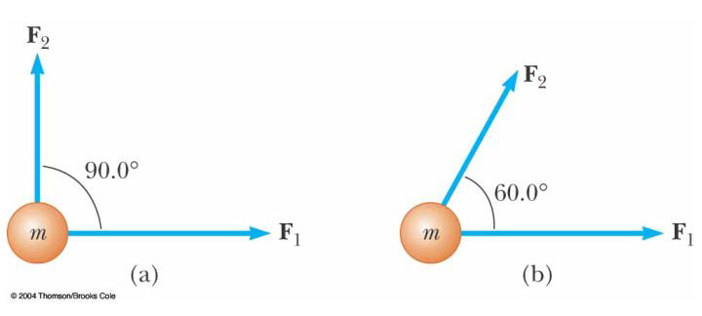Figure P5.11

Solution
(a)
(b)

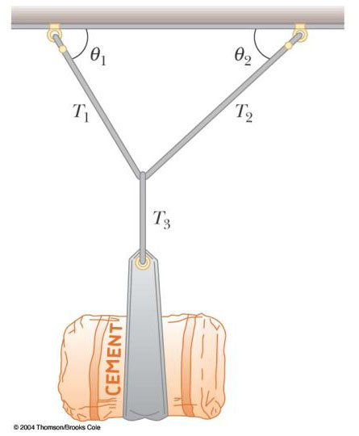

Figure P5.18 Problem 19

19. A bag of cement of weight F_{g} hangs from three wires as shown in Figure P5.18. Two of the wires make angles ₁ and ₂ with the horizontal. If the system is in equilibrium, show that the tension in the left-hand wire is T₁ = F_{g} cos ₂ /sin(₁ +₂)

23. A 1.00-kg object is observed to accelerate at 10.0 m/s² in a direction 30.0° north of east (Fig. P5.23). The force F₂ acting on the object has a magnitude of 5.00 N and is directed north. Determine the magnitude and direction of the force F₁ acting on the object.
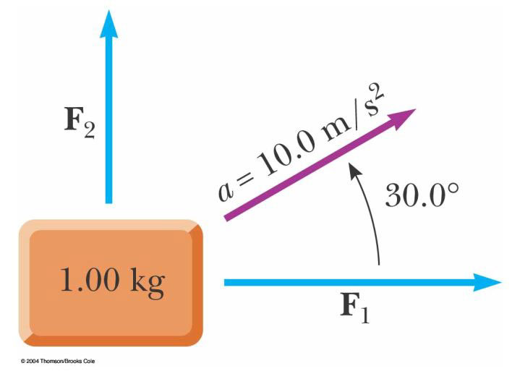
Figure P5.23

25. A block is given an initial velocity of 5.00 m/s up a frictionless 20.0° incline (Fig. P5.22). How far up the incline does the block slide before coming to rest?
.

31. In the system shown in Figure P5.31, a horizontal force F_{x} acts on the 8.00-kg object. The horizontal surface is frictionless. (a) For what values of F_{x} does the 2.00-kg object accelerate upward? (b) For what values of F_{x} is the tension in the cord zero? (c) Plot the acceleration of the 8.00-kg object versus F_{x}. Include values of F_{x} from –100 N to +100 N.
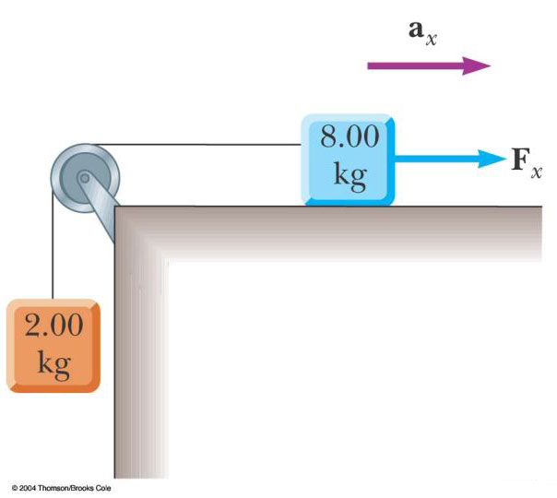

Figure P5.31
(a)
(b).

33. A 72.0-kg man stands on a spring scale in an elevator. Starting from rest, the elevator ascends, attaining its maximum speed of 1.20 m/s in 0.800 s. It travels with this constant speed for the next 5.00 s. The elevator then undergoes a uniform acceleration in the negative y direction for 1.50 s and comes to rest. What does the spring scale register (a) before the elevator starts to move? (b) during the first 0.800 s? (c) while the elevator is traveling at constant speed? (d) during the time it is slowing down?

(a).(b).
(c) .(d) .

41. A 3.00-kg block starts from rest at the top of a 30.0° incline and slides a distance of 2.00 m down the incline in 1.50 s. Find (a) the magnitude of the acceleration of the block, (b) the coefficient of kinetic friction between block and plane, (c) the friction force acting on the block, and (d) the speed of the block after it has slid 2.00 m.
(a) (b)
(c) (d)

45. Two blocks connected by a rope of negligible mass are being dragged by a horizontal force F (Fig. P5.45). Suppose that F = 68.0 N, m₁ = 12.0 kg, m₂ = 18.0 kg, and the coefficient of kinetic friction between each block and the surface is 0.100. (a) Draw a free-body diagram for each block. (b) Determine the tension T and the magnitude of the acceleration of the system.

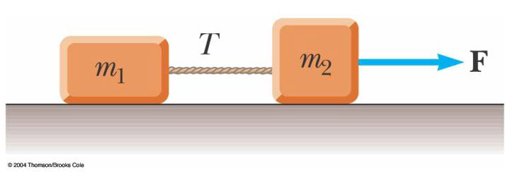
Figure P5.45

51. An inventive child named Pat wants to reach an apple in a tree without climbing the tree. Sitting in a chair connected to a rope that passes over a frictionless pulley (Fig. P5.51), Pat pulls on the loose end of the rope with such a force that the spring scale reads 250 N. Pat's true weight is
320 N, and the chair weighs 160 N. (a) Draw free-body diagrams for Pat and the chair considered as separate systems, and another diagram for Pat and the chair considered as one system. (b) Show that the acceleration of the system is upward and find its magnitude. (c) Find the force Pat exerts on the chair.

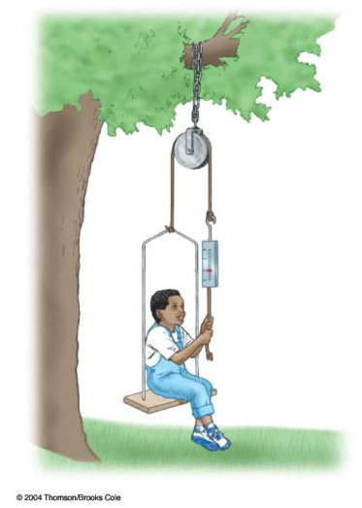
Figure P5.51
(b).
(c)

55. An object of mass M is held in place by an applied force F and a pulley system as shown in Figure P5.55. The pulleys are massless and frictionless. Find (a) the tension in each section of rope, T₁, T₂, T₃, T₄, and T₅ and (b) the magnitude of F. Suggestion: Draw a free-body diagram for
each pulley.
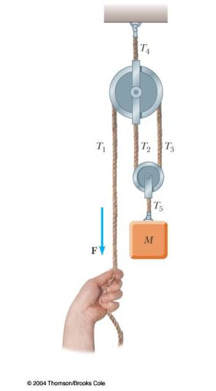
(a),,.
- .

61. What horizontal force must be applied to the cart shown in Figure P5.61 in order that the blocks remain stationary relative to the cart? Assume all surfaces, wheels, and pulley are frictionless. (Hint: Note that the force exerted by the string accelerates m₁.)
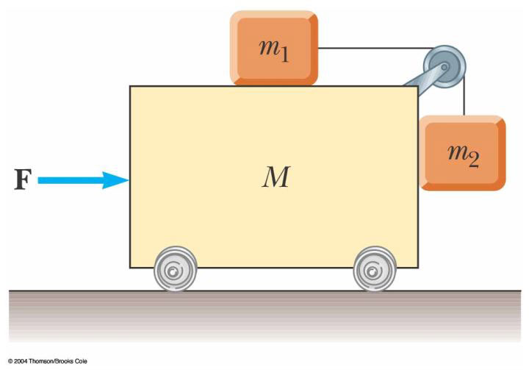
Figure P5.61 Problems 61 and 63

