Bab 4 Hukum-hukum Gerakan

SOALAN-SOALAN

Q5.4 In the motion picture It Happened One
Night (Columbia Pictures, 1934), Clark Gable is
standing inside a stationary bus in front of
Claudette Colbert, who is seated. The bus suddenly starts moving forward and Clark falls into Claudette's lap. Why did this happen?

Solution
When the bus starts moving, the mass of Claudette is accelerated by the force of the back of the seat on her body. Clark is standing, however, and the only force on him is the friction between his shoes and the floor of the bus. Thus, when the bus starts moving, his feet start accelerating forward, but the rest of his body experiences almost no accelerating force (only that due to his being attached to his accelerating feet!). As a consequence, his body tends to stay almost at rest, according to Newton’s first law, relative to the ground. Relative to Claudette, however, he is moving toward her and falls into her lap. (Both performers won Academy Awards.)

Q5.7
A rubber ball is dropped onto the floor. What force causes the ball to bounce?

Solution
The molecules of the floor resist the ball on impact and push the ball back, upward. The actual force acting is due to the forces between molecules that allow the floor to keep its integrity and to prevent the ball from passing through. Notice that for a ball passing through a window, the molecular forces weren’t strong enough.

Q5.10 A weightlifter stands on a bathroom
scale. He pumps a barbell up and down. What
happens to the reading on the bathroom scale as
this is done? What if he is strong enough to ctually
throw the barbell upward? How does the reading
on the scale vary now?

Solution
As the barbell goes through the bottom of a cycle,
the lifter exerts an upward force on it, and the
scale reads
the larger upward force that the floor exerts on
them together. Around the top of the weight’s
motion, the scale reads less than average. If the
iron is moving upward, the lifter can declare that
she has thrown it, just by letting go of it for a
moment, so our answer applies also to this case.

Q5.14 Identify the action-reaction pairs in the
following situation: a man takes a step; a snowball
hits a girl in the back; a baseball player catches a
ball; a gust of wind strikes a window

Solution
As a man takes a step, the action is the force his
foot exerts on the Earth; the reaction is the force of
the Earth on his foot. In the second case, the action
is the force exerted on the girl’s back by the
snowball; the reaction is the force exerted on the
snowball by the girl’s back. The third action is the
force of the glove on the ball; the reaction is the
force of the ball on the glove. The fourth action is
the force exerted on the window by the air
molecules; the reaction is the force on the air
molecules exerted by the window. We could in
each case interchange the terms ‘action’ and
‘reaction.’

Masalah-masalah

3. A 3.00-kg object undergoes an acceleration given by . Find the resultant force acting on it and the magnitude of the resultant force.

Solution

5. To model a spacecraft, a toy rocket engine is securely fastened to a large puck, which can glide with negligible friction over a horizontal surface, taken as the xy plane. The 4.00-kg puck has a velocity of at one instant. Eight seconds later, its velocity is to be . Assuming the rocket engine exerts a constant horizontal force, find (a) the components of the force and (b) its magnitude.

Solution
, , ,

7. An electron of mass 9.11 × 10^{–31} kg has an initial speed of 3.00 × 10⁵ m/s. It travels in a straight line, and its speed increases to 7.00 × 10⁵ m/s in a distance of 5.00 cm. Assuming its acceleration is constant, (a) determine the force exerted on the electron and (b) compare this force with the weight of the electron, which we neglected.

Solution
(a) and or .
Therefore (b) The weight of the electron is
The accelerating force is

11. Two forces F₁ and F₂ act on a 5.00-kg object. If F₁ = 20.0 N and F₂ = 15.0 N, find the accelerations in (a) and (b) of Figure P5.11.
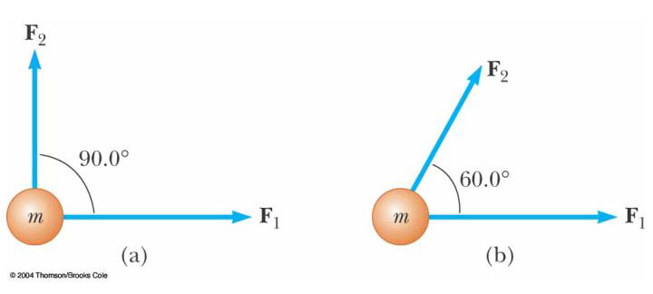Figure P5.11

Solution
(a)

or

(b)

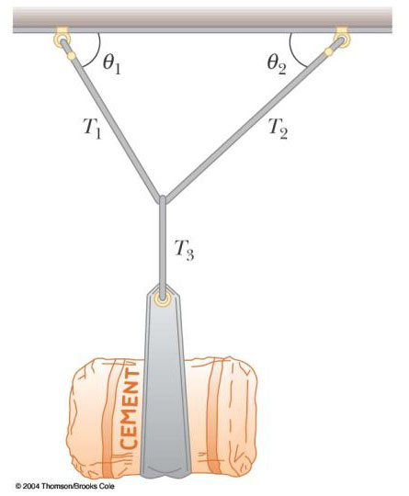

Figure P5.18 Problems 18 and 19

19. A bag of cement of weight F_{g} hangs from three wires as shown in Figure P5.18. Two of the wires make angles ₁ and ₂ with the horizontal. If the system is in equilibrium, show that the tension in the left-hand wire is T₁ = F_{g} cos ₂ /sin(₁ +₂)

Solution
(1)
(2)
(3)
Eliminate and solve for

23. A 1.00-kg object is observed to accelerate at 10.0 m/s² in a direction 30.0° north of east (Fig. P5.23). The force F₂ acting on the object has a magnitude of 5.00 N and is directed north. Determine the magnitude and direction of the force F₁ acting on the object.
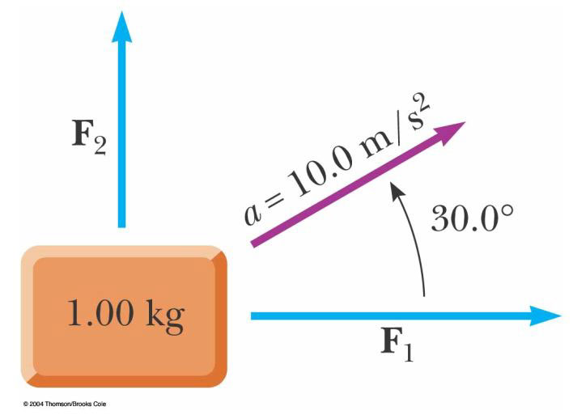
Figure P5.23

Solution
Choose a coordinate system with East and North.
at

25. A block is given an initial velocity of 5.00 m/s up a frictionless 20.0° incline (Fig. P5.22). How far up the incline does the block slide before coming to rest?

Solution
After it leaves your hand, the block’s speed changes only because of one component of its weight:
Taking , , and gives
or
.

31. In the system shown in Figure P5.31, a horizontal force F_{x} acts on the 8.00-kg object. The horizontal surface is frictionless. (a) For what values of F_{x} does the 2.00-kg object accelerate upward? (b) For what values of F_{x} is the tension in the cord zero? (c) Plot the acceleration of the 8.00-kg object versus F_{x}. Include values of F_{x} from –100 N to +100 N.
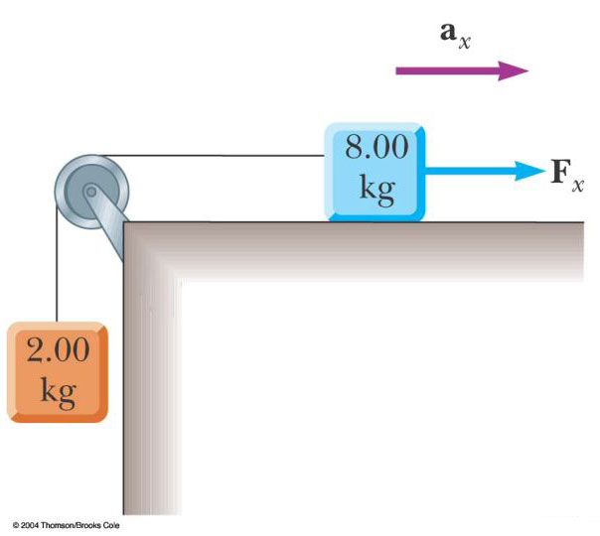

Figure P5.31
Solution
Forces acting on 2.00 kg block:

(1)

Forces acting on 8.00 kg block:

(2)

(a) Eliminate T and solve for a:

.

(b) Eliminate a and solve for T:

.

33. A 72.0-kg man stands on a spring scale in an elevator. Starting from rest, the elevator ascends, attaining its maximum speed of 1.20 m/s in 0.800 s. It travels with this constant speed for the next 5.00 s. The elevator then undergoes a uniform acceleration in the negative y direction for 1.50 s and comes to rest. What does the spring scale register (a) before the elevator starts to move? (b) during the first 0.800 s? (c) while the elevator is traveling at constant speed? (d) during the time it is slowing down?

Solution
First, we will compute the needed accelerations:

Newton’s second law is:
(a) When , .
(b) When , .
(c) When , .
(d) When , .

41. A 3.00-kg block starts from rest at the top of a 30.0° incline and slides a distance of 2.00 m down the incline in 1.50 s. Find (a) the magnitude of the acceleration of the block, (b) the coefficient of kinetic friction between block and plane, (c) the friction force acting on the block, and (d) the speed of the block after it has slid 2.00 m.

Solution
, , ,
(a) :
:

(b) ,
(c) ,
(d)
where

45. Two blocks connected by a rope of negligible mass are being dragged by a horizontal force F (Fig. P5.45). Suppose that F = 68.0 N, m₁ = 12.0 kg, m₂ = 18.0 kg, and the coefficient of kinetic friction between each block and the surface is 0.100. (a) Draw a free-body diagram for each block. (b) Determine the tension T and the magnitude of the acceleration of the system.

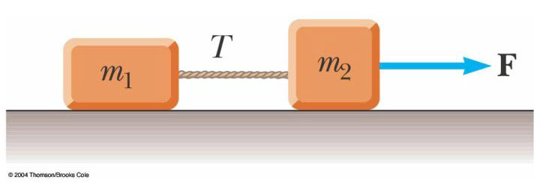
Figure P5.45

Solution
(a) See Figure

(b)
Adding,

51. An inventive child named Pat wants to reach an apple in a tree without climbing the tree. Sitting in a chair connected to a rope that passes over a frictionless pulley (Fig. P5.51), Pat pulls on the loose end of the rope with such a force that the spring scale reads 250 N. Pat's true weight is
320 N, and the chair weighs 160 N. (a) Draw free-body diagrams for Pat and the chair considered as separate systems, and another diagram for Pat and the chair considered as one system. (b) Show that the acceleration of the system is upward and find its magnitude. (c) Find the force Pat exerts on the chair.

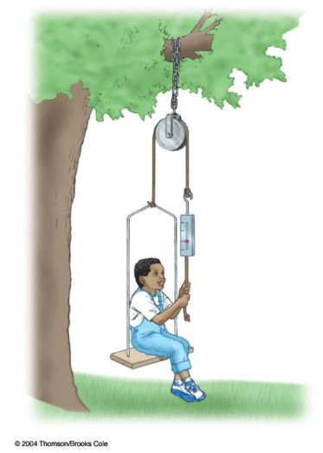
Figure P5.51
Solution
(a)
(b) First consider Pat and the chair as the system. Note that two ropes support the system, and in each rope. Applying

, where .
Solving for a gives

.
(c) on Pat:
, where
55. An object of mass M is held in place by an applied force F and a pulley system as shown in Figure P5.55. The pulleys are massless and frictionless. Find (a) the tension in each section of rope, T₁, T₂, T₃, T₄, and T₅ and (b) the magnitude of F. Suggestion: Draw a free-body diagram for
each pulley.
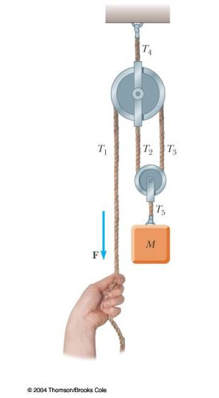
Solution
(a) First, we note that . Next, we focus on the mass M and write . Next, we focus on the bottom pulley and write . Finally, we focus on the top pulley and write .
Since the pulleys are not starting to rotate and are frictionless, , and . From this information, we have , so.
Then , and , and .
- Since , we have .

61. What horizontal force must be applied to the cart shown in Figure P5.61 in order that the blocks remain stationary relative to the cart? Assume all surfaces, wheels, and pulley are frictionless. (Hint: Note that the force exerted by the string accelerates m₁.)
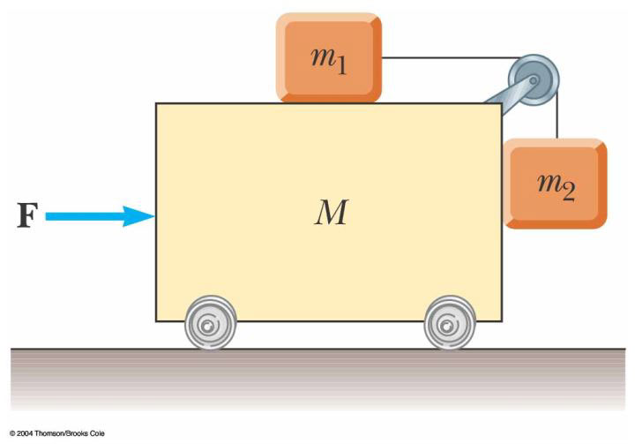
Figure P5.61 Problems 61 and 63

Solution
For :
For :
Eliminating T, . For all 3 blocks:

