Bab 5 Aplikasi Hukum-hukum Newton

SOALAN-SOALAN

10. It has been suggested that rotating cylinders about 10 mi in length and 5 mi in diameter be
placed in space and used as colonies. The purpose of the rotation is to simulate gravity for the inhabitants. Explain this concept for producing an effective imitation of gravity.

14. Why does a pilot tend to black out when pulling out of a steep dive?

17. A falling sky diver reaches terminal speed with her parachute closed. After the parachute is
opened, what parameters change to decrease this terminal speed?

MASALAH-MASALAH

1. A light string can support a stationary hanging load of 25.0 kg before breaking. A 3.00-kg object attached to the string rotates on a horizontal, frictionless table in a circle of radius 0.800 m, while the other end of the string is held fixed. What range of speeds can the object have before the string breaks?
.

5. A coin placed 30.0 cm from the center of a rotating, horizontal turntable slips when its speed is 50.0 cm/s. (a) What force causes the centripetal acceleration when the coin is stationary relative to the turntable? (b) What is the coefficient of static friction between coin and turntable?

(a)(b)

7. A crate of eggs is located in the middle of the flat bed of a pickup truck as the truck negotiates an unbanked curve in the road. The curve may be regarded as an arc of a circle of radius 35.0 m. If the coefficient of static friction between crate and truck is 0.600, how fast can the truck be moving without the crate sliding?

13. A 40.0-kg child swings in a swing supported by two chains, each 3.00 m long. If the tension in each chain at the lowest point is 350 N, find (a) the child's speed at the lowest point and (b) the force exerted by the seat on the child at the lowest point. (Neglect the mass of the seat.)

Solution
, ,
(a) (b)

15. Tarzan (m = 85.0 kg) tries to cross a river by swinging from a vine. The vine is 10.0 m long, and his speed at the bottom of the swing (as he just clears the water) will be 8.00 m/s. Tarzan doesn't know that the vine has a breaking strength of 1 000 N. Does he make it safely across the river?

Solution
Let the tension at the lowest point be T.

17. A pail of water is rotated in a vertical circle of radius 1.00 m. What is the minimum speed of the pail at the top of the circle if no water is to spill out?
.

23. A 0.500-kg object is suspended from the ceiling of an accelerating boxcar as in Figure 6.13. If a = 3.00 m/s², find (a) the angle that the string makes with the vertical and (b) the tension in the string.
(a) (b) .

25. A person stands on a scale in an elevator. As the elevator starts, the scale has a constant reading of 591 N. As the elevator later stops, the scale reading is
391 N. Assume the magnitude of the acceleration is the same during starting and stopping, and determine (a) the weight of the person, (b) the person's mass, and (c) the acceleration of the elevator.
(a) (b) (c)

39. A motorboat cuts its engine when its speed is 10.0 m/s and coasts to rest. The equation describing the motion of the motorboat during this period is v = v_{i}e^{–ct}, where v is the speed at time t, v_{i} is the initial speed, and c is a constant. At t = 20.0 s, the speed is 5.00 m/s. (a) Find the constant c. (b) What is the speed at t = 40.0 s? (c) Differentiate the expression for v(t) and thus show that the acceleration of the boat is proportional to the speed at any time.
(a) (b) (c)

57. Because the Earth rotates about its axis, a point on the equator experiences a centripetal acceleration of 0.033 7 m/s², while a point at the poles experiences no centripetal acceleration. (a) Show that at the equator the gravitational force on an object must exceed the normal force required to support the object. That is, show that the object's true weight exceeds its apparent weight. (b) What is the apparent weight at the equator and at the poles of a person having a mass of 75.0 kg? (Assume the Earth is a uniform sphere and take g = 9.800 m/s².)
(a) (b) down.

65. An amusement park ride consists of a large vertical cylinder that spins about its axis fast enough that any person inside is held up against the wall when the floor drops away (Fig. P6.65). The coefficient of static friction between person and wall is µ_{s}, and the radius of the cylinder is R. (a) Show that the maximum period of revolution necessary to keep the person from falling is T = (4π²Rµ_{s}/g)^{1/2}. (b) Obtain a numerical value for T if R = 4.00 m and µ_{s} = 0.400. How many revolutions per minute does the cylinder make?
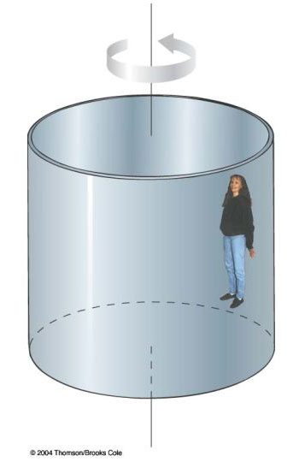
Figure P6.65
(b)
71. A model airplane of mass 0.750 kg flies in a horizontal circle at the end of a 60.0-m control wire, with a speed of
35.0 m/s. Compute the tension in the wire if it makes a constant angle of 20.0° with the horizontal. The forces exerted on the airplane are the pull of the control wire, the gravitational force, and aerodynamic lift, which acts at 20.0° inward from the vertical as shown in Figure P6.71.
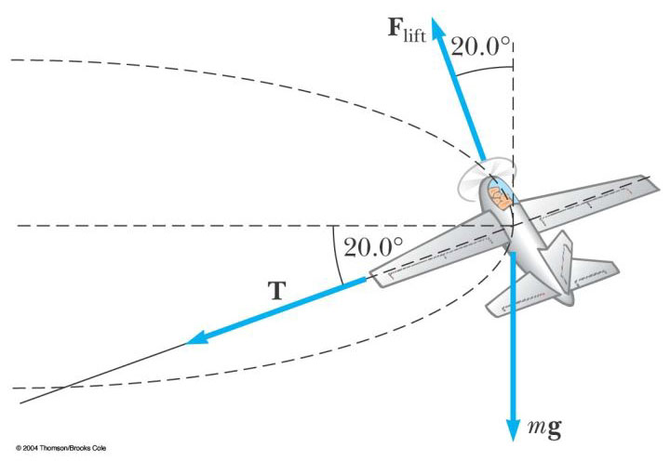
Figure P6.71

