Bab 5 Aplikasi Hukum-hukum Newton

SOALAN-SOALAN

10. It has been suggested that rotating cylinders about 10 mi in length and 5 mi in diameter be
placed in space and used as colonies. The purpose of the rotation is to simulate gravity for the inhabitants. Explain this concept for producing an effective imitation of gravity.

Solution
This is the same principle as the centrifuge. All the material inside the cylinder tends to move along a straight-line path, but the walls of the cylinder exert an inward force to keep everything moving around in a circular path.

14. Why does a pilot tend to black out when pulling out of a steep dive?

Solution
Blood pressure cannot supply the force necessary both to balance the gravitational force and to provide the centripetal acceleration, to keep blood flowing up to the pilot’s brain.

17. A falling sky diver reaches terminal speed with her parachute closed. After the parachute is
opened, what parameters change to decrease this terminal speed?

Solution
From the proportionality of the drag force to the speed squared and from Newton’s second law, we derive the equation that describes the motion of the skydiver:
where D is the coefficient of drag of the parachutist, and A is the projected area of the parachutist’s body. At terminal speed,
and .
When the parachute opens, the coefficient of drag D and the effective area A both increase, thus reducing the speed of the skydiver.

Modern parachutes also add a third term, lift, to change the equation to
where is the vertical velocity, and is the horizontal velocity. The effect of lift is clearly seen in the “paraplane,” an ultralight airplane made from a fan, a chair, and a parachute.

MASALAH-MASALAH

1. A light string can support a stationary hanging load of 25.0 kg before breaking. A 3.00-kg object attached to the string rotates on a horizontal, frictionless table in a circle of radius 0.800 m, while the other end of the string is held fixed. What range of speeds can the object have before the string breaks?

Solution
, . The string will break if the tension exceeds the weight corresponding to 25.0 kg, so .
When the 3.00 kg mass rotates in a horizontal circle, the tension causes the centripetal acceleration,
so .
Thenand or .

5. A coin placed 30.0 cm from the center of a rotating, horizontal turntable slips when its speed is 50.0 cm/s. (a) What force causes the centripetal acceleration when the coin is stationary relative to the turntable? (b) What is the coefficient of static friction between coin and turntable?

Solution
(a)
(b)
thus and
.
Then

7. A crate of eggs is located in the middle of the flat bed of a pickup truck as the truck negotiates an unbanked curve in the road. The curve may be regarded as an arc of a circle of radius 35.0 m. If the coefficient of static friction between crate and truck is 0.600, how fast can the truck be moving without the crate sliding?

Solution
since
The force causing the centripetal acceleration is the frictional force f. From Newton’s second law . But the friction condition is i.e.,

13. A 40.0-kg child swings in a swing supported by two chains, each 3.00 m long. If the tension in each chain at the lowest point is 350 N, find (a) the child's speed at the lowest point and (b) the force exerted by the seat on the child at the lowest point. (Neglect the mass of the seat.)

Solution
, ,
(a)
(b)
FIG. P6.13(a) | FIG. P6.13(b)
15. Tarzan (m = 85.0 kg) tries to cross a river by swinging from a vine. The vine is 10.0 m long, and his speed at the bottom of the swing (as he just clears the water) will be 8.00 m/s. Tarzan doesn't know that the vine has a breaking strength of 1 000 N. Does he make it safely across the river?

Solution
Let the tension at the lowest point be T.
FIG. P6.15

17. A pail of water is rotated in a vertical circle of radius 1.00 m. What is the minimum speed of the pail at the top of the circle if no water is to spill out?

Solution
But at this minimum speed condition, so
.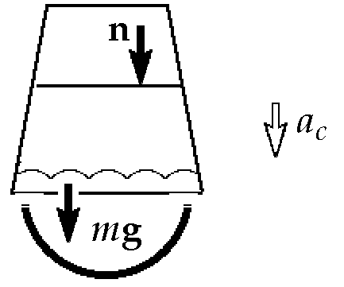

23. A 0.500-kg object is suspended from the ceiling of an accelerating boxcar as in Figure 6.13. If a = 3.00 m/s², find (a) the angle that the string makes with the vertical and (b) the tension in the string.

Solution
The only forces acting on the suspended object are the force of gravity and the force of tension T, as shown in the free-body diagram. Applying Newton’s second law in the x and y directions,
(1)
or (2)

(a) Dividing equation (1) by (2) gives
.
Solving for θ,

(b)From Equation (1),
.

25. A person stands on a scale in an elevator. As the elevator starts, the scale has a constant reading of 591 N. As the elevator later stops, the scale reading is
391 N. Assume the magnitude of the acceleration is the same during starting and stopping, and determine (a) the weight of the person, (b) the person's mass, and (c) the acceleration of the elevator.

Solution
(a) Adding, ,
(b) Since ,
(c) Subtracting the above equations,

39. A motorboat cuts its engine when its speed is 10.0 m/s and coasts to rest. The equation describing the motion of the motorboat during this period is v = v_{i}e^{–ct}, where v is the speed at time t, v_{i} is the initial speed, and c is a constant. At t = 20.0 s, the speed is 5.00 m/s. (a) Find the constant c. (b) What is the speed at t = 40.0 s? (c) Differentiate the expression for v(t) and thus show that the acceleration of the boat is proportional to the speed at any time.

Solution

(a)
, .

So and

(b)At
(c)

57. Because the Earth rotates about its axis, a point on the equator experiences a centripetal acceleration of 0.033 7 m/s², while a point at the poles experiences no centripetal acceleration. (a) Show that at the equator the gravitational force on an object must exceed the normal force required to support the object. That is, show that the object's true weight exceeds its apparent weight. (b) What is the apparent weight at the equator and at the poles of a person having a mass of 75.0 kg? (Assume the Earth is a uniform sphere and take g = 9.800 m/s².)
Solution
(a) Since the centripetal acceleration of a person is downward (toward the axis of the earth), it is equivalent to the effect of a falling elevator. Therefore,
or
(b) At the poles and down.

65. An amusement park ride consists of a large vertical cylinder that spins about its axis fast enough that any person inside is held up against the wall when the floor drops away (Fig. P6.65). The coefficient of static friction between person and wall is µ_{s}, and the radius of the cylinder is R. (a) Show that the maximum period of revolution necessary to keep the person from falling is T = (4π²Rµ_{s}/g)^{1/2}. (b) Obtain a numerical value for T if R = 4.00 m and µ_{s} = 0.400. How many revolutions per minute does the cylinder make?
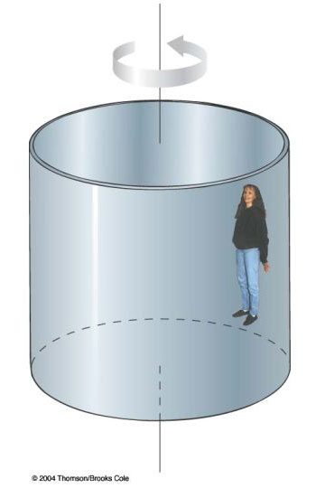
Figure P6.65
Solution
(a)

(b)

71. A model airplane of mass 0.750 kg flies in a horizontal circle at the end of a 60.0-m control wire, with a speed of
35.0 m/s. Compute the tension in the wire if it makes a constant angle of 20.0° with the horizontal. The forces exerted on the airplane are the pull of the control wire, the gravitational force, and aerodynamic lift, which acts at 20.0° inward from the vertical as shown in Figure P6.71.
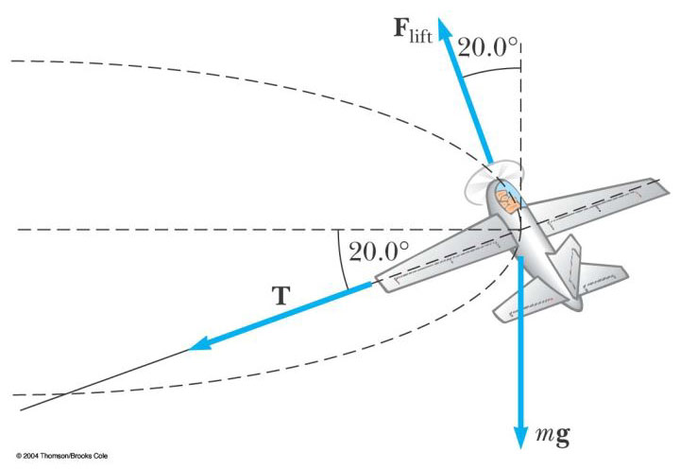
Figure P6.71

Solution

