Bab 6 Tenaga dan perpindahan tenaga

SOALAN-SOALAN

Q7.5
As a simple pendulum swings back and forth, the forces acting on the suspended object are the gravitational force, the tension in the supporting cord, and air resistance. (a) Which of these forces, if any, does no work on the pendulum? (b) Which of these forces does negative woi k at all times during its motion? (c) Describe the work done by the gravitational force while the pendulum is swinging.

Solution
(a) Tension
(b) Air resistance
(c) Positive in increasing velocity on the downswing.Negative in decreasing velocity on the upswing.

Q7.10 Can kinetic energy be negative? Explain.

Solution
Kinetic energy is always positive. Mass and
squared speed are both positive. A moving object
can always do positive work in striking another
object and causing it to move along the same
direction of motion.

Q7.12
52.10iie bullet has twice the mass of a second
bullet. If both are fired so that they have the same
speed, which has more kinetic energy? What is the
ratio of the kinetic energies of the two bullets?

Solution
Kinetic energy is proportional to mass. The first
bullet has twice as much kinetic energy.

Q7.14 (a) If the speed of a particle is doubled,
what happens to its kinetic energy? (b) What can
be said about the speed of a particle if the net
work done on it is zero?

Solution
(a) Kinetic energy is proportional to
squared speed. Doubling the speed makes an object's kinetic energy four times larger.

(b) If the total work on an object is zero in some process, its speed must be the same at the final point as it was at the initial point.

MASALAH-MASALAH

1. A block of mass 2.50 kg is pushed 2.20 m
along a frictionless horizontal table by a constant
16.0-N force directed 25.0° below the horizontal.
Determine the work done on the block by (a) the
applied force, (b) the normal force exerted by the
table, and (c) the gravitational force (d) Determine
the total work done on the block.

Solution
(b), (c) The normal force and the weight are both
at 90° to the displacement in any time interval.
Both do work.
(d)

- Batman, whose mass is 80.0 kg, is dangling
on the free end of a 12.0-m rope, the other end of which is fixed to a tree limb above. He is able to get the rope in motion as only Batman knows how, eventually getting it to swing enough that he can reach a ledge when the rope makes a 60.0° angle with the vertical. How much work was done by the gravitational force on Batman in this maneuver?

Solution
Method One.

Let φ represent the instantaneous angle the rope makes with the vertical as it is swinging up from to . In an incremental bit of motion from angle φ to , the definition of radian measure implies that . The angle θ between the incremental displacement and the force of gravity is . Then .
The work done by the gravitational force on
Batman is

FIG. P7.3

Method Two.

The force of gravity on Batman is
down. Only his
vertical displacement contributes to the work
gravity does. His original y-coordinate below the
tree limb is –12 m. His final y-coordinate is
. His change in elevation is
. The work done by gravity
is
.

- A force acts on a
particle that undergoes a displacement . Find (a) the work done
by the force on the particle and (b) the angle
between F and r.

Solution

(a)
(b)
13. A particle is subject to a force F_{x} that varies
with position as in Figure P7.13. Find the work
done by the force on the particle as it moves (a)
from x = 0 to x = 5.00 m, (b) from x = 5.00 m to x =
10.0 m, and (c) from x = 10.0 m to x = 15.0 m. (d)
What is the total work done by the force over the
distance x = 0 to x = 15.0 m?
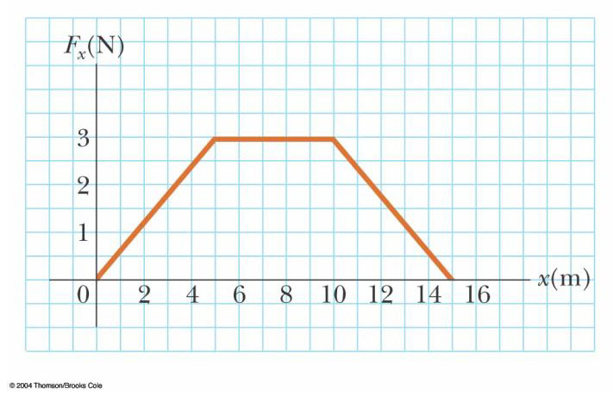

Figure P7.13 Problems 13 and 28

Solution
and W equals the area under the Force-
Displacement curve
- For the region ,
(b) For the region ,
(c) For the region ,
(d) For the region

- If it takes 4.00 J of work to stretch a
Hooke's-law spring 10.0 cm from its unstressed length, determine the extra work required to stretch it an additional 10.0 cm.

Solution
and to stretch the spring to 0.200
m requires

- A 2 100-kg pile driver is used to drive a
steel I-beam into the ground. The pile driver falls 5.00 m before coming into contact with the top of the beam, and it drives the beam 12.0 cm farther into the ground before coming to rest. Using energy considerations, calculate the average force the beam exerts on the pile driver while the pile driver is brought to rest.

Solution
Consider the work done on the pile driver from the time it starts from rest until it comes to rest at the end of the fall. Let represent the distance over which the driver falls freely, and the distance it moves the piling.

so
.
Thus,
The force on the pile driver is .

31. A 40.0-kg box initially at rest is pushed
5.00 m along a rough, horizontal floor with a
constant applied horizontal force of 130 N. If the
coefficient of friction between box and floor is
0.300, find (a) the work done by the applied force,
(b) the increase in internal energy in the box-floor
system due to friction, (c) the work done by the
normal force, (d) the work done by the gravitational
force, (e) the change in kinetic energy of the box,
and (f) the final speed of the box.

Solution
:
(a)
(b)
(c)
(d)
(e)
(f)

33. A crate of mass 10.0 kg is pulled up a
rough incline with an initial speed of 1.50 m/s. The
pulling force is 100 N parallel to the incline, which
makes an angle of 20.0° with the horizontal. The
coefficient of kinetic friction is 0.400, and the crate
is pulled 5.00 m. (a) How much work is done by
the gravitational force on the crate? (b) Determine
the increase in internal energy of the crate-incline
system due to friction. (c) How much work is done
by the 100-N force on the crate? (d) What is the
change in kinetic energy of the crate? (e) What is
the speed of the crate after being pulled 5.00 m?

Solution
(a)
(b)
(c)

(d)
(e)

35. A sled of mass m is given a kick on a frozen pond. The kick imparts to it an initial speed of 2.00 m/s. The coefficient of kinetic friction between sled and ice is 0.100. Use energy considerations to find the distance the sled moves before it stops.

Solution
:

37. A 700-N Marine in basic training climbs a
10.0-m vertical rope at a constant speed in 8.00 s.
What is his power output?

Solution

45. A compact car of mass 900 kg has an overall motor efficiency of 15.0%. (That is, 15% of the energy supplied by the fuel is delivered to the wheels of the car.) (a) If burning one gallon of gasoline supplies 1.34 × 10⁸ J of energy, find the amount of gasoline used in accelerating the car from rest to 55.0 mi/h. Here you may ignore the effects of air resistance and rolling friction. (b) How many such accelerations will one gallon provide? (c) The mileage claimed for the car is 38.0 mi/gal at 55 mi/h. What power is delivered to the wheels (to overcome frictional effects) when the car is driven at this speed?

Solution
(a) fuel needed
(b)
(c) power

49. A 4.00-kg particle moves along the x axis. Its position varies with time according to x = t + 2.0t³, where x is in meters and t is in seconds. Find (a) the kinetic energy at any time t, (b) the acceleration of the particle and the force acting on it at time t, (c) the power being delivered to the particle at time t, and (d) the work done on the particle in the interval t = 0 to t = 2.00 s.

Solution
(a)
Therefore,
(b)

(c)
(d)

61. A 200-g block is pressed against a spring of force constant 1.40 kN/m until the block compresses the spring 10.0 cm. The spring rests at the bottom of a ramp inclined at 60.0° to the horizontal. Using energy considerations, determine how far up the incline the block moves before it stops (a) if there is no friction between the block and the ramp and (b) if the coefficient of kinetic friction is 0.400.

Solution
(a) :
(b) :

63. The ball launcher in a pinball machine has a spring that has a force constant of 1.20 N/cm (Fig. P7.63). The surface on which the ball moves is inclined 10.0° with respect to the horizontal. If the spring is initially compressed 5.00 cm, find the launching speed of a 100-g ball when the plunger is released. Friction and the mass of the plunger are negligible.

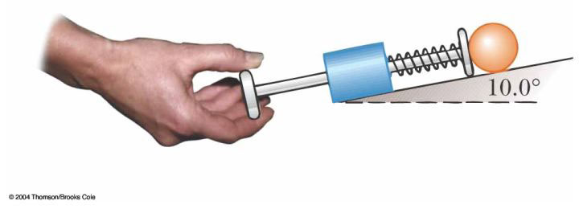
Figure P7.63
Solution

