Bab 7 Tenaga keupayaan

SOALAN-SOALAN

Q3. One person drops a ball from the top of a building while another person at the bottom observes its motion. Will these two people agree on the value of the gravitational potential energy of the ball-Earth system? On the change in potential energy? On the kinetic energy?

Q9 You ride a bicycle. In what sense is your bicycle solarpowered?

Q11 A bowling ball is suspended from the ceiling of a lecture hall by a strong cord. The ball is drawn away from its equilibrium position and released from rest at the tip of the demonstrator's nose as in Figure Q8.1 1. If the demonstrator remains stationary, explain why she is not struck by the ball on its return swing. Would this demonstrator be safe if the ball were given a push from its starting position at her nose?
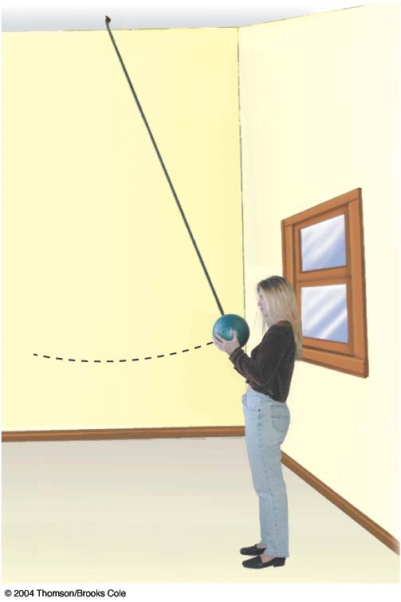

MASALAH-MASALAH
5. A bead slides without friction around a loop-the-loop (Fig. P8.5). The bead is released from a height h = 3.50R. (a) What is its speed at point A? (b) How large is the normal force on it if its mass is 5.00 g?
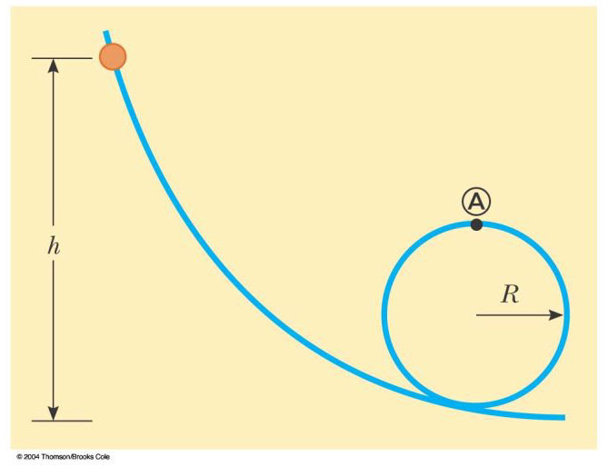
Figure P8.5
,

11. A block of mass 0.250 kg is placed on top of a light vertical spring of force constant 5 000 N/m and pushed downward, so that the spring is compressed by 0.100 m. After the block is released from rest it travels upward and then leaves the spring. To what maximum height above the point of release does it rise?

13. Two objects are connected by a light string passing over a light frictionless pulley as shown in Figure P8.13. The object of mass 5.00-kg is released from rest. Using the principle of conservation of energy, (a) determine the speed of the 3.00-kg object just as the 5.00-kg object hits the ground. (b) Find the maximum height to which the 3.00-kg object rises.
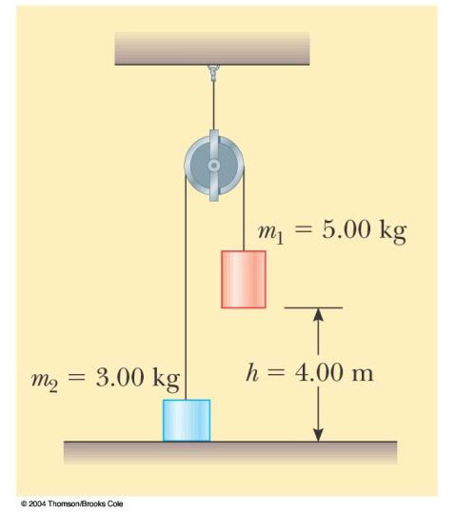

Figure P8.13 Problems 13 and 14.
.
(a) (b)

21. A 4.00-kg particle moves from the origin to position C, having coordinates x = 5.00 m and y = 5.00 m. One force on the particle is the gravitational force acting in the negative y direction (Fig. P8.21). Using Equation 7.3, calculate the work done by the gravitational force in going from O to C along (a) OAC, (b) OBC, (c) OC. Your results should all be identical. Why?
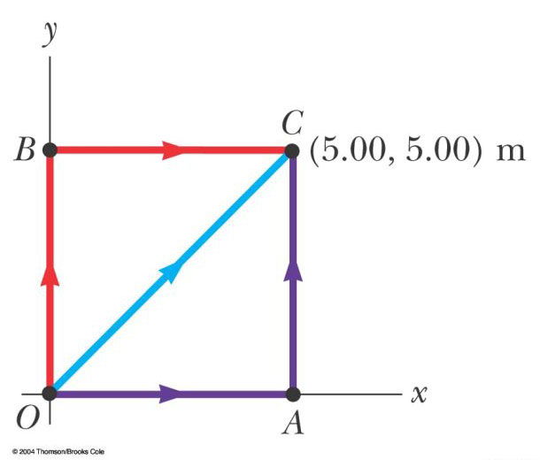
Figure P8.21 Problem 21
(a) (b)
(c)

23. A force acting on a particle moving in the xy plane is given by , where x and y are in meters. The particle moves from the origin to a final position having coordinates x = 5.00 m and y = 5.00 m, as in Figure P8.21. Calculate the work done by F along (a) OAC, (b) OBC, (c) OC. (d) Is F conservative or nonconservative? Explain
(a) (b)
(c) (d)

31. The coefficient of friction between the 3.00-kg block and the surface in Figure P8.31 is 0.400. The system starts from rest. What is the speed of the 5.00-kg ball when it has fallen 1.50 m?

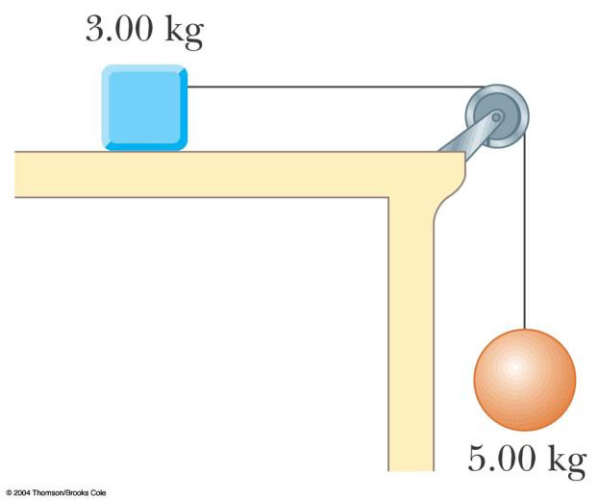

Figure P8.31

33. A 5.00-kg block is set into motion up an inclined plane with an initial speed of 8.00 m/s (Fig. P8.33). The block comes to rest after traveling 3.00 m along the plane, which is inclined at an angle of 30.0° to the horizontal. For this motion determine (a) the change in the block's kinetic energy, (b) the change in the potential energy of the block-Earth system, and (c) the friction force exerted on the block (assumed to be constant). (d) What is the coefficient of kinetic friction?

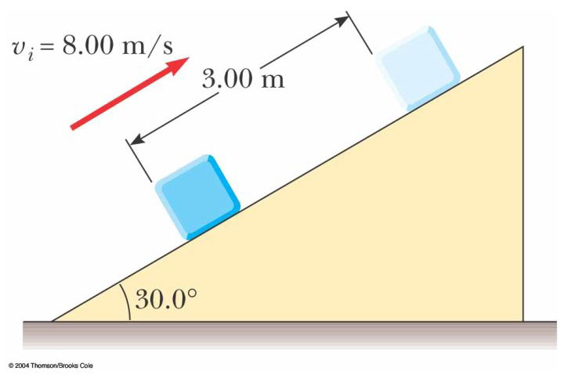
Figure P8.33
(a) (b) (c)
(d)

41. A single conservative force acts on a 5.00-kg particle. The equation F_{x} = (2x + 4) N describes the force, where x is in meters. As the particle moves along the x axis from x = 1.00 m to x = 5.00 m, calculate (a) the work done by this force, (b) the change in the potential energy of the system, and (c) the kinetic energy of the particle at
x = 5.00 m if its speed is 3.00 m/s at
x = 1.00 m.
(a) (b) (c)

43. The potential energy of a system of two particles separated by a distance r is given by U(r) = A/r, where A is a constant. Find the radial force F_{r} that each particle exerts on the other.

53. The particle (Fig. P8.52) is released from rest at A, and the surface of the bowl is rough. The speed of the particle at B is 1.50 m/s. (a) What is its kinetic energy at B? (b) How much mechanical energy is transformed into internal energy as the particle moves from A to B ? (c) Is it possible to determine the coefficient of friction from these results in any simple manner? Explain.

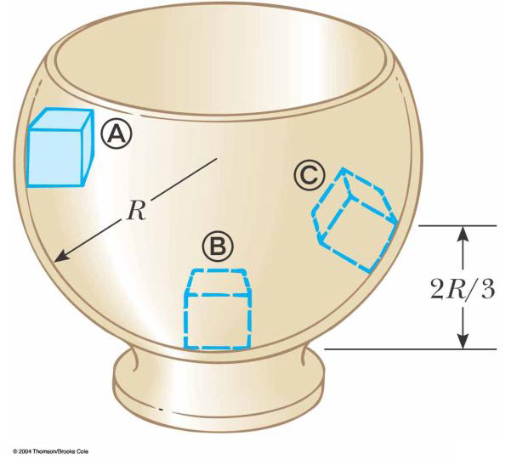
Figure P8.52 Problem 53.
(a) (b)

(c) It’s possible to find an effective coefficient of friction, but not the actual value of μ

57. A 10.0-kg block is released from point A in Figure P8.57. The track is frictionless except for the portion between points B and C , which has a length of 6.00 m. The block travels down the track, hits a spring of force constant 2 250 N/m, and compresses the spring 0.300 m from its equilibrium position before coming to rest momentarily. Determine the coefficient of kinetic friction between the block and the rough surface between B and C.

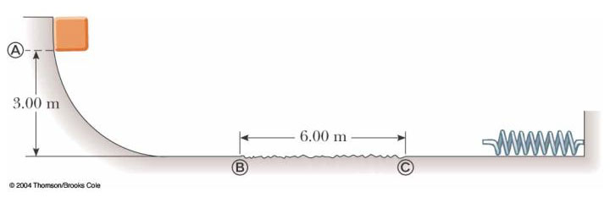
Figure P8.57

59. A 20.0-kg block is connected to a 30.0-kg block by a string that passes over a light frictionless pulley. The 30.0-kg block is connected to a spring that has negligible mass and a force constant of 250 N/m, as shown in Figure P8.59. The spring is unstretched when the system is as shown in the figure, and the incline is frictionless. The 20.0-kg block is pulled 20.0 cm down the incline (so that the 30.0-kg block is 40.0 cm above the floor) and released from rest. Find the speed of each block when the 30.0-kg block is 20.0 cm above the floor (that is, when the spring is unstretched).

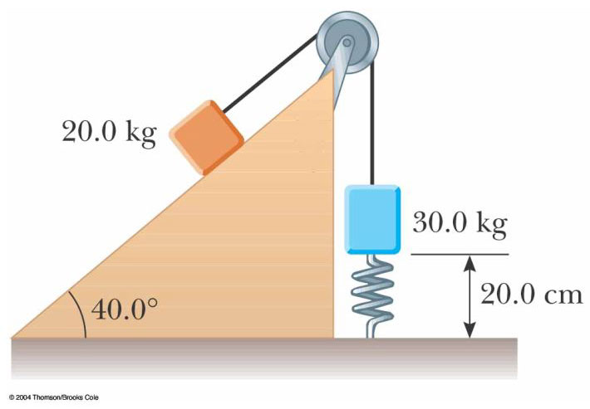
Figure P8.59

61. A block of mass 0.500 kg is pushed against a horizontal spring of negligible mass until the spring is compressed a distance x (Fig. P8.61). The force constant of the spring is 450 N/m. When it is released, the block travels along a frictionless, horizontal surface to point B, the bottom of a vertical circular track of radius R = 1.00 m, and continues to move up the track. The speed of the block at the bottom of the track is v_{B} = 12.0 m/s, and the block experiences an average friction force of 7.00 N while sliding up the track. (a) What is x? (b) What speed do you predict for the block at the top of the track? (c) Does the block actually reach the top of the track, or does it fall off before reaching the top?
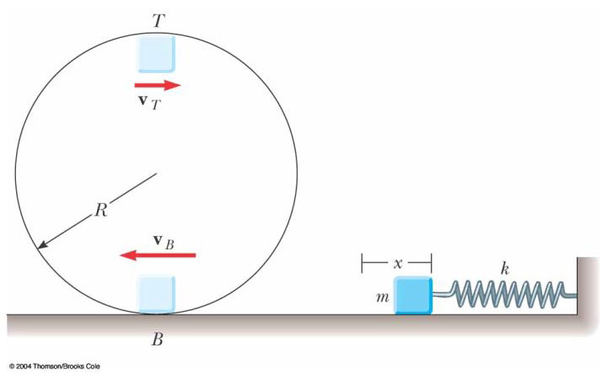
Figure P8.61
(a) (b)
(c).

71. A ball whirls around in a vertical circle at the end of a string. If the total energy of the ball-Earth system remains constant, show that the tension in the string at the bottom is greater than the tension at the top by six times the weight of the ball

