BAB 8 MOMENTUM LINEAR DAN PERLANGGANRAN

SOALAN-SOALAN

Q9.3 If two particles have equal kinetic energies, are their momenta necessarily equal? Explain.

Q9.7 Explain how linear momentum is conserved when a ball bounces from a floor.

Q9.13 A sharpshooter fires a rifle while standing with the butt of the gun against his boulder. If the forward momentum of a bullet is the same as the backward momentum of the gun, why isn't it as dangerous to be hit by the gun as by the bullet?

MASALAH-MASALAH

7. An estimated force-time curve for a baseball struck by a bat is shown in Figure P9.7. From this curve, determine (a) the impulse delivered to the ball, (b) the average force exerted on the ball, and (c) the peak force exerted on the ball.
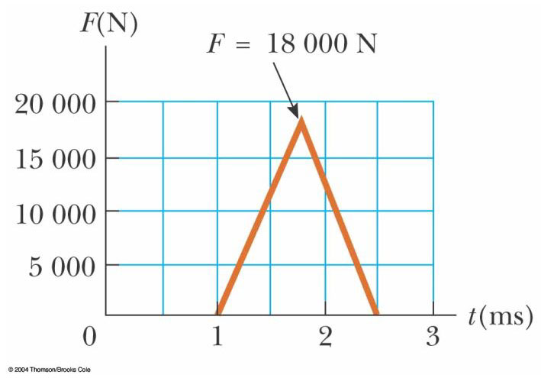
Figure P9.7
(a) (b)
(c)

9. A 3.00-kg steel ball strikes a wall with a speed of 10.0 m/s at an angle of 60.0° with the surface. It bounces off with the same speed and angle (Fig. P9.9). If the ball is in contact with the wall for 0.200 s, what is the average force exerted on the ball by the wall?
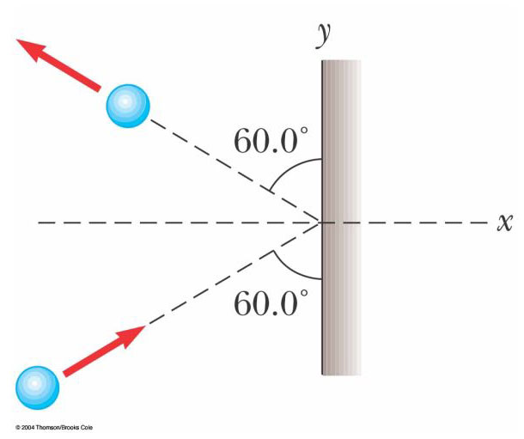
Figure P9.9

17. A 10.0-g bullet is fired into a stationary block of wood (m = 5.00 kg). The relative motion of the bullet stops inside the block. The speed of the bullet-plus-wood combination immediately after the collision is 0.600 m/s. What was the original speed of the bullet?

21. A 45.0-kg girl is standing on a plank that has a mass of 150 kg. The plank, originally at rest, is free to slide on a frozen lake, which is a flat, frictionless supporting surface. The girl begins to walk along the plank at a constant speed of 1.50 m/s relative to the plank. (a) What is her speed relative to the ice surface? (b) What is the speed of the plank relative to the ice surface?
,

23. A neutron in a nuclear reactor makes an elastic head-on collision with the nucleus of a carbon atom initially at rest. (a) What fraction of the neutron's kinetic energy is transferred to the carbon nucleus? (b) If the initial kinetic energy of the neutron is 1.60 × 10^{–13} J, find its final kinetic energy and the kinetic energy of the carbon nucleus after the collision. (The mass of the carbon nucleus is nearly 12.0 times the mass of the neutron.)
(a)
(b),

25. A 12.0-g wad of sticky clay is hurled horizontally at a 100-g wooden block initially at rest on a horizontal surface. The clay sticks to the block. After impact, the block slides 7.50 m before coming to rest. If the coefficient of friction between the block and the surface is 0.650, what was the speed of the clay immediately before impact?

33. A billiard ball moving at 5.00 m/s strikes a stationary ball of the same mass. After the collision, the first ball moves at 4.33 m/s, at an angle of 30.0° with respect to the original line of motion. Assuming an elastic collision (and ignoring friction and rotational motion), find the struck ball's velocity after the collision.

35. An object of mass 3.00 kg, with an initial velocity of , collides with and sticks to an object of mass 2.00 kg, with an initial velocity of . Find the final velocity of the composite object.

37. An unstable atomic nucleus of mass 17.0 × 10^{–27} kg initially at rest disintegrates into three particles. One of the particles, of mass 5.00 × 10^{–27} kg, moves along the y axis with a speed of 6.00 × 10⁶ m/s. Another particle, of mass 8.40 × 10^{–27} kg, moves along the x axis with a speed of 4.00 × 10⁶ m/s. Find (a) the velocity of the third particle and (b) the total kinetic energy increase in the process.
(a)
(b)

41. A uniform piece of sheet steel is shaped as in Figure P9.41. Compute the x and y coordinates of the center of mass of the piece.
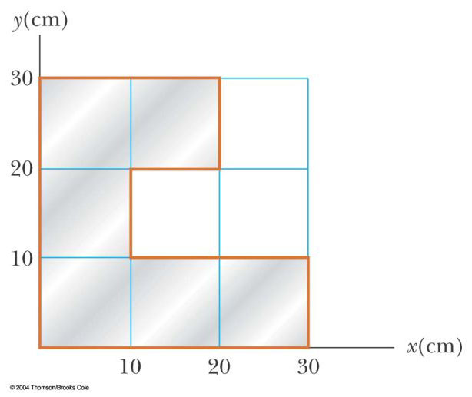
Figure P9.41

45. A 2.00-kg particle has a velocity , and a 3.00-kg particle has a velocity . Find (a) the velocity of the center of mass and (b) the total momentum of the system.
(a)
(b)

47. Romeo (77.0 kg) entertains Juliet (55.0 kg) by playing his guitar from the rear of their boat at rest in still water, 2.70 m away from Juliet who is in the front of the boat. After the serenade, Juliet carefully moves to the rear of the boat (away from shore) to plant a kiss on Romeo's cheek. How far does the 80.0-kg boat move toward the shore it is facing?

49. The first stage of a Saturn V space vehicle consumed fuel and oxidizer at the rate of 1.50 × 10⁴ kg/s, with an exhaust speed of 2.60 × 10³ m/s. (a) Calculate the thrust produced by these engines. (b) Find the acceleration of the vehicle just as it lifted off the launch pad on the Earth if the vehicle’s initial mass was 3.00 × 10⁶ kg. Note: You must include the gravitational force to solve part (b).

(a) (b)

*

57. An 80.0-kg astronaut is working on the engines of his ship, which is drifting through space with a constant velocity. The astronaut, wishing to get a better view of the Universe, pushes against the ship and much later finds himself 30.0 m behind the ship. Without a thruster, the only way to return to the ship is to throw his 0.500-kg wrench directly away from the ship. If he throws the wrench with a speed of 20.0 m/s relative to the ship, how long does it take the astronaut to reach the ship?

67. A 5.00-g bullet moving with an initial speed of 400 m/s is fired into and passes through a 1.00-kg block, as in Figure P9.67. The block, initially at rest on a frictionless, horizontal surface, is connected to a spring of force constant 900 N/m. If the block moves 5.00 cm to the right after impact, find (a) the speed at which the bullet emerges from the block and (b) the mechanical energy converted into internal energy in the collision.

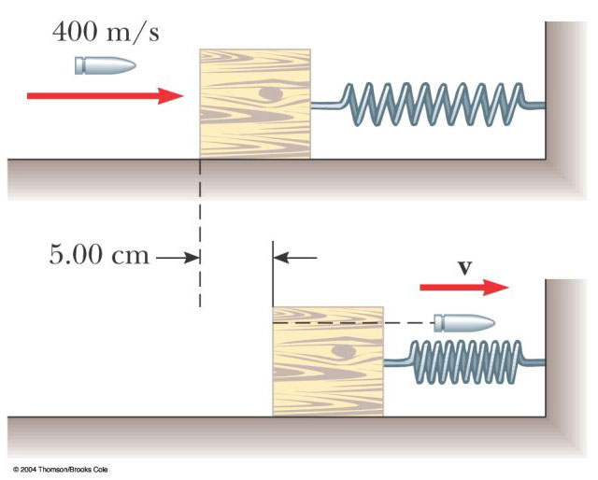

Figure P9.67
(a)
(b) .

