BAB 8 MOMENTUM LINEAR DAN PERLANGGANRAN

SOALAN-SOALAN

Q9.3 If two particles have equal kinetic energies, are their momenta necessarily equal? Explain.

Solution
The momenta of two particles will only be the same if the masses of the particles of the same.

Q9.7 Explain how linear momentum is conserved when a ball bounces from a floor.

Solution
Interestingly, mutual gravitation brings the ball and the Earth together. As the ball moves downward, the Earth moves upward, although with an acceleration times smaller than that of the ball. The two objects meet, rebound, and separate. Momentum of the ball-Earth system is conserved.

Q9.13 A sharpshooter fires a rifle while standing with the butt of the gun against his boulder. If the forward momentum of a bullet is the same as the backward momentum of the gun, why isn't it as dangerous to be hit by the gun as by the bullet?

Solution
The rifle has a much lower speed than the bullet and much less kinetic energy. The butt distributes the recoil force over an area much larger than that of the bullet.

MASALAH-MASALAH

7. An estimated force-time curve for a baseball struck by a bat is shown in Figure P9.7. From this curve, determine (a) the impulse delivered to the ball, (b) the average force exerted on the ball, and (c) the peak force exerted on the ball.
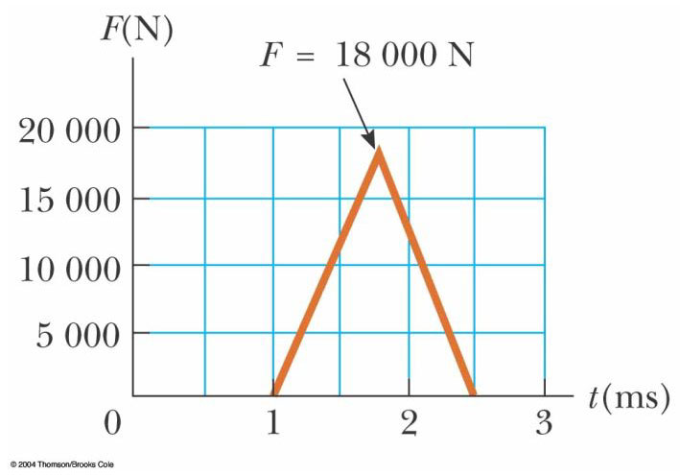
Figure P9.7
Solution
(a) area under curve
(b)
(c) From the graph, we see that

9. A 3.00-kg steel ball strikes a wall with a speed of 10.0 m/s at an angle of 60.0° with the surface. It bounces off with the same speed and angle (Fig. P9.9). If the ball is in contact with the wall for 0.200 s, what is the average force exerted on the ball by the wall?
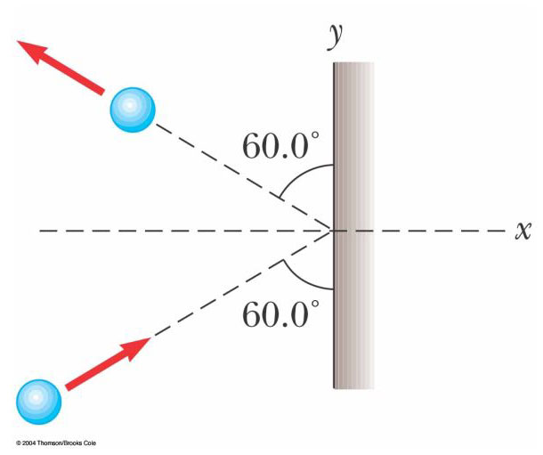
Figure P9.9

Solution

17. A 10.0-g bullet is fired into a stationary block of wood (m = 5.00 kg). The relative motion of the bullet stops inside the block. The speed of the bullet-plus-wood combination immediately after the collision is 0.600 m/s. What was the original speed of the bullet?

Solution
m is conserved

21. A 45.0-kg girl is standing on a plank that has a mass of 150 kg. The plank, originally at rest, is free to slide on a frozen lake, which is a flat, frictionless supporting surface. The girl begins to walk along the plank at a constant speed of 1.50 m/s relative to the plank. (a) What is her speed relative to the ice surface? (b) What is the speed of the plank relative to the ice surface?

Solution
(a), (b) Let and be the velocity of the girl and the plank relative to the ice surface. Then we may say that is the velocity of the girl relative to the plank, so that

(1)

But also we must have , since total momentum of the girl-plank system is zero relative to the ice surface. Therefore
, or
Putting this into the equation (1) above gives
or
Then

23. A neutron in a nuclear reactor makes an elastic head-on collision with the nucleus of a carbon atom initially at rest. (a) What fraction of the neutron's kinetic energy is transferred to the carbon nucleus? (b) If the initial kinetic energy of the neutron is 1.60 × 10^{–13} J, find its final kinetic energy and the kinetic energy of the carbon nucleus after the collision. (The mass of the carbon nucleus is nearly 12.0 times the mass of the neutron.)

Solution
(a) According to the Example in the chapter text, the fraction of total kinetic energy transferred to the moderator is
where is the moderator nucleus and in this case,
of the neutron energy is transferred to the carbon nucleus.
(b)

25. A 12.0-g wad of sticky clay is hurled horizontally at a 100-g wooden block initially at rest on a horizontal surface. The clay sticks to the block. After impact, the block slides 7.50 m before coming to rest. If the coefficient of friction between the block and the surface is 0.650, what was the speed of the clay immediately before impact?

Solution
At impact, momentum of the clay-block system is conserved, so:
After impact, the change in kinetic energy of the clay-block-surface system is equal to the increase in internal energy:

33. A billiard ball moving at 5.00 m/s strikes a stationary ball of the same mass. After the collision, the first ball moves at 4.33 m/s, at an angle of 30.0° with respect to the original line of motion. Assuming an elastic collision (and ignoring friction and rotational motion), find the struck ball's velocity after the collision.

Solution
By conservation of momentum for the system of the two billiard balls (with all masses equal),
Note that we did not need to use the fact that the collision is perfectly elastic.

35. An object of mass 3.00 kg, with an initial velocity of , collides with and sticks to an object of mass 2.00 kg, with an initial velocity of . Find the final velocity of the composite object.

Solution
:

37. An unstable atomic nucleus of mass 17.0 × 10^{–27} kg initially at rest disintegrates into three particles. One of the particles, of mass 5.00 × 10^{–27} kg, moves along the y axis with a speed of 6.00 × 10⁶ m/s. Another particle, of mass 8.40 × 10^{–27} kg, moves along the x axis with a speed of 4.00 × 10⁶ m/s. Find (a) the velocity of the third particle and (b) the total kinetic energy increase in the process.

Solution
(the parent nucleus)

(a)
where

(b)

41. A uniform piece of sheet steel is shaped as in Figure P9.41. Compute the x and y coordinates of the center of mass of the piece.
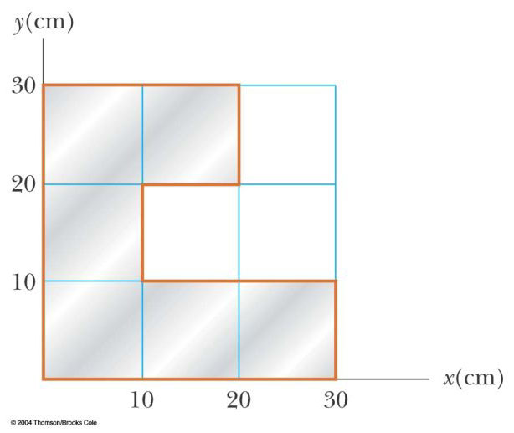
Figure P9.41
Solution
Let represent the area of the bottom row of squares, the middle square, and the top pair.
, , ,

45. A 2.00-kg particle has a velocity , and a 3.00-kg particle has a velocity . Find (a) the velocity of the center of mass and (b) the total momentum of the system.

Solution
(a)

(b)

47. Romeo (77.0 kg) entertains Juliet (55.0 kg) by playing his guitar from the rear of their boat at rest in still water, 2.70 m away from Juliet who is in the front of the boat. After the serenade, Juliet carefully moves to the rear of the boat (away from shore) to plant a kiss on Romeo's cheek. How far does the 80.0-kg boat move toward the shore it is facing?

Solution
Let distance from shore to center of boat

length of boat
distance boat moves as Juliet moves toward Romeo
The center of mass stays fixed.
Before:
After:

49. The first stage of a Saturn V space vehicle consumed fuel and oxidizer at the rate of 1.50 × 10⁴ kg/s, with an exhaust speed of 2.60 × 10³ m/s. (a) Calculate the thrust produced by these engines. (b) Find the acceleration of the vehicle just as it lifted off the launch pad on the Earth if the vehicle’s initial mass was 3.00 × 10⁶ kg. Note: You must include the gravitational force to solve part (b).

Solution
(a)Thrust
Thrust
(b) :

*

57. An 80.0-kg astronaut is working on the engines of his ship, which is drifting through space with a constant velocity. The astronaut, wishing to get a better view of the Universe, pushes against the ship and much later finds himself 30.0 m behind the ship. Without a thruster, the only way to return to the ship is to throw his 0.500-kg wrench directly away from the ship. If he throws the wrench with a speed of 20.0 m/s relative to the ship, how long does it take the astronaut to reach the ship?

Solution
We hope the momentum of the wrench provides enough recoil so that the astronaut can reach the ship before he loses life support! We might expect the elapsed time to be on the order of several minutes based on the description of the situation.

No external force acts on the system (astronaut plus wrench), so the total momentum is constant. Since the final momentum (wrench plus astronaut) must be zero, we have final momentum = initial momentum = 0.
Thus At this speed, the time to travel to the ship is
The astronaut is fortunate that the wrench gave him sufficient momentum to return to the ship in a reasonable amount of time! In this problem, we were told that the astronaut was not drifting away from the ship when he threw the wrench. However, this is not quite possible since he did not encounter an external force that would reduce his velocity away from the ship (there is no air friction beyond earth’s atmosphere). If this were a real-life situation, the astronaut would have to throw the wrench hard enough to overcome his momentum caused by his original push away from the ship.

67. A 5.00-g bullet moving with an initial speed of 400 m/s is fired into and passes through a 1.00-kg block, as in Figure P9.67. The block, initially at rest on a frictionless, horizontal surface, is connected to a spring of force constant 900 N/m. If the block moves 5.00 cm to the right after impact, find (a) the speed at which the bullet emerges from the block and (b) the mechanical energy converted into internal energy in the collision.

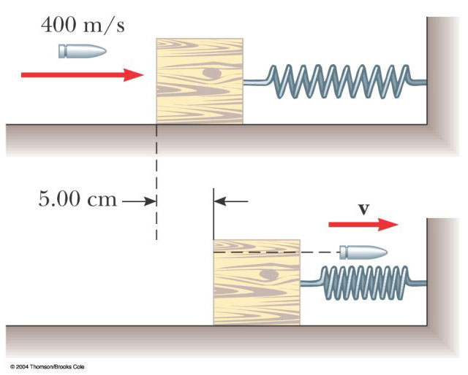

Figure P9.67

Solution
(a) Find the speed when the bullet emerges from the block by using momentum conservation:
The block moves a distance of 5.00 cm. Assume for an approximation that the block quickly reaches its maximum velocity, , and the bullet kept going with a constant velocity, v. The block then compresses the spring and stops.
(b)
, or there is an energy loss of .

