Tutorial on Special Relativity

Special relativity

Conceptual Questions

- The speed of light in water is c/n, where n = 1.33 is the index of refraction of water. Thus the speed of light in water is less than c. Why doesn’t this violate the speed of light postulate?

- What is the significance of the negative result of Michelson-Morley experiment?

- Is it possible to have particles that travel at the speed of light?

4) What is the twin-paradox? What is the solution to the paradox?

PROBLEMS

- Space Travel
Alpha Centauri, a nearby star in our galaxy, is 4.3 light-years away. If a rocket leaves for Alpha Centauri and travels at a speed of v = 0.95c relative to the Earth, (i) by how much will the passengers have aged, according to their own clock, when they reach their destination? ii) What is the distance between Earth and Alpha Centauri as measured by the passengers in the rocket? Assume that the Earth and Alpha Centauri are stationary with respect to one another.

Hint:
In dealing with time dilation, decide which interval is the proper time interval as follows: (1) Identify the two events that define the interval. (2) Determine the reference frame in which the events occur at the same place; an observer at rest in this frame measures the proper time interval Δt₀.

- The Contraction of a Spacecraft
An astronaut, using a meter stick that is at rest relative to a cylindrical spacecraft, measures the length and diameter of the spacecraft to be 82 and 21 m respectively. The spacecraft moves with a constant speed of v = 0.95c relative to the Earth. What are the dimensions of the spacecraft, as measured by an observer on Earth?

Hint:
The proper length L₀ is always larger than the contracted length L.

3) Two spaceship A and B are exploring a new planet. Relative to this planet, spaceship A has a speed of 0.60c, and spaceship B has a speed of 0.80c. What is the ratio D_{A}/ D_{B} of the values for the planet’s diameter that each spaceship measures in a direction that is parallel to its motion?

4) The Relativistic Momentum of a High-Speed Electron
The particle accelerator at Stanford University is three kilometers long and accelerates electrons to a speed of 0.999 999 999 7c, which is very nearly equal to the speed of light. Find the magnitude of the relativistic momentum of an electron that emerges from the accelerator, and compare it with the non-relativistic value.

5) The Energy Equivalent of a Golf Ball
A 0.046-kg golf ball is lying on the green. (a) Find the rest energy of the golf ball. (b) If this rest energy were used to operate a 75-W light bulb, for how many years could the bulb stay on?

6) A High-Speed electron
An electron (mass = 9.1 × 10⁻³¹ kg) is accelerated to a speed of 0.9995c in a particle accelerator. Determine the electron’s (a) rest energy, (b) total energy, and (c) kinetic energy in MeV

7) The Sun Is Losing Mass
The sun radiates electromagnetic energy at the rate of 3.92×10¹⁶ W. (a) What is the change in the sun's mass during each second that it is radiating energy? (b) The mass of the sun is 1.99 × 10³⁰ kg. What fraction of the sun's mass is lost during a human lifetime of 75 years?
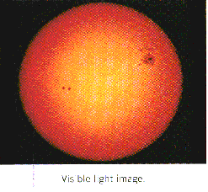

8) Figure below shows the top view of a spring lying on a horizontal table. The spring is initially unstrained. Suppose that the spring is either stretched or compressed by an amount x from its unstrained length, as part (b) of the drawing shows. Has the mass of the spring changed? If so, is the change greater, smaller, or the same when the spring is stretched rather than compressed?
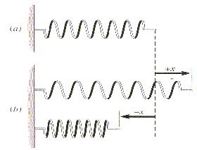

- This spring is unstrained.
- The spring is stretched or compressed by an amount x

9) The Speed of a Laser Beam
Figure below shows an intergalactic cruiser approaching a hostile spacecraft. The velocity of the cruiser relative to the spacecraft is v_{CS} = +0.7c. Both vehicles are moving at a constant velocity. The cruiser fires a beam of laser light at the enemy. The velocity of the laser beam relative to the cruiser is v_{LC} = +c. (a) What is the velocity of the laser beam v_{LS} relative to the renegades aboard the spacecraft? (b) At what velocity do the renegades aboard the spacecraft see the laser beam move away from the cruiser?

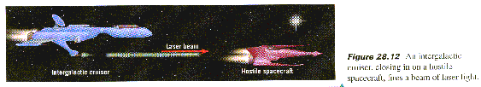

10) Mass and Energy
The rest energy E₀ and the total energy E of three particles, expressed in terms of a basic amount of energy E' = 5.98 × 10⁻¹⁰ J, are listed in the table below. The speeds of these particles are large, in some cases approaching the speed of light. For each particle, determine its mass and kinetic energy.

Rest Total
Particle Energy Energy
___________________________

a E' 2E'
b E' 4E'
c 5E' 6E'
___________________________

