Chapter 4: Motion in Two Dimensions

Conceptual Questions

Q4.6 A spacecraft drifts through space at a constant velocity. Suddenly a gas leak in the side of the spacecraft gives it a constant acceleration in a direction perpendicular to its velocity. The orientation of the spacecraft does not change, so that the acceleration remains perpendicular to the original direction of the velocity. What is the shape of the path followed by the spacecraft in the situation?

ANS: A parabola.

Q4.12
A projectile is launched at some angle to the horizontal with some initial speed v_{i}, and air resistance is negligible. Is the
projectile a free falling body? What is its acceleration in the vertical direction? What is its acceleration in the horizontal
direction?

ANS: The projectile is in free fall.

Q4.18
Explain whether or not the following particles have an acceleration: (a) a particle moving in a straight line with constant
speed and (b) a particle moving around a curve with constant speed

ANS (a) no (b)yes

Problems

- A motorist drives south at 20.0 m/s for 3.00 min, then turns west and travels at 25.0 m/s for 2.00 min, and finally travels northwest at 30.0 m/s for 1.00 min. For this 6.00-min trip, find (a) the total vector displacement, (b) the average speed, and (c) the average velocity. Let the positive x axis point east.

(a) (b)
(c)

7. A fish swimming in a horizontal plane has velocity at a point in the ocean where the position relative to a certain rock is . After the fish swims with constant acceleration for 20.0 s, its velocity is . (a) What are the components of the acceleration? (b) What is the direction of the acceleration with respect to unit vector ? (c) If the fish maintains constant acceleration, where is it at t = 25.0 s, and in what direction is it moving?

(a) ;
(b)
(c)

11. In a local bar, a customer slides an empty beer mug down the counter for a refill. The bartender is momentarily distracted and does not see the mug, which slides off the counter and strikes the floor 1.40 m from the base of the counter. If the height of the counter is 0.860 m, (a) with what velocity did the mug leave the counter, and (b) what was the direction of the mug's velocity just before it hit the floor?
(a) .(b) .

15. A projectile is fired in such a way that its horizontal range is equal to three times its maximum height. What is the angle of projection?
.

19. A place-kicker must kick a football from a point 36.0 m (about 40 yards) from the goal, and half the crowd hopes the ball will clear the crossbar, which is 3.05 m high. When kicked, the ball leaves the ground with a speed of 20.0 m/s at an angle of 53.0° to the horizontal. (a) By how much does the ball clear or fall short of clearing the crossbar? (b) Does the ball approach the crossbar while still rising or while falling?
(a).
(b).

33. A train slows down as it rounds a sharp horizontal turn, slowing from 90.0 km/h to 50.0 km/h in the 15.0 s that it takes to round the bend. The radius of the curve is 150 m. Compute the acceleration at the moment the train speed reaches 50.0 km/h. Assume it continues to slow down at this time at the same rate.

41. A river has a steady speed of 0.500 m/s. A student swims upstream a distance of 1.00 km and swims back to the starting point. If the student can swim at a speed of 1.20 m/s in still water, how long does the trip take? Compare this with the time the trip would take if the water were still.
, .

45. A science student is riding on a flatcar of a train traveling along a straight horizontal track at a constant speed of 10.0 m/s. The student throws a ball into the air along a path that he judges to make an initial angle of 60.0° with the horizontal and to be in line with the track. The student's professor, who is standing on the ground nearby, observes the ball to rise vertically. How high does she see the ball rise?

51. Barry Bonds hits a home run so that the baseball just clears the top row of bleachers, 21.0 m high, located 130 m from home plate. The ball is hit at an angle of 35.0° to the horizontal, and air resistance is negligible. Find (a) the initial speed of the ball, (b) the time at which the ball reaches the cheap seats, and (c) the velocity components and the speed of the ball when it passes over the top row. Assume the ball is hit at a height of 1.00 m above the ground.

(a) ; (b).
(c) ,

61. A hawk is flying horizontally at 10.0 m/s in a straight line, 200 m above the ground. A mouse it has been carrying struggles free from its grasp. The hawk continues on its path at the same speed for 2.00 seconds before attempting to retrieve its prey. To accomplish the retrieval, it dives in a straight line at constant speed and recaptures the mouse 3.00 m above the ground. (a) Assuming no air resistance, find the diving speed of the hawk. (b) What angle did the hawk make with the horizontal during its descent? (c) For how long did the mouse "enjoy" free fall?
(a) (b) (c)

- A car is parked on a steep incline overlooking the ocean, where the incline makes an angle of 37.0° below the horizontal. The negligent driver leaves the car in neutral, and the parking brakes are defective. Starting from rest at t = 0, the car rolls down the incline with a constant acceleration of 4.00 m/s², traveling 50.0 m to the edge of a vertical cliff. The cliff is 30.0 m above the ocean. Find (a) the speed of the car when it reaches the edge of the cliff and the time at which it arrives there, (b) the velocity of the car when it lands in the ocean, (c) the total time interval that the car is in motion, and (d) the position of the car when it lands in the ocean, relative to the base of the cliff.

(a) (b)

(c) (d)

67. A skier leaves the ramp of a ski jump with a velocity of 10.0 m/s, 15.0° above the horizontal, as in Figure P4.67. The slope is inclined at 50.0°, and air resistance is negligible. Find (a) the distance from the ramp to where the jumper lands and (b) the velocity components just before the landing. (How do you think the results might be affected if air resistance were included? Note that jumpers lean forward in the shape of an airfoil, with their hands at their sides, to increase their distance. Why does this work?)
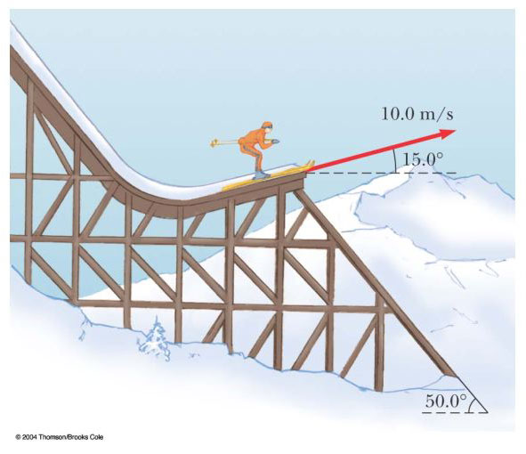
(a) and .
(b)

