Chapter 8 Conservation of energy

Problems

Analysis Model: Isolated system (energy)

6. A particle of mass m = 5.00 kg is released from point A and slides on the frictionless track shown in Figure P8.24. Determine (a) the particle's speed at points B and C and (b) the net work done by the gravitational force in moving the particle from A to C.

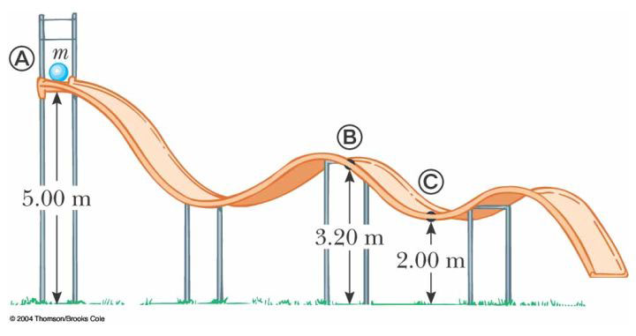 Figure P8.24

7. Two objects are connected by a light string passing over a light frictionless pulley as in Figure P8.13. The object of mass m₁ is released from rest at height h. Using the principle of conservation of energy, (a) determine the speed of m₂ just as m₁ hits the ground. (b) Find the maximum height to which m₂ rises.
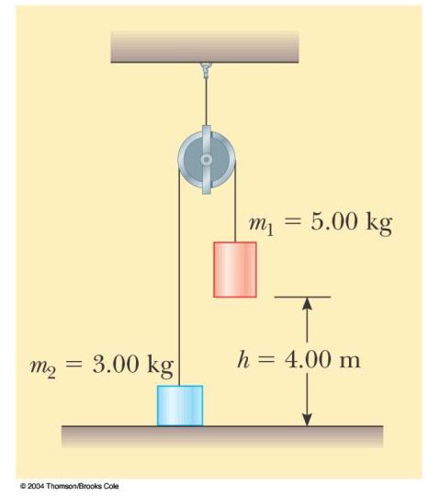

Figure P8.7 Problem 7.

ANS: ; (a); (b) ;

Situations Involving Kinetic Friction

16. A 40.0-kg box initially at rest is pushed 5.00 m along a rough, horizontal floor with a constant applied horizontal force of 130 N. If the coefficient of friction between box and floor is 0.300, find (a) the work done by the applied force, (b) the increase in internal energy in the box-floor system due to friction, (c) the work done by the normal force, (d) the work done by the gravitational force, (e) the change in kinetic energy of the box, and (f) the final speed of the box. ANS: (a) 650 J; (b) 588 J; (c) 0; (d) 0; (e) 62.0 J; (f) 1.76 m/s

Changes in Mechanical Energy for Nonconservative Forces

20. At time t_{i}, the kinetic energy of a particle is 30.0 J and the potential energy of the system to which it belongs is 10.0 J. At some later time t_{f}, the kinetic energy of the particle is 18.0 J. (a) If only conservative forces act on the particle, what are the potential energy and the total energy at time t_{f}? (b) If the potential energy of the system at time t_{f} is 5.00 J, are there any nonconservative forces acting on the particle? Explain. ANS: (a) 22.0 J; 40.0J; (b) Yes.

Power
39*. A skier of mass 70.0 kg is pulled up a slope by a motor-driven cable. (a) How much work is required to pull him a distance of 60.0 m up a 30.0° slope (assumed frictionless) at a constant speed of 2.00 m/s? (b) A motor of what power is required to perform this task? ANS: (a) 20.6 kJ; (b) 686 W

40. A 650-kg elevator starts from rest. It moves upward for 3.00 s with constant acceleration until it reaches its cruising speed of 1.75 m/s. (a) What is the average power of the elevator motor during this period? (b) How does this power compare with the motor power when the elevator moves at its cruising speed? ANS: (a) 2.63 m; (b)

Additional problems

54. A 2.00-kg block situated on a rough incline is connected to a spring of negligible mass having a spring constant of 100 N/m (Fig. P8.54). The pulley is frictionless. The block is released from rest when the spring is unstretched. The block moves 20.0 cm down the incline before coming to rest. Find the coefficient of kinetic friction between block and incline. ANS:
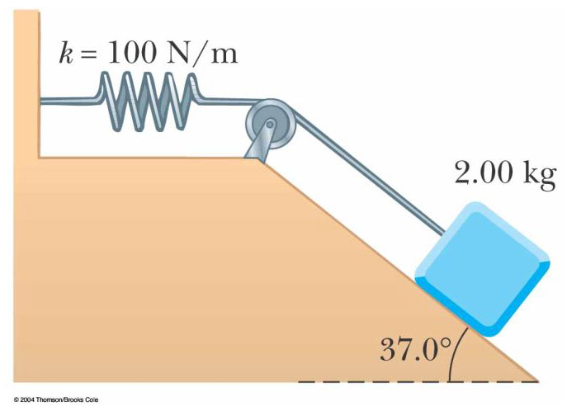
Figure P8.54 Problems 54.

48. A block slides down a curved frictionless track and then up an inclined plane as in Figure P8.48. The coefficient of kinetic friction between block and incline is _{k}. Use energy methods to show that the maximum height reached by the block is

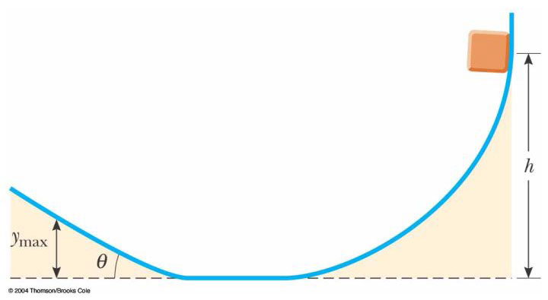
36. A 50.0-kg block and 100-kg block are connected by a string as in Figure P8.36. The pulley is frictionless and of negligible mass. The coefficient of kinetic friction between the 50-kg block and incline is 0.250. Determine the change in the kinetic energy of the 50-kg block as it moves from A to B, a distance of 20.0 m. ANS:
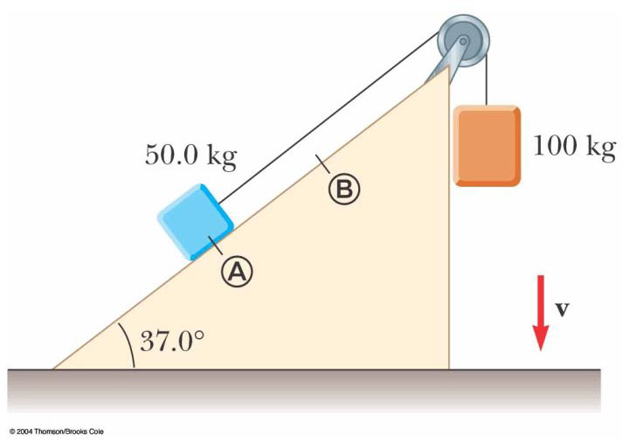 Figure P8.36

5. A bead slides without friction around a loop-the-loop (Fig. P8.5). The bead is released from a height h = 3.50R. (a) What is its speed at point A? (b) How large is the normal force on it if its mass is 5.00 g? ANS: (a); (b)
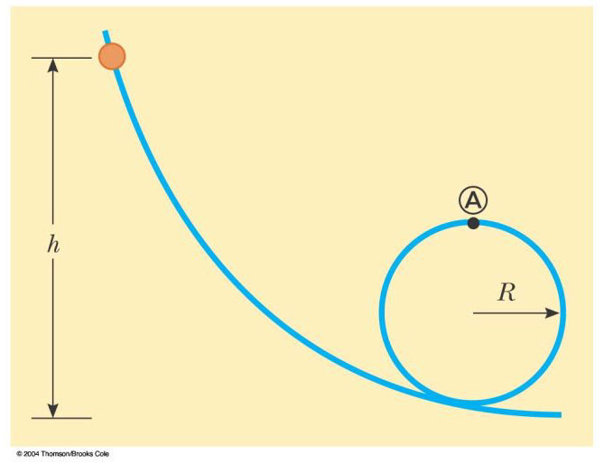
Figure P8.5

