Chapter 7 Energy of a system

Conceptual question
Q7.1 Can kinetic energy be negative? Explain.

Solution
Kinetic energy is always positive. Mass and
squared speed are both positive. A moving object
can always do positive work in striking another
object and causing it to move along the same
direction of motion.

Q 7.4 What shape would the graph of U versus x have if a particle were in a region of nutral equilibrium?
Solution

Q 7.7 Does the KE of an object depends on the frame of reference in which its motion is measured? Provide an example to prove this point.
Solution

Q 7.10 Cite two examples in which a force is exerted on an object without doing any work on the object.
Solution

Q 14. If only one external force acts on a particle, does it necessarily change the particle’s (a) KE? (b) Its velocity?

Problems

Work done by a constant Force

11. A force acts on a particle that undergoes a displacement . Find (a) the work done
by the force on the particle and (b) the angle between F and r.

Solution

(a)
(b)

15 A particle is subject to a force F_{x} that varies with position as in Figure P7.15. Find the work done by the force on the particle as it moves (a) from x = 0 to x = 5.00 m, (b) from x = 5.00 m to x = 10.0 m, and (c) from x = 10.0 m to x = 15.0 m. (d) What is the total work done by the force over the distance x = 0 to x = 15.0 m?
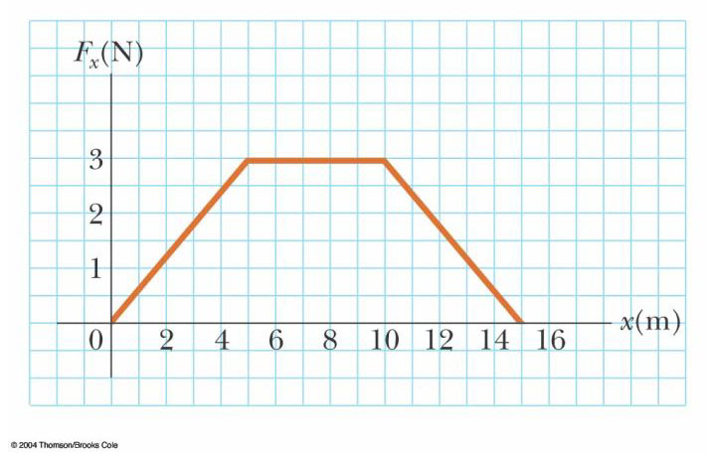

Figure P7.15 Problems 15, 28

Solution
and W equals the area under the Force-
Displacement curve
- For the region ,
(b) For the region ,
(c) For the region ,
(d) For the region

7. 23 A light spring with spring constant k₁ is hung from an elevated support. From its lower end a second light spring is hung, which has spring constant k₂. An object of mass m is hung at rest from the lower end of the second spring. (a) Find the total extension distance of the pair of springs. (b) Find the effective spring constant of the pair of springs as a system. We describe these springs as in series.

Solution
(a) The hanging mass moves down by

(b) We define the effective spring constant as

Kinetic energy and the work-kinetic energy theorem

32. A 4.00-kg particle is subject to a total force that varies with position as shown in Figure P7.15. The particle starts from rest at x = 0. What is its speed at (a) x = 5.00 m, (b) x = 10.0 m, (c) x = 15.0 m?
Solution

(a) (area under curve from to m)

(b) (area under curve from to m)

(c) (area under curve from to m)

33. A 3.00-kg object has a velocity . (a) What is its kinetic energy at this time? (b) Find the total work done on the object if its velocity changes to . (Note: From the definition of the dot product, v² = v·v.)
Solution

(a)

(b)

Potential Energy of a system

42. A 400-N child is in a swing that is attached to ropes 2.00 m long. Find the gravitational potential energy of the child–Earth system relative to the child's lowest position when (a) the ropes are horizontal, (b) the ropes make a 30.0° angle with the vertical, and (c) the child is at the bottom of the circular arc.

Solution
(a) We take the zero configuration of system potential energy with the child at the lowest point of the arc. When the string is held horizontal initially, the initial position is 2.00 m above the zero level. Thus,  .  (b) From the sketch, we see that at an angle of 30.0° the child is at a vertical height of  above the lowest point of the arc. Thus, | FIG. P8.2

- The zero level has been selected at the lowest point of the arc. Therefore, at this location.

Conservative and Nonconservation forces

45. A force acting on a particle moving in the xy plane is given by , where x and y are in meters. The particle moves from the origin to a final position having coordinates x = 5.00 m and y = 5.00 m, as in Figure P8.21. Calculate the work done by F along (a) OAC, (b) OBC, (c) OC. (d) Is F conservative or nonconservative? Explain.

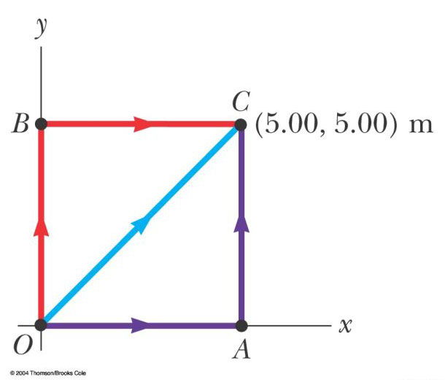

Figure P7.43

Solution
(a)

and since along this path,

For ,

and

(b)

since along this path, ,

since ,

(c)

Since along OC,

(d) F is since the work done is path dependent.

Relationship between conservative forces and potential energy
51. A single conservative force acts on a 5.00-kg particle within a system due to its intteaction with the rest of the system. The equation F_{x} = (2x + 4) N describes the force, where x is in meters. As the particle moves along the x axis from x = 1.00 m to x = 5.00 m, calculate (a) the work done by this force, (b) the change in the potential energy of the system, and (c) the kinetic energy of the particle at x = 5.00 m if its speed is 3.00 m/s at x = 1.00 m.

Solution
(a)

(b)

(c)

Energy Diagrams and Equilibrium of a System

46. A particle moves along a line where the potential energy of its system depends on its position r as graphed in Figure P8.46. In the limit as r increases without bound, U(r) approaches +1 J. (a) Identify each equilibrium position for this particle. Indicate whether each is a point of stable, unstable or neutral equilibrium. (b) The particle will be bound if the total energy of the system is in what range? Now suppose that the system has energy −3 J. Determine (c) the range of positions where the particle can be found, (d) its maximum kinetic energy, (e) the location where it has maximum kinetic energy, and (f) the binding energy of the system—that is, the additional energy that it would have to be given in order for the particle to move out to r→.

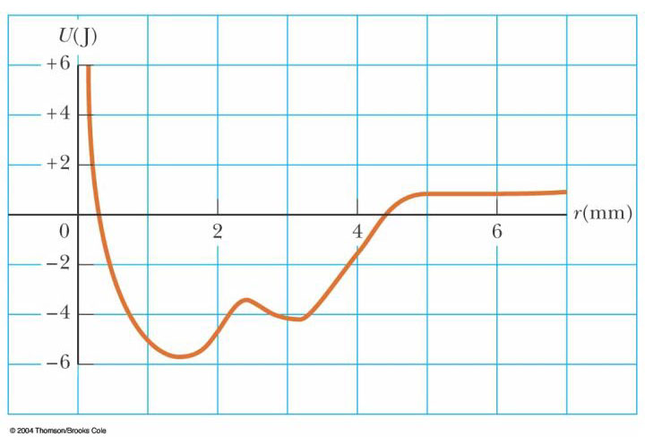

Figure P8.46

Solution
P8.46 (a) There is an equilibrium point wherever the graph of potential energy is horizontal:

At and 3.2 mm, the equilibrium is stable.
At , the equilibrium is unstable.
A particle moving out toward approaches neutral equilibrium.

(b) The system energy E cannot be less than –5.6 J. The particle is bound if .

(c) If the system energy is –3 J, its potential energy must be less than or equal to –3 J. Thus, the particle’s position is limited to .

(d) . Thus, .

(e) Kinetic energy is a maximum when the potential energy is a minimum, at .

(f) . Hence, the binding energy is .

Additional problem

19. If it takes 4.00 J of work to stretch a Hooke's-law spring 10.0 cm from its unstressed length, determine the extra work required to stretch it an additional 10.0 cm.

Solution
and to stretch the spring to 0.200 m requires

3. Batman, whose mass is 80.0 kg, is dangling on the free end of a 12.0-m rope, the other end of which is fixed to a tree limb above. He is able to get the rope in motion as only Batman knows how, eventually getting it to swing enough that he can reach a ledge when the rope makes a 60.0° angle with the vertical. How much work was done by the gravitational force on Batman in this maneuver?

solution
P7.3 | Method One.  Let φ represent the instantaneous angle the rope makes with the vertical as it is swinging up from to . In an incremental bit of motion from angle φ to , the definition of radian measure implies that . The angle θ between the incremental displacement and the force of gravity is . Then .  The work done by the gravitational force on Batman is | FIG. P7.3

Method Two.

The force of gravity on Batman is down. Only his vertical displacement contributes to the work gravity does. His original y-coordinate below the tree limb is –12 m. His final y-coordinate is . His change in elevation is . The work done by gravity is

.

