Instruction: Answer any FIVE (5) questions in this Section. Each question carries 11 marks.
[Arahan: Jawab mana-mana LIMA (5) soalan dalam Bahagian ini. Setiap soalan membawa 11 markah.
1(a)
Solution 1(a) [3 marks]
(a) ( =)

1 (b)
Solution 1(b) [4 marks]
Use :

1(c) [Hint: use x - 1=sinθ]
Solution 1(c): SP 28, pg. 300. [4 marks]
;

2. A tangent line is drawn to the ellipse at some point. Refer to figure Q2 below. It cuts through the points A and B on the y- and the x-axis respectively.
[Suatu garis tangen dilukiskan pada elips pada titik . Sila rujuk gambarajah Q2. Ia merentasi titik-titik A dan B pada paksi-y dan paksi-x masing-masing. Apakah nisbah yang meminimumkan panjang AB?]
_________________________________________________________________________
2(a) Show that the gradient, m, of the tangent line at is given by .
Solution 2(a) (pg. 128, SupP 39): [3 marks]
At , take

2(b) Show that the coordinates of A and B are respectively.

Solution 2(b) [4 marks]
The tangent line’s equation is, going through.
The tangent line cuts the y-axis at A when x=0. Hence the coordinate of point A is (0,c).

The tangent line cuts the x-axis at B when y=0. Hence the coordinate of point B is (-c/m,0).

Since the tangent line goes through, we slot into the tangent line equation :
is related via ,
Hence the coordinate of point A is.
The coordinate of point B is.

2(c) What is the ratio that minimizes the length of AB?

Solution 2(c) [4 marks]
Let
Set :

== 0

3. (a) Given , find .
Solution 3(a): (pg 173, Supp 17) [3 marks]:

3 (b) Prove
Solution 3(b): (pg 169,Eq. 18.6) [4 marks]
y
x
1y

_______________________________________________________________________

3 (c) Sketch and its inverse on the same graph.
Solution 3(c): (pg 235, figure 26-1) [4 marks]
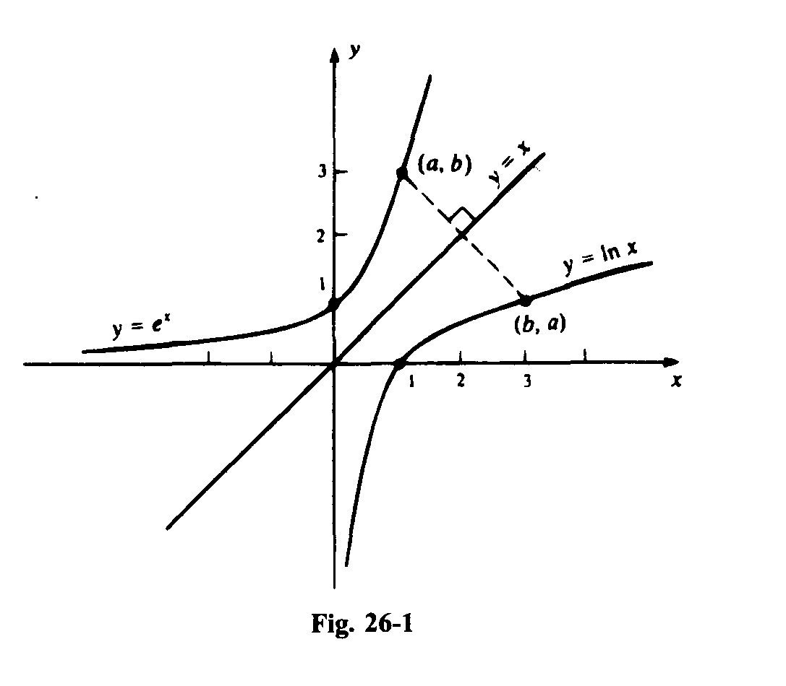

4. (a) Find the derivative of using DEFINITION.
[Dapatkan terbitan bagi mengikut takrifan.]

Solution 4(a): SP7, pg 82. [5 marks]
Given,

[4 marks for correct working + 1 mark for correct final answer = 5 marks]
[**1 marks only if not employ the definition.]
________________________________________________________________________

4(b) Evaluate using RIEMANN INTEGRAL.
[Hitungkan secara KAMIRAN RIEMANN.]

Solution 4(b): Example 2, page 209 [6 marks]

Subdivide close interval [a,b] into n tiny uniform subdivisions.

Let .

The width of the n-th interval is Δ=(b-a)/n

The area as the strip in the n-th interval is

The sum of the area of individual strips is

The Riemanian integral is defined as

[5 marks for correct working + 1 mark for correct final answer = 6 marks]
[**1 marks only if not employ the definition.]

5. (a) Find the volume of the solid generated by revolving about the y axis the region in the first quadrant inside the circle , and between y = a and y = r (where 0 < a < r). See figure Q5.
[Hitungkan isipadu jasad terjanakan dengan memutarkan rantau di antara sukuan pertama dalam bulatan , y = a dan y = r (dengan 0 < a < r). Rujuk gambarajah Q5]

Solution 5(a): SP 5, pg. 272. [4 marks]
(Accept any method of volume generation)

x
y
0
a
r
Figure Q5
dy
x
The differential volume of the disk generated when revolved about the y axis is
_____________________________________________________________________

5(b) (i) Evaluate
[Hitungkan ]
Solution 5(b) (i) Solution: Example 5, pg. 244: [3 marks]

By L’Hopital’s rule:
__________________________________________________________________

5(b) (ii) Sketch the graph of y = xln x
[Lakarkan graf y = xln x]

Solution: 5(b) (ii) Solution: SupP 6, pg. 248 [4 marks]

x
y
0
1/e
1
1/e
__________________________________________________________________

6. (a) Show that the following series diverges:
[Tunjukkan bahawa siri yang berikut mencapah: ]
Solution 6(a): SP 2, pg 403 [5 marks]
Write the series as =, where s_{n}= ,
n = 1,2,3…
Let f(x)= so that f(n) = s_{n}
Hence, the series S_{n} diverges by integral test.

6(b)
Consider the harmonic series.
[Pertimbangkan siri harmonik ]
  - What is? (is the term in the series)
  - Show that the harmonic series diverges.
[Tunjukkan bahawa siri harmonik ini mencapah. ]

Solution 6(b) (i) [2 marks]

Solution 6b(ii) Example 4, pg 396. [4 marks]
Harmonic series The trend of the partial sum:
So, in general, the partial sum of goes like > 1 + k/2 when k>1/
This implies that , and therefore diverges.

