6.

(a)

(c)(i) **Ans:**

Consider the non-homogeneous equation system=, whereand *A* an arbitrary 3-vector in *R*3.

. Hence, rank of K *is* , *r* = 3.

The rank of [*K* | *A*] is also 3 irrespective of what the component of *A* are. So the system *KX* = *A* is consistent. Hence, it is always possible to express any 3-vector *A* in *R*3 as linear combination in in the form

,

with the solution of guaranteed to exist. This prove *S*= {*K*1, *K*2, *K*3} spans *R*3.

c(ii)

Consider the homogeneous problem $\text{KX}=0$, where *K*= $\left(K_{1},K_{2},K_{3}\right)$, a 3 by 3 matrix, and *X*=T.

*K*= $\left(\begin{matrix}1 & 1 & 3 \\ 1 & 3 & 5 \\ 1 & 5 & 3\end{matrix}\right)$ ~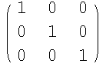, hence rank [*K*] = 3; so is the number of unknown, *n* = 3. The HE system also has the same number of unknowns. Since *r* = *n,* the HE system $\text{KX}=0$ admits only trivial solution, *X*=T.

By definition, this proves the linearly independence of the vector set {$K_{1},K_{2},K_{3}$}, as is true only for *X*=T*.*

Q2

1. (i) Sketch the graph (page 320, PE 46). You must label your sketch appropriately.

$y=\frac{x^{2}−x+1}{x}$

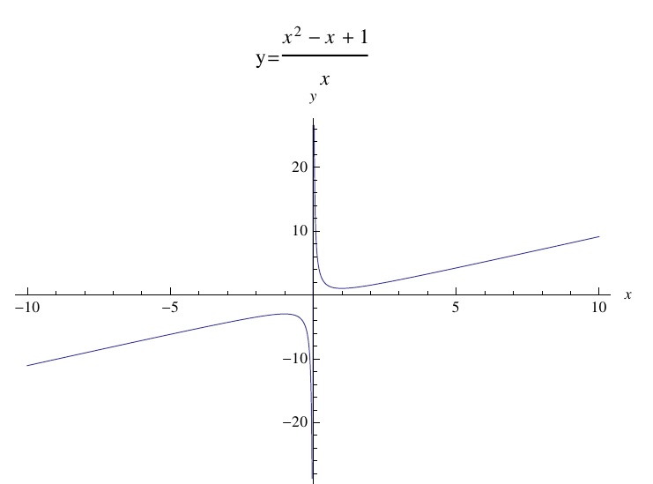

25 marks full for labeling the asymptots.

Use l’Hopital rule to find the limits (page 320, PE 53, 60).

(ii)

$\lim_{x→π}{\frac{tanx}{x}}$ Solution = 0. Just simple substitution.

(iii)

$\lim_{x→0}\left(\frac{1}{x^{4}}−\frac{1}{x^{2}}\right)$. Solution = +infinity.

1. Find the height and radius of the largest right circular cylinder that can be put in a sphere of radius $\sqrt{3}$

Sol: Pg 321, PE 67

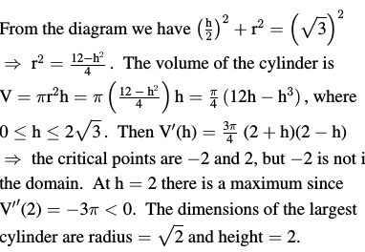

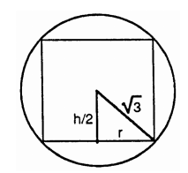

(ii) State the Mean Value Theorem. [*Nyatakan teorem Nilai Min.*]

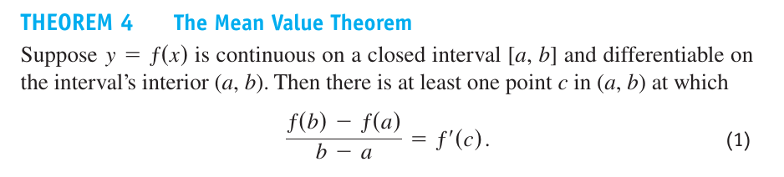

(iii) Use the Mean Value Theorem to proof the following statement: If *f* ’(*x*)=0 at each point *x* of an open interval (*a*,*b*), then *f*(*x*)=*C* for all $x∈\left(a,b\right)$, where *C* is a constant.

