Tutorial 1 (Chapter 1)
Thomas' Calculus 11th edition

Exercise 1.3

Functions and Their Graphs

find the domain and range of each function.
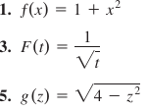

Finding Formulas for Functions

13. Express the edge length of a cube as a function of the cube’s diagonal length d. Then express the surface area and volume of the cube as a function of the diagonal length.

Functions and Graphs

Find the domain and graph the functions
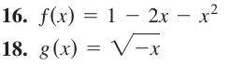

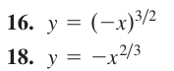

22. Graph the following equations and explain why they are not graphs of functions of x.
Piecewise-Defined Functions

Graph the function
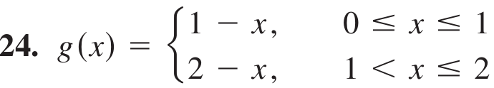
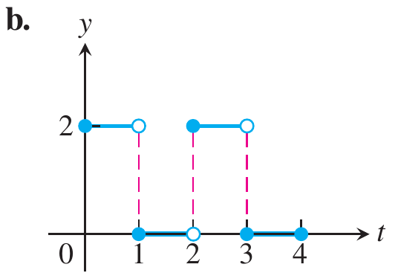

Exercise 1.4

Recognizing Functions

In Exercises 3, identify each function as a constant function, linear function, power function, polynomial (state its degree), rational function, algebraic function, trigonometric function, exponential function, or logarithmic function. Remember that some functions can fall into
more than one category.
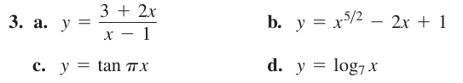
Increasing and Decreasing Functions

Graph the functions. What symmetries, if any, do the graphs have? Specify the intervals over which the function is increasing and the intervals where it is decreasing.

Even and Odd Functions

Say whether the function is even, odd, or neither. Give reasons for your answer.
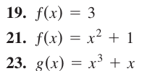

EXERCISES 1.5
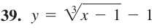
Sums, Differences, Products, and Quotients

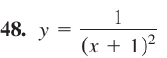
Find the domains and ranges of ƒ, g, ƒ + g , and
.

Composites of Functions

6. If ƒ(x) = x - 1 and g(x) = 1/(x + 1), find
a. ƒ(g (½))
b. g (ƒ(1/2))

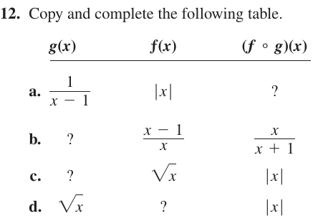
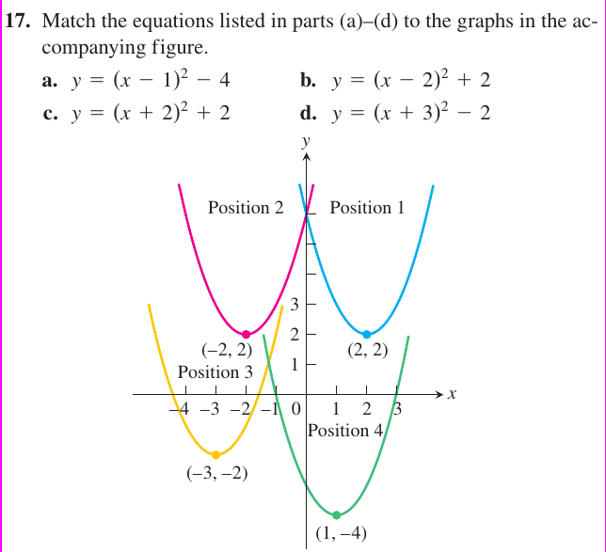
Shifting Graphs

Graph the functions

Vertical and Horizontal Scaling

Exercises below tell by what factor and direction the graphs of the given functions are to be stretched or compressed. Give an equation
for the stretched or compressed graph.

EXERCISES 1.6

Radians, Degrees, and Circular Arcs

4. If you roll a 1-m-diameter wheel forward 30 cm over level ground, through what angle will the wheel turn? Answer in radians (to the nearest tenth) and degrees (to the nearest degree).

Evaluating Trigonometric Functions

5. Copy and complete the following table of function values. If the function is undefined at a given angle, enter “UND.” Do not use a
calculator or tables.
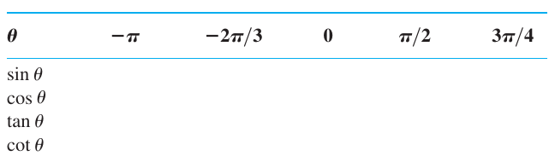
Find the other two if x lies in the specified interval.
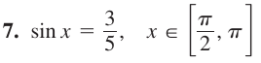

Graphing Trigonometric Functions

Graph the functions the ts-plane (t-axis horizontal, s-axis vertical). What is the period of each function? What symmetries do the graphs have?
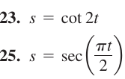

Additional Trigonometric Identities

Use the addition formulas to derive the identity.
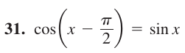

Using the Addition Formulas

Express the given quantity in terms of sin x and
cos x.
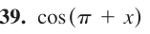

Using the Double-Angle Formulas

Find the function values
