Tutorial 2 (Chapter 2)
Thomas' Calculus 11th edition

Exercise 2.1

Limits from Graphs
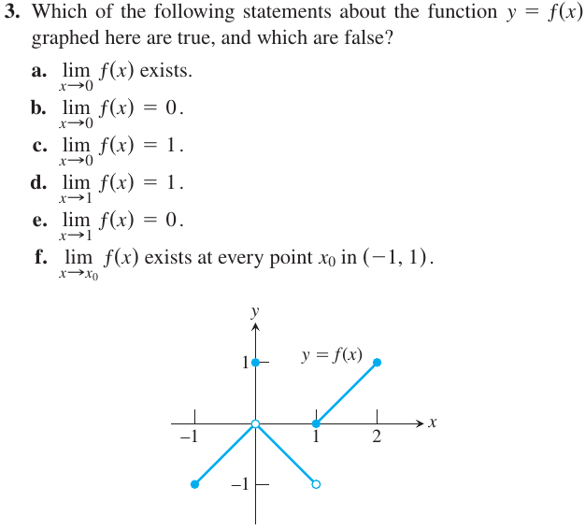
Existence of Limits

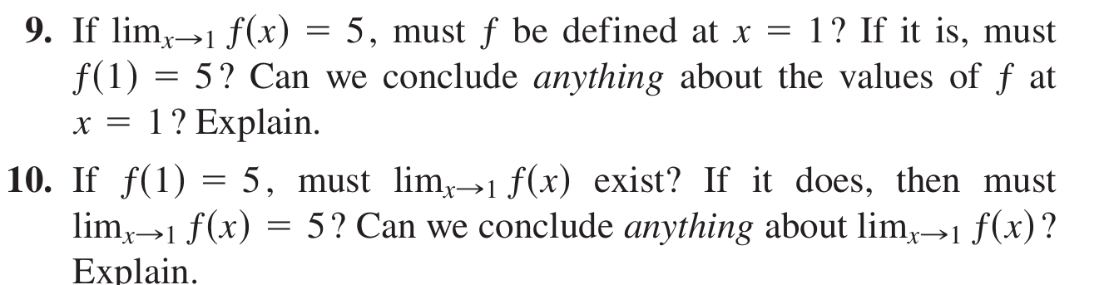
Limits by Substitution

Find the limits by substitution.
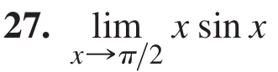

Average Rates of Change

Find the average rate of change of the function
over the given interval or intervals.
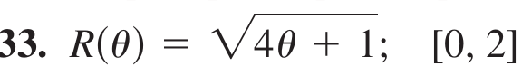

Exercise 2.2

Limit Calculations

Find the limits.

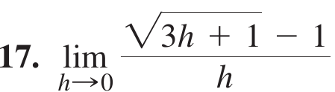

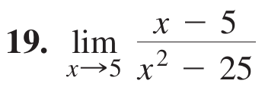

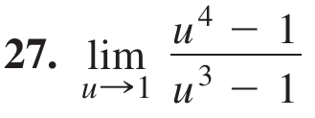

Using Limit Rules
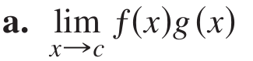

Limits of Average Rates of Change

Because of their connection with secant lines, tangents, and instantaneous rates, limits of the form
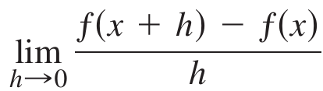

occur frequently in calculus. Evaluate this limit
for the given value of x and function ƒ.
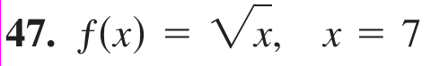

Using the Sandwich Theorem
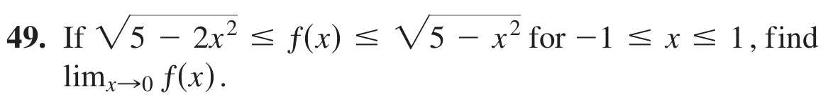
EXERCISES 2.3

Centering Intervals About a Point

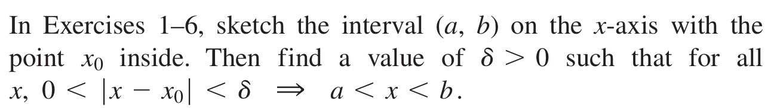
Finding Deltas Graphically

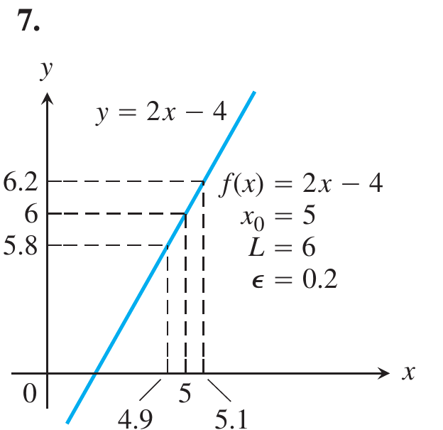

Finding Deltas Algebraically

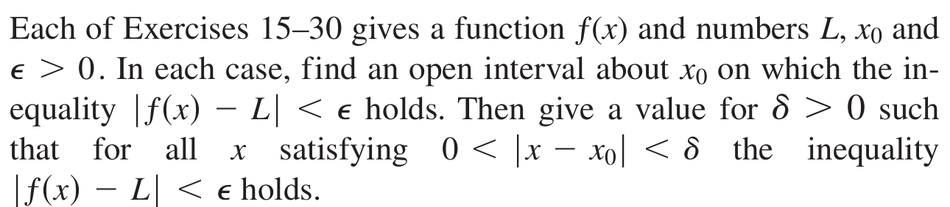

More on Formal Limits

Prove the limit statements
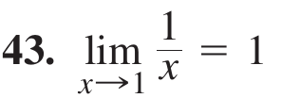

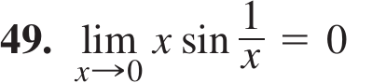

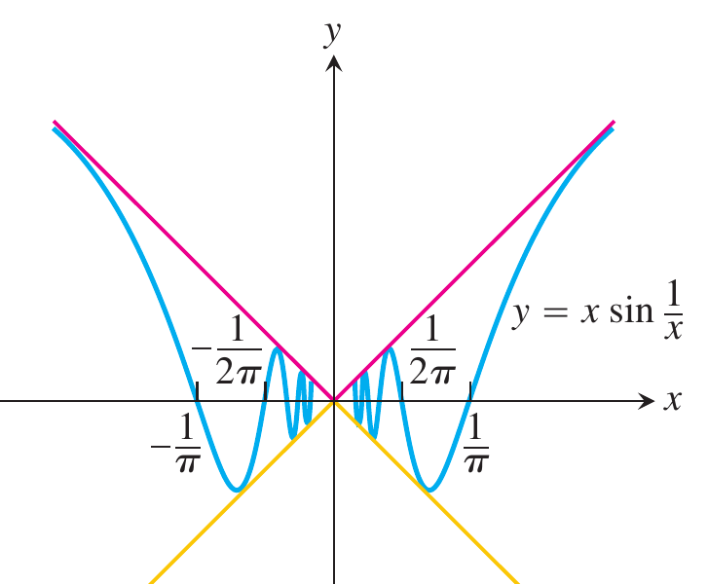

EXERCISES 2.4

Finding Limits Graphically
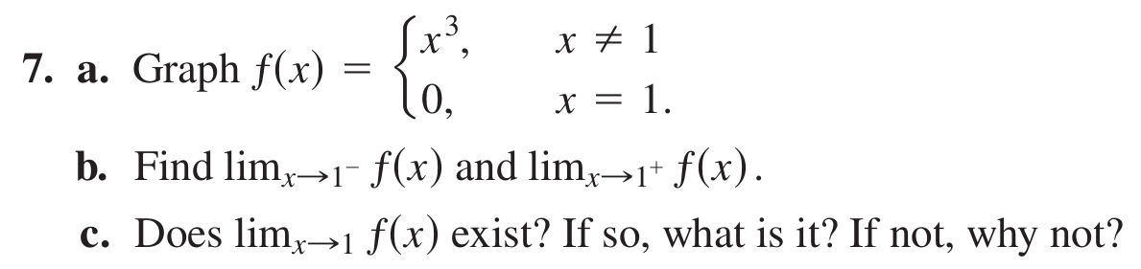
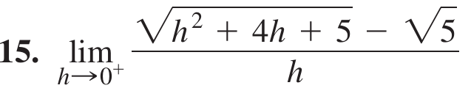
Finding One-Sided Limits Algebraically

Find the limit

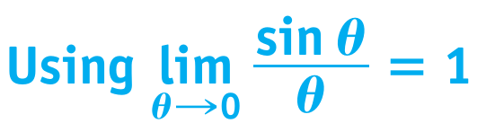

Find the limits
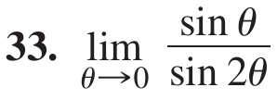

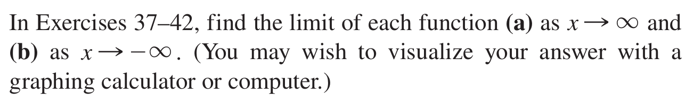
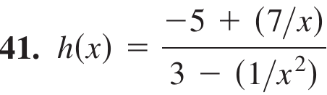

Limits of Rational Functions
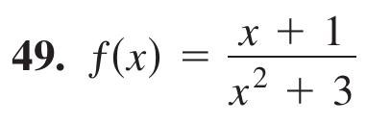
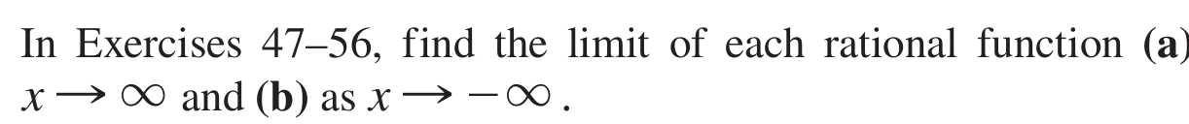

EXERCISES 2.5

Infinite Limits

Find the limits.
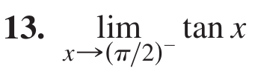

Additional Calculations

Find the limits.
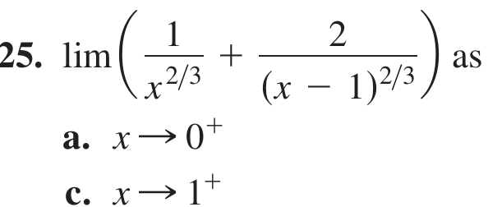

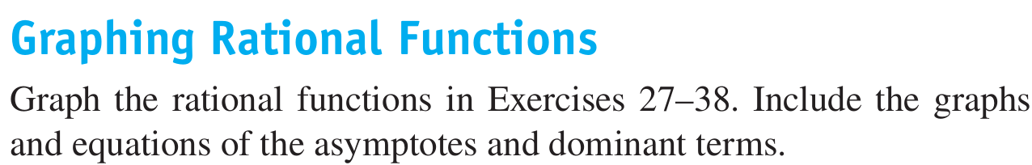
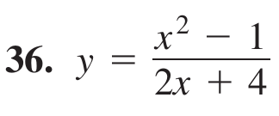

Inventing Functions

Find a function that satisfies the given conditions and sketch its graph. (The answers here are not unique. Any function that satisfies the conditions is acceptable. Feel free to use formulas defined in pieces if that will help.)

Graphing Terms
The function is given as the sum or difference of two terms. First graph the terms (with the same set of axes).
Then, using these graphs as guides, sketch in the graph of the function.
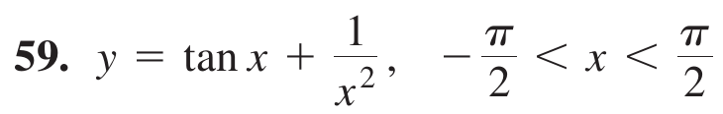

EXERCISES 2.6

Continuity from Graphs

In the exercises below, say whether the function graphed is continuous on [ -1, 3] . If not, where does it fail to be continuous and why?
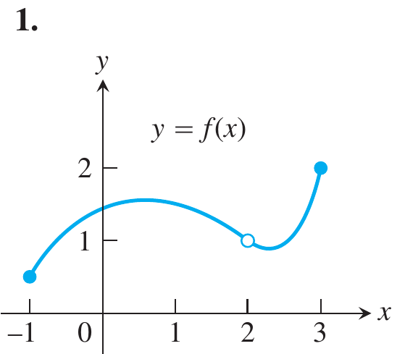

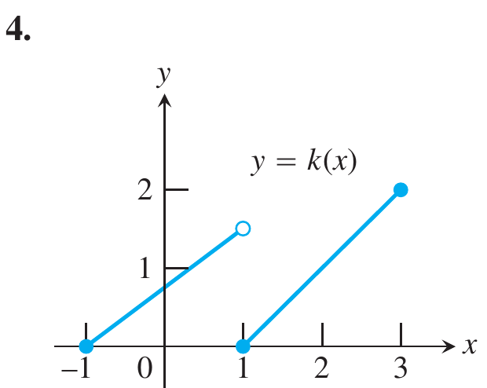

Applying the Continuity Test

At which points do the functions fail to be continuous? At which points, if any, are the discontinuities removable? Not removable? Give reasons for your
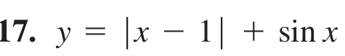
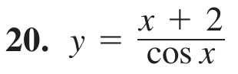

Composite Functions

Find the limits. Are the functions continuous at the
point being approached?
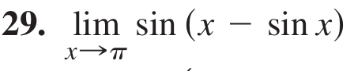

EXERCISES 2.7

Slopes and Tangent Lines

Find an equation for the tangent to the curve at the
given point. Then sketch the curve and tangent together.
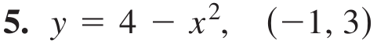

Find the slope of the function’s graph at the given point. Then find an equation for the line tangent to the graph there.
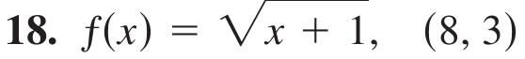

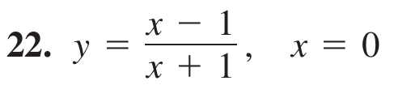

Tangent Lines with Specified Slopes
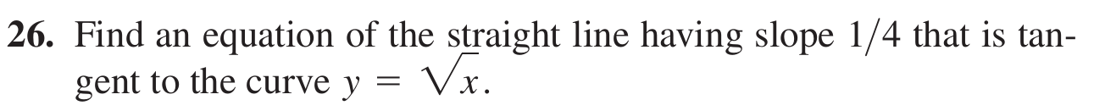

Rates of Change
