Tutorial 3 (Chapter 3)
Thomas' Calculus 11th edition

EXERCISES 3.1

Finding Derivative Functions and Values

Using the definition, calculate the derivatives of the functions. Then find the values of the derivatives as specified.

Find the indicated derivatives.
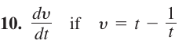

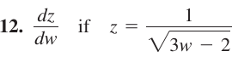

Slopes and Tangent Lines
Differentiate the functions. Then find an equation of the tangent line at the indicated point on the graph of the function.

Find the values of the derivative.
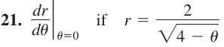

Differentiability and Continuity on an Interval

The figure below shows the graph of a function over a closed interval D. At what domain points does the function appear to be
a. differentiable?
b. continuous but not differentiable?
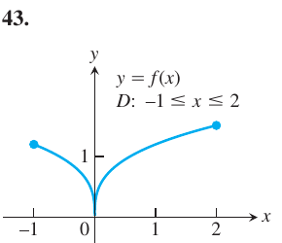
c. neither continuous nor differentiable?

EXERCISES 3.2

Derivative Calculations
Find the derivatives of the functions
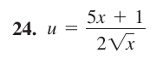

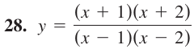

Find the first and second derivatives.
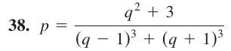

Using Numerical Values
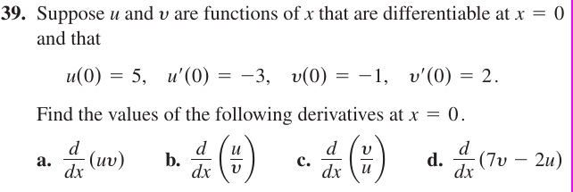
Slopes and Tangents
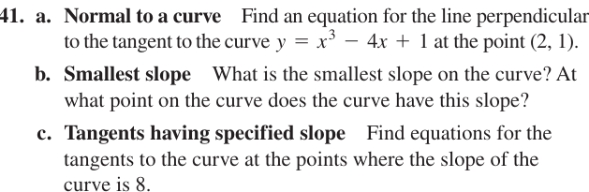
EXERCISES 3.3

Motion Along a Coordinate Line

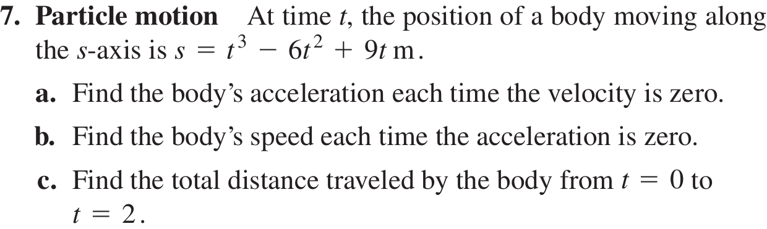

Free-Fall Applications

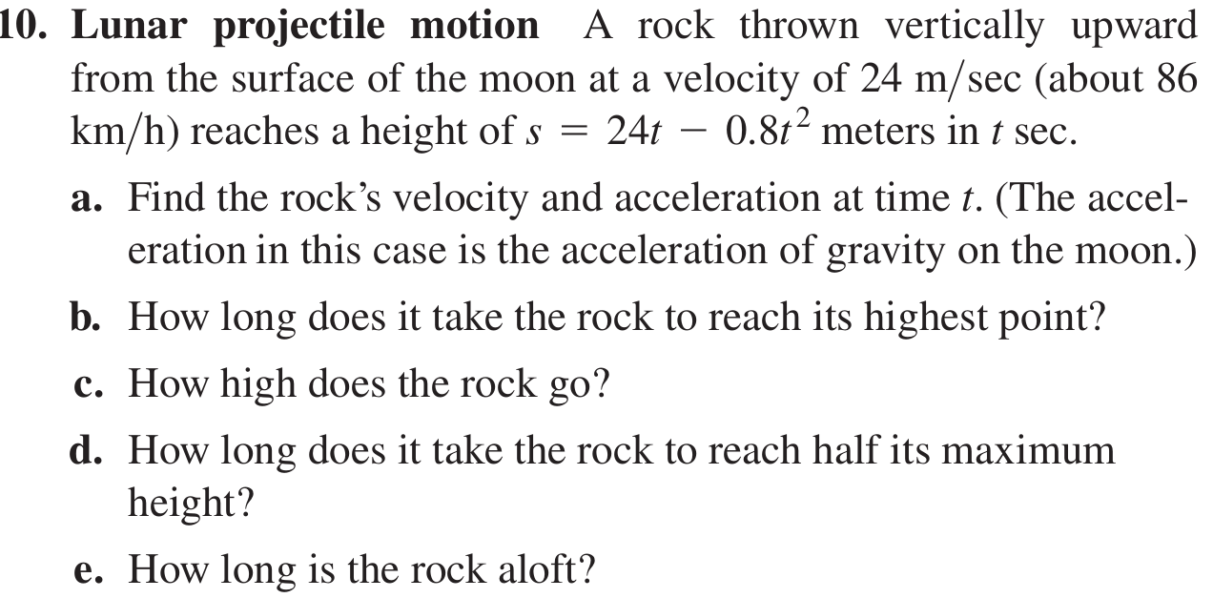
Conclusions About Motion from Graphs

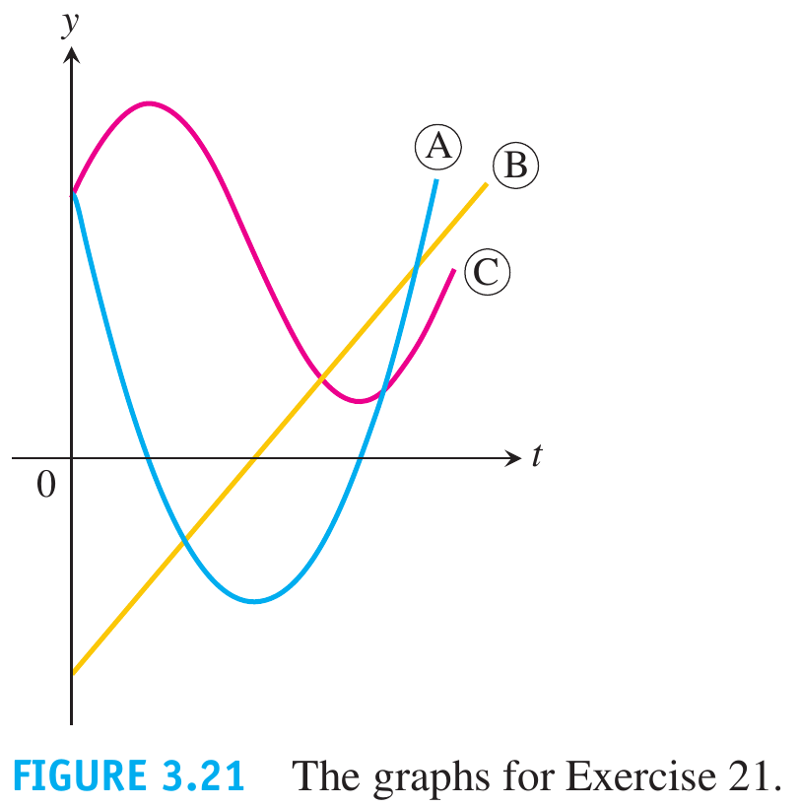
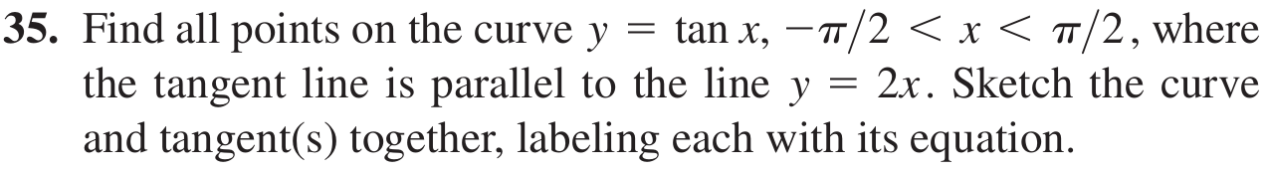

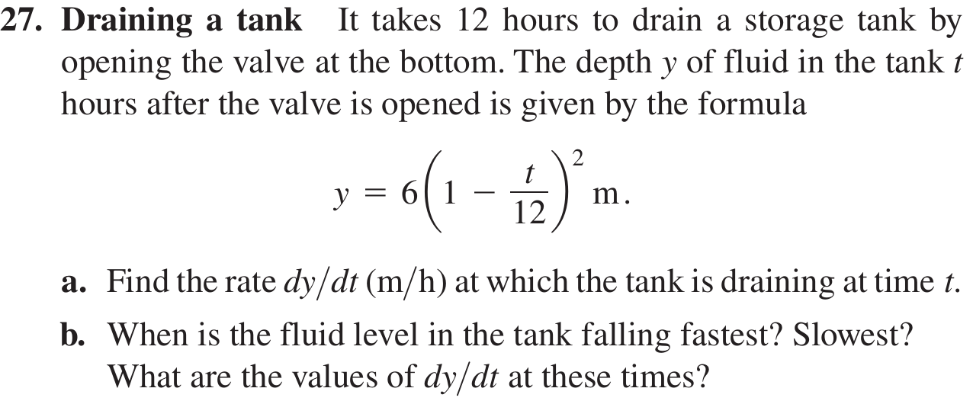
EXERCISES 3.4

Derivatives
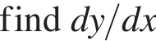

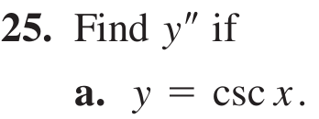

Tangent Lines

Graph the curves over the given intervals, together with their tangents at the given values of x. Label each curve and tangent with its equation.
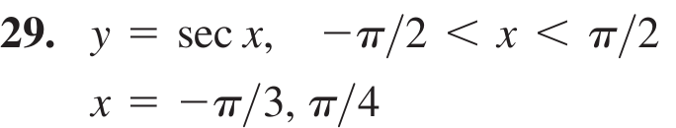

Trigonometric Limits

Find the limits
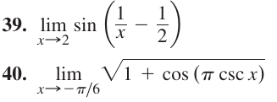

EXERCISES 3.5

Derivative Calculations

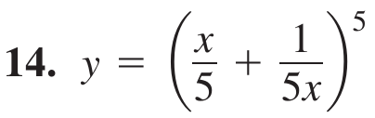

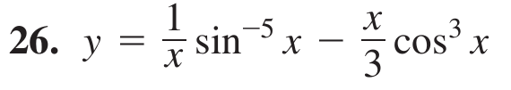

Second Derivatives
Find y''
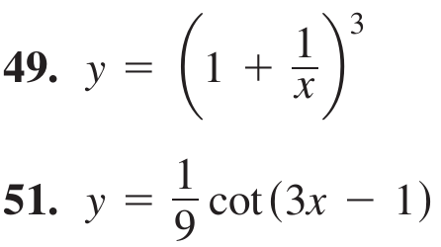

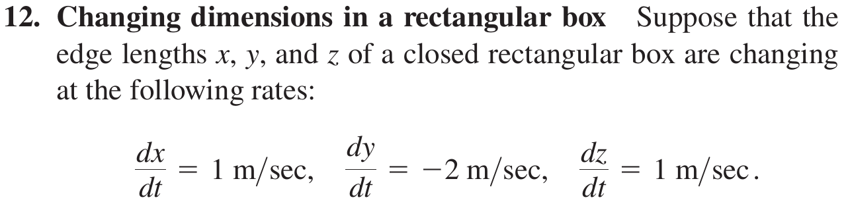
Finding Numerical Values of Derivatives

Tangents to Parametrized Curves

EXERCISES 3.6

Derivatives of Rational Powers
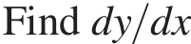

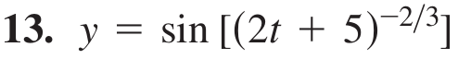

Differentiating Implicitly

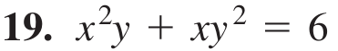

Second Derivatives
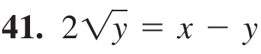

Slopes, Tangents, and Normals

Verify that the given point is on the curve and find
the lines that are (a) tangent and (b) normal to the curve at the given point.

Implicitly Defined Parametrizations

EXERCISES 3.7

20. A growing raindrop Suppose that a drop of mist is a perfect sphere and that, through condensation, the drop picks up moisture at a rate proportional to its surface area. Show that under these circumstances the drop’s

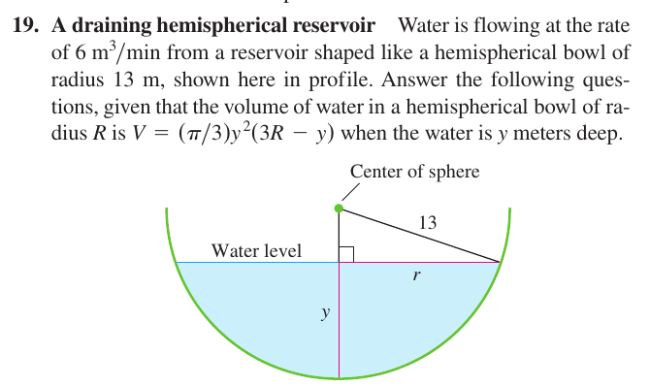

EXERCISES 3.8

Finding Linearizations

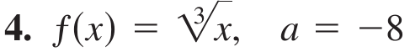

Linearization for Approximation

You want linearizations that will replace the functions in the following over intervals that include the given points x₀. To make your subsequent work as simple as possible, you want to center each linearization not at x₀ but at a nearby integer x = a at which the given function and its derivative are easy to evaluate. What linearization do
you use in each case?
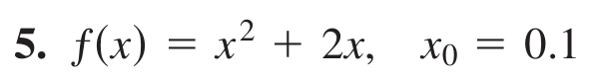

Linearizing Trigonometric Functions

Find the linearization of ƒ at x = a.
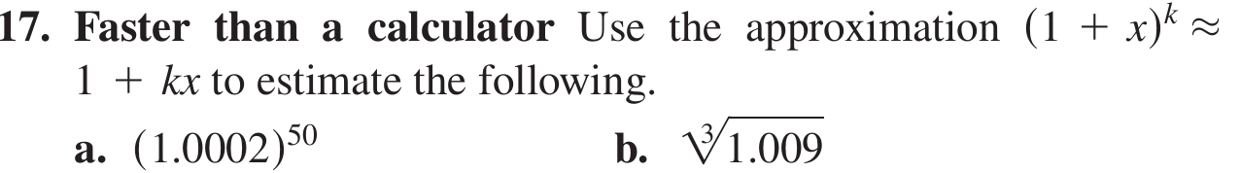
Derivatives in Differential Form

Find dy.
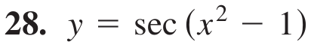

Approximation Error
The function ƒ(x) changes value when x changes
from x₀ to x₀ + dx . Find
