**Special Assigment**

**ZCE 111**

**First Part: Planckian locus**

Read Planckian locus on <https://en.wikipedia.org/wiki/Planckian_locus>

In the [CIE XYZ color space](https://en.wikipedia.org/wiki/CIE_1931_color_space), the three coordinates defining a electromagnetic spectrum are given by $X_{T},Y_{T},Z_{T}$:

$X_{T}=\int{\bar{x}}\left(λ\right)M\left(λ,T\right)dλ,Y_{T}=\int{\bar{y}}\left(λ\right)M\left(λ,T\right)dλ,Z_{T}=\int{\bar{z}}\left(λ\right)M\left(λ,T\right)dλ,$

where *M(λ,T)* is the [spectral radiant exitance](https://en.wikipedia.org/wiki/Spectral_radiant_exitance) of the light being viewed, and $\bar{x}\left(λ\right),\bar{y}\left(λ\right),\bar{z}\left(λ\right)$ are the [color matching functions](https://en.wikipedia.org/wiki/Color_matching_function) of the CIE [standard colorimetric observer](https://en.wikipedia.org/wiki/Standard_colorimetric_observer), shown in the diagram illustration 1, and *λ* is the wavelength.

Illustration 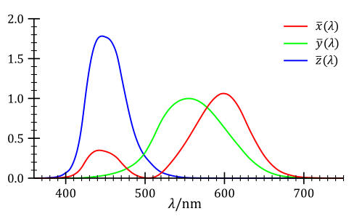1: CIE color matching functions.

The Planckian locus is determined by substituting into the above equations the black body spectral radiant exitance, which is given by [Planck's law](https://en.wikipedia.org/wiki/Planck's_law):



where:

*c*1 = 2π*hc*2 is the [first radiation constant](https://en.wikipedia.org/wiki/Planck's_law" \l "First_and_second_radiation_constants)

*c*2 = *hc/k* is the [second radiation constant](https://en.wikipedia.org/wiki/Planck's_law" \l "First_and_second_radiation_constants)

and

*M* is the black body spectral radiant exitance (power per unit area per unit wavelength: watt per square meter per meter (W/m3))

*T* is the [temperature](https://en.wikipedia.org/wiki/Temperature) of the black body

*h* is [Planck's constant](https://en.wikipedia.org/wiki/Planck's_constant)

*c* is the [speed of light](https://en.wikipedia.org/wiki/Speed_of_light)

*k* is [Boltzmann's constant](https://en.wikipedia.org/wiki/Boltzmann's_constant)

This will give the Planckian locus in CIE XYZ color space. If these coordinates are *XT*, *YT*, *ZT* where *T* is the temperature, then the CIE chromaticity coordinates will be





A pair of crhomatocity coordinates (*x,y*) can be exprssed in MacAdam's chromaticity scale (*u,* *v*) as



A Planckian locus can be mapped out in the (*u*,*v*) chromaticity space, see Illustration 2.

Illustration 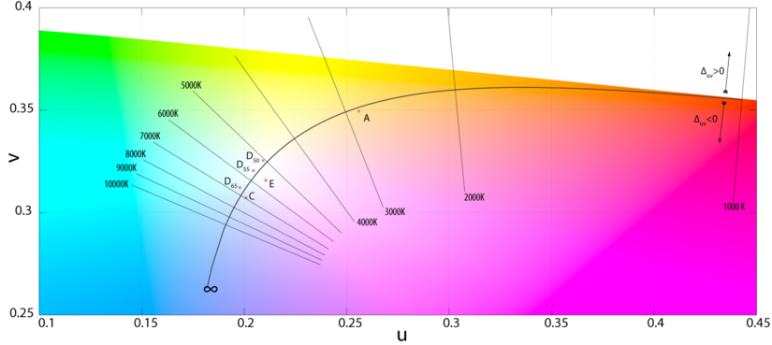2: Plackian locus in (u,v) chromatocity space

**Task No.1 to perform:** Given the CIE color matching functions data, write a code to automatically generate the Plackian locus in (*u*,*v*) space as shown in Ilustration 2. The numerical data file for the [color matching functions](https://en.wikipedia.org/wiki/Color_matching_function) $\bar{x}\left(λ\right),\bar{y}\left(λ\right),\bar{z}\left(λ\right)$ can be downloaded from <http://comsics.usm.my/tlyoon/teaching/ZCE111_1516SEM2/data/StdObsFuncs.xls> (as an Excel file).

**Second Part: Correlated Color temperature (CCT)**

Read CCT on <https://en.wikipedia.org/wiki/Color_temperature>

The tristimulus values (X,Y,Z) for a colour with a [spectral power distribution](https://en.wikipedia.org/wiki/Spectral_power_distribution) $S\left(λ\right)$

are given in terms of:

$X=\int{S}\left(λ\right)\bar{x}\left(λ\right)dλ,Y=\int{S}\left(λ\right)\bar{y}\left(λ\right)dλ,Z=\int{S}\left(λ\right)\bar{z}\left(λ\right)dλ,$

where  is the wavelength of the equivalent [monochromatic](https://en.wikipedia.org/wiki/Monochromatic) light (measured in [nanometers](https://en.wikipedia.org/wiki/Nanometers)). In practice, $S\left(λ\right)$ is a spectrum measured experimentally, e.g., that emitted from a LED light bulb.

**Task No. 2 to perform:** Download the numerical data of a spectrum $S\left(λ\right)$ from <http://comsics.usm.my/tlyoon/teaching/ZCE111_1516SEM2/data/spectral_power_distribution.dat>. Note that the numerical data for $S\left(λ\right)$ is expressed in SI unit (in particular the wavelength values (in the first column) is in unit of meter).

Modify your code from **Task No. 1** to obtain the chromatocity coordinates for the spectrum $S\left(λ\right)$. Call it $C_{s}\left(u_{s},v_{s}\right)$.

(a) CCT *=* ??K

**Answer**: $\left(u_{s},v_{s}\right)=\left(0.210696,0.321492\right)$

**Task No. 3 to perform:** Extent your code to do the following: Identify a point on the Planckian locus $P_{N}\left(u_{N},v_{N}\right)$ at which the normal line at that point pass through $C_{s}\left(u_{s},v_{s}\right)$. Identify the temperature corresponds to the Planckian locus point $P_{N}\left(u_{N},v_{N}\right)$. This temperature is the CCT of the spectrum $S\left(λ\right)$.

**Answer**:5259.3 K

**Task No. 4 to perform:** Output a diagram displaying (i) the Planckian curve, (ii) the point $C_{s}\left(u_{s},v_{s}\right)$, (iii) $P_{N}\left(u_{N},v_{N}\right)$,(iii) the normal line that passes through both $C_{s}\left(u_{s},v_{s}\right)$ and $P_{N}\left(u_{N},v_{N}\right)$, see the sample output below.

Note:

1. Make sure that your code must output explicitely (a) the values of the CCT for $S\left(λ\right)$, (b) the $C_{s}\left(u_{s},v_{s}\right)$ dot, (c) the $P_{N}\left(u_{N},v_{N}\right)$ dot, (d) the Planckian locus and (e) the normal line.

2. Your code should be fully automatic and should produce all the required output at a press of a button wihtout any manual intervention (except the act of pressing the shift+enter burron keys).

Illustration 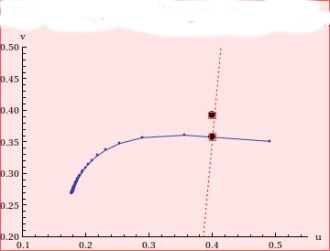3: Sample output of your diagram

*Cs*(*us*,*v****s***)

(e) Normal line

(c) *PN*(*uN*,*v****N***)

(d) Planckian locus

*Cs*(*us*,*v****s***)

(b) *Cs*(*us*,*v****s***)