The program of Physics
A passage adapted from Elementary Modern Physics, by Richard T. Widner and Robert L. Sells, Allyn and Bacon Inc., third edition

The program of physics is to devise concepts and laws that can help understand the physical universe.

A law in physics is a statement, usually in the succinct and precise language of mathematics, of a relation that has been found by repeated experiment to hold among physical quantities and that reflects persistent regularities in the behaviour of the physical world.

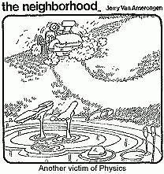

A "good" physical laws has the greatest possible, generality, simplicity, and precision.

The final criteria of a successful law of physics is how accurately it predicts experimental results.

On the other hand, extrapolating any law beyond its range of validity may predict results inconsistent with later experiments.

One example of this was the Michelson-Morley experiment, which refuted the 19th-century conception of the ether as the medium for propagation of electromagnetic waves. Such contradictions of the theory are important part of the evolution of physics.

Early theories that proves inadequate are supplanted by more general, comprehensive theories and laws that describe phenomena in the new, as well as the old, regions of investigation.

Figure 1 -1 shows the regions in which classical physics relativity physics, quantum physics, and relativistic quantum physics apply.

Fig 1.1
Classical physics is the physics of ordinary-sized objects moving at ordinary speeds; it embraces Newtonian mechanics and electromagnetism.

For speeds approaching the speed of light, classical physics must be supplanted by relativity physics;

for sizes of about 10^{-10} m (approximately the size of an atom), classical physics must be supplanted by quantum physics.

For subatomic dimensions and speeds approaching the speed of light, only relativistic quantum physics is adequate.

The limits of the several physical theories are not sharply defined; in fact, they overlap. Relativistic quantum physics is the most comprehensive and complete theoretical structure in present-day physics. At dimensions of about 10⁻¹⁵ m (the approximate size of the atomic nucleus) perplexing phenomena appear, at present only partly understood. Physics smaller than the Planck scale (~10⁻³⁴ m) is at the moment the strongest mystery in the physics research frontier.

Similarly,

Important cosmological questions remain unresolved in the domain of the very large (of the order of 10²⁵ m) – General theory of relativity.

Our understanding of atomic and nuclear structure is grounded in the two great ideas of modem physics, relativity theory and quantum theory. Both originated early in this century, when improved experimental techniques first allowed physicists to study phenomena at small enough dimensions and high enough speeds and energies. Indeed, by modem physics we mean the physics of the twentieth century.

The 'architects' of modern physics.

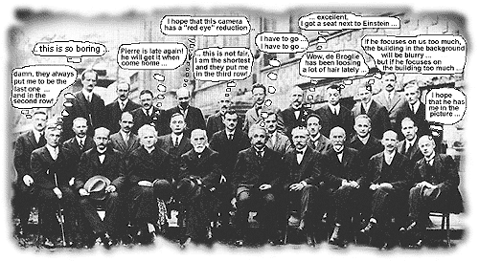

From left to right:
[first row] (1) I. Langmuir, (2) M. Planck, (3) M. Curie, (4) H.A. Lorentz, (5) A. Einstein, (6) P. Langevin, (7) C.E. Guye, (8) C.T.R. Wilson, (9) O.W. Richardson
[second row] (1) P. Debye, (2) M. Knudsen, (3) W.L. Bragg, (4) H.A. Kramers, (5) P.A.M. Dirac, (6) A.H. Compton, (7) L.V. de Broglie, (8) M. Born, (9) N. Bohr
[third row] (1) A. Piccard, (2) E. Henriot, (3) P. Ehrenfest, (4) E. Herzen, (5) Th. de Donder, (6) E. Schroedinger, (7) E. Verschaffelt, (8) W. Pauli, (9) W. Heisenberg, (10) R.H. Fowler, (11) L. Brillouin

In this course we shall study relativity theory and quantum theory and use them to analyze atomic structure.

We shall deal with situations in which some familiar notions in physics may be inapplicable - situations in which classical physics is downright wrong.

Does this mean, then, that all the time and effort spent in studying elementary classical physics is wasted, that one might better begin with relativity and quantum theory? Not at all! (see The Correspondence Principle)

Many of the concepts and laws of classical physics carry over into the new physics.

The Correspondence Principle

As we mentioned before, any theory or law in physics is more or less tentative and approximate; extrapolation to untested situations may show that it is incomplete or incorrect.

If a new, more general theory is proposed, there is a completely reliable guide for relating the new theory to the older, more restricted (and better known) one. This guide, the correspondence principle, was first proposed by the Danish physicist Niels Bohr in 1923. We shall find it helpful to apply this principle in a broader sense to both relativity physics and quantum physics.

The Correspondence Principle: Any new theory in physics, whatever its character or details, must reduce to the well established classical theory to which it corresponds when it is applied under the circumstances in which the less general theory is known to hold.

For example,
when we are analyzing the motion of a projectile with a comparatively small range, we make the following assumptions:
- The weight of the projectile is constant in magnitude and is given by the mass times a gravitational acceleration constant in magnitude;
- the earth is represented by a plane surface, and
- the weight of the projectile is constant in direction, vertically downward.

With these assumptions, the theory predicts a parabolic path-in excellent agreement with experiment, provided that the projectile motion extends over only relatively short distances. However, if we try to describe the motion of an earth satellite on the same assumptions, very serious errors will be made. To discuss the satellite motion we must instead assume that
- the weight of the body is not constant in magnitude but varies inversely with the square of its distance from the earth's centre;
- the earth's surface is spherical, not flat; and
- the direction of the weight is not constant but always points toward the earth's centre. With these assumptions, the theory predicts an elliptical path and describes satellite motion properly.

Now, if we apply the second, more general, theory to the motion of a body travelling a distance that is small compared with the earth's radius at the surface of the earth, notice what happens. The weight appears to be constant in both magnitude and direction, the earth appears flat, and the elliptical path becomes parabolic. This is precisely what the correspondence principle requires!

The correspondence principle asserts that when the conditions of the new and old theories correspond, the predictions will also correspond; that is, a new (general) theory will yield the old (restricted) theory as a special approximation. We have, then, an infallible guide when testing a new theory or law: The new theory must reduce to the theory it supplants. Any new theory that fails in this respect is so fundamentally defective that it cannot possibly be accepted. Therefore, we know that the relativity and quantum theories must yield classical physics when applied to large-scale objects moving at speeds much lower than the speed of light. In the next section, we shall see another familiar example of the correspondence principle.

Another example: Ray Optics and Wave Optics

Two means of describing the propagation of light:

- ray (geometrical) optics –
  - only rectilinear propagation, reflection, refraction
  - valid only when λ /d -> 0

- wave (physical) optics –
  - more general (diffraction, interference, also rectilinear propagation)
  - more comprehensive, valid up to λ  d
  - Need other theory to account for λ  d

The correspondence principle requires that the comprehensive theory (wave optics) reduce to the restricted theory (ray optics) in the correspondence limit
Limit (wave optics) = ray optics
λ /d -> 0 (no wave phenomena)

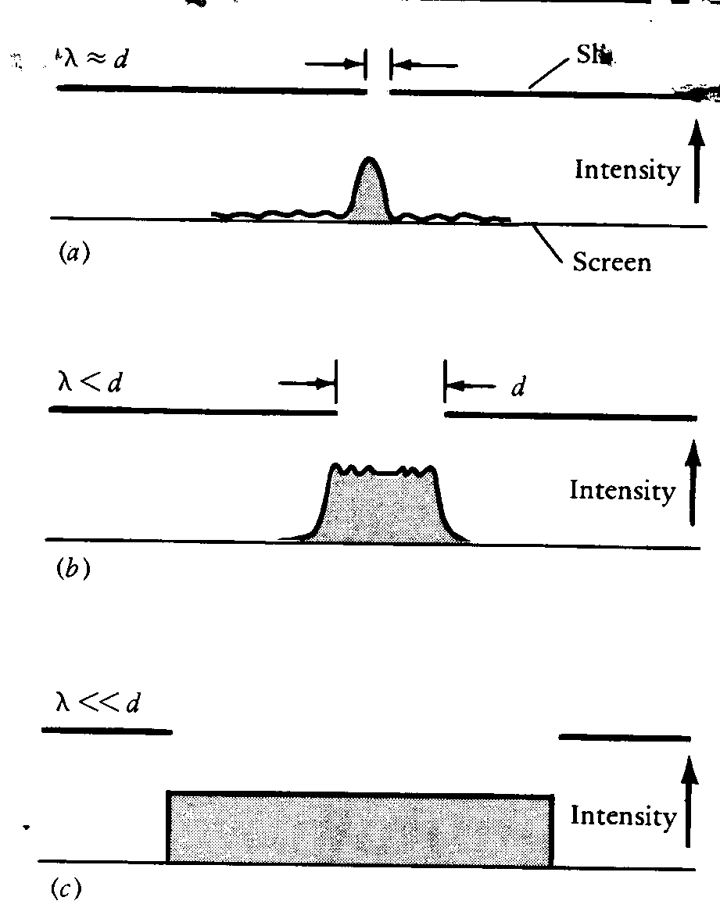

FIGURE 1-2. Distribution of intensity of monochromatic Light passing through single slits of increasing width

In (a) the wave disturbance is spread far into the geometrical shadow, sees diffraction

In (c) light travels in straight light, no wave phenomena

YOU MIGHT BE A PHYSICS MAJOR...
if you have no life - and you can PROVE it mathematically.
if you enjoy pain.
if you know vector calculus but you can't remember how to do long division.
if you chuckle whenever anyone says 'centrifugal force.'
if you've actually used every single function on your scientific calculator.
if when you look in a mirror, you see a physics major.
if you always do homework on Friday and Saturday nights.
if you know how to integrate a chicken and can take the derivative of water.
if you think in 'math.'
if you hesitate to look at something because you don't want to break down its wave function.
if you have a pet named after a scientist.
if you laugh at jokes about mathematicians.
if the Humane society has you arrested because you actually performed the Schrodinger's Cat experiment.
if you can't remember what's behind the door in the science building which says 'Exit.'
if you have to bring a jacket with you, in the middle of summer, because there's a wind-chill factor in the lab.
if you avoid doing anything because you don't want to contribute to the eventual heat-death of the universe.
if you consider ANY non-science course 'easy.'
if the 'fun' centre of your brain has deteriorated from lack of use.
if you'll assume that a 'horse' is a 'sphere' in order to make the math easier.
if you understood more than five of these indicators.
if you make a hard copy of this list, and post it on your door.
If these indicators apply to you, there is good reason to suspect that you might be classified as a physics major. I hope this clears up any confusion

