Tutorial 1

Special Relativity

Conceptual Questions

- What is the significance of the negative result of Michelson-Morley experiment?

- Is it possible to have particles that travel at the speed of light?

- A particle is moving at a speed less that c/2. If the speed of the particle is doubled, what happens to its momentum?

- The rest energy and total energy respectively, of three particles, expressed in terms of a basic amount A are (1) A, 2A; (2) A, 3A; (3) 3A, 4A. Without written calculation, rank the particles according to their (a) rest mass, (b) Lorentz factor, and (c) speed, greatest first.

ANS
(a)(1)>(2)=(2);(b)(2)>(1)>(3); (c) (2)>(1)> in (3)

PROBLEMS

- Space Travel (from Cutnell and Johnson, pg 861,863)
Alpha Centauri, a nearby star in our galaxy, is 4.3 light-years away. If a rocket leaves for Alpha Centauri and travels at a speed of v = 0.95c relative to the Earth, (i) by how much will the passengers have aged, according to their own clock, when they reach their destination? ii) What is the distance between Earth and Alpha Centauri as measured by the passengers in the rocket? Assume that the Earth and Alpha Centauri are stationary with respect to one another.
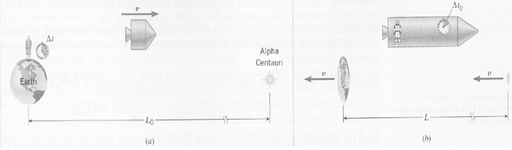

Figure: (a) As measured by an observer on the earth, the distance to Alpha Centauri is L₀, and the time required to make the trip is Δt. (b) According to the passenger on the spacecraft, the earth and Alpha Centauri move with speed v relative to the craft. The passenger measures the distance and time of the trip to be L and Δt₀ respectively, both quantities being less than those in part (a).
ANS (i)1.4 years; (ii) 1.3 light-years.

2) The Contraction of a Spacecraft (Cutnell, pg 863)
An astronaut, using a meter stick that is at rest relative to a cylindrical spacecraft, measures the length and diameter of the spacecraft to be 82 and 21 m respectively. The spacecraft moves with a constant speed of v = 0.95c relative to the Earth. What are the dimensions of the spacecraft, as measured by an observer on Earth?
ANS 26 m x 21 m

3) Additional problem 36, Cutnell pg. 879.
Two spaceship A and B are exploring a new planet. Relative to this planet, spaceship A has a speed of 0.60c, and spaceship B has a speed of 0.80c. What is the ratio D_{A}/D_{B} of the values for the planet’s diameter that each spaceship measures in a direction that is parallel to its motion?
ANS 4/3

4) The Energy Equivalent of a Golf Ball (Cutnell, pg 866)
A 0.046-kg golf ball is lying on the green. (a) Find the rest energy of the golf ball. (b) If this rest energy were used to operate a 75-W light bulb, for how many years could the bulb stay on?
ANS (a) 4.1 × 10¹⁵ J; (b) 1.7 million years

5) A High-Speed electron (Cutnell pg. 867)
An electron (mass = 9.1 × 10⁻³¹ kg) is accelerated to a speed of 0.9995c in a particle accelerator. Determine the electron’s (a) rest energy, (b) total energy, and (c) kinetic energy in MeV
ANS (a); (b) 16.3 MeV; (c) 15.7 MeV

6) The Sun Is Losing Mass (Cutnell, pg 868)
The sun radiates electromagnetic energy at the rate of 3.92×10²⁶ W. (a) What is the change in the sun's mass during each second that it is radiating energy? (b) The mass of the sun is 1.99 × 10³⁰ kg. What fraction of the sun's mass is lost during a human lifetime of 75 years?

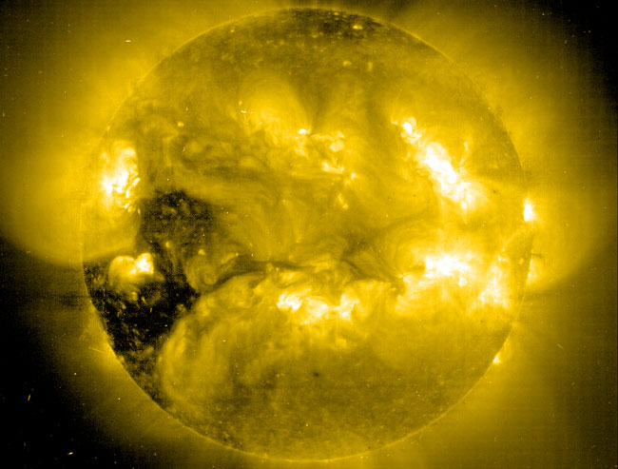
ANS (a) (4.36×10⁹) kg; (b)5.0×10⁻¹²

7) The Speed of a Laser Beam (Cutnell, pg 871)
Figure below shows an intergalactic cruiser approaching a hostile spacecraft. The velocity of the cruiser relative to the spacecraft is v_{CS} = +0.7c. Both vehicles are moving at a constant velocity. The cruiser fires a beam of laser light at the enemy. The velocity of the laser beam relative to the cruiser is v_{LC} = +c. (a) What is the velocity of the laser beam v_{LS} relative to the renegades aboard the spacecraft? (b) At what velocity do the renegades aboard the spacecraft see the laser beam move away from the cruiser?
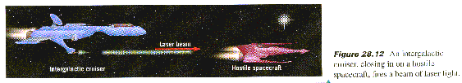
Reasoning and Solution

ANS (a)+c; (b) 0.3c.

(8) The Relativistic Momentum of a High-Speed Electron (Cutnell, pg 865)
The particle accelerator at Stanford University is three kilometers long and accelerates electrons to a speed of 0.999 999 999 7c, which is very nearly equal to the speed of light. Find the magnitude of the relativistic momentum of an electron that emerges from the accelerator, and compare it with the non-relativistic value.
ANS $1×{\text{10}}^{−\text{17}}$Ns m/s; relativistic momentum is larger by .

- Resnick and Halliday, Sample problem 37-8, pg. 1047.
The most energetic proton ever detected in the cosmic rays coming to Earth from space had an astounding kinetic energy of 3.0 x 10²⁰ eV. (a) What were the proton’s Lorentz factor γ and speed v (both relative to the ground-based detector)?

ANS

