Top of Form

ZCT 104/3E Modern Physics
2nd semester, academic session 2005/06, School of Physics, USM, Penang, Malaysia
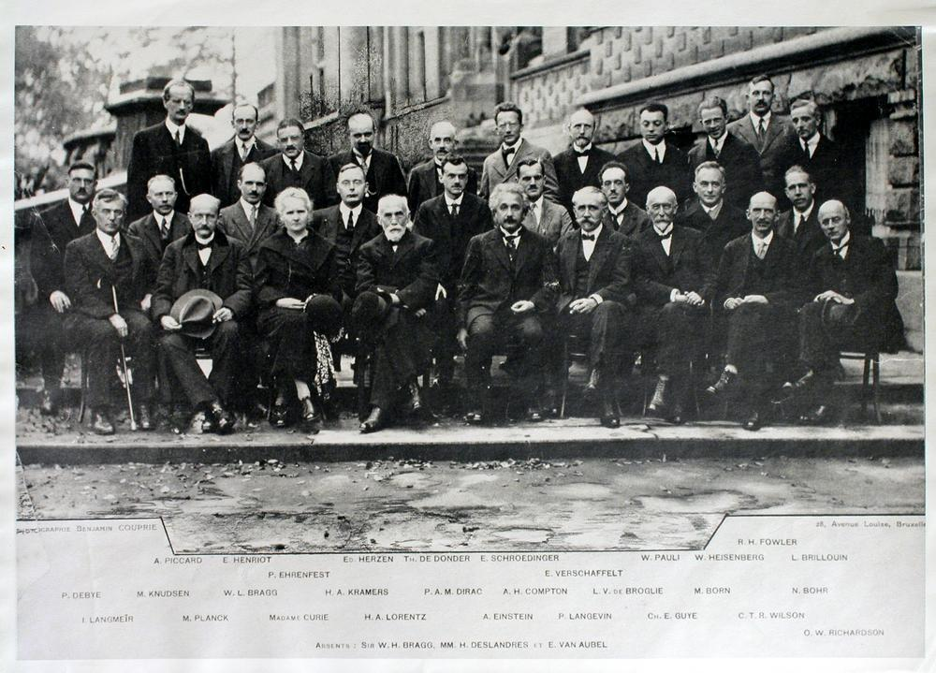

Course webpage:
www.fizik.usm.my/tlyoon/teaching/ZCT104_05_06/
mirror site: http://www.usm.my/phy/tlyoon/teaching/ZCT104_05_06/

Exam Grading:
Grading will be weighted: Coursework (in the forms of 2 midterm tests) will contribute 30 marks, while final exam 70 marks, totaling (30 + 70 =100) marks.

Lecturer: Yoon Tiem Leong
Contact: Room 115, School of Physics, USM. Tel:04-6533674
Email: tlyoon@usm.my

Course Meeting Times:
1) Monday, 11.00-11.50 am, SK3
2) Wednesday, 9.00-9.50 am, SK4
3) Friday, 3.00 - 3.50 pm, SK3

Tutorials: Friday, (alternate with lectures)
Bottom of Form
Course Materials
Hard copy of lecture notes plus problem sets will be available for sale in the photocopy shop at the Main library basement. If you like to view the simulation and colour pages not available in the hard copy version, powerpoint lecture notes are also downloadable in the course webpage. Past year questions plus their solutions (tests, final exam and KSCP papers) and problem sheets (i.e. tutorial sheets) are also available on the course webpage.

Course Description
This course is intended to cover some of the standard concepts in modern physics since 1900. It includes special theory of relativity, wave-particle duality of light and material particles, introductory quantum theory of atoms and introductory quantum mechanics. The course aims to lay the foundational concepts for students who would take up papers on quantum mechanics at a higher level.
Course Duration
This course is offered in the second semester for science students in USM -- a 14-week term at USM that runs from 26 Dec 2005 until 7 April 2006.
Course Prerequisites
Since ZCT 104 is conducted in English, students must prepare to take the challenge to deal with language barrier (if relevant). Despite requiring no formal prerequisites (prasyarat kursus), students are assumed to be familiar with elementary calculus, differential equations, and Newtonian mechanics. Most importantly, students are expected to exercise independence throughout the learning process. This course demands ones to think critically to comprehend some rather counter intuitive physics ideas.
Consultation hours
There is no specific timeslots allocated for consultation with the lecturer as he of dedicated willingness to offer consultation and advice to students who wish to engage discussion with him. The principle of the lecturer is that: as long as the students are showing enthusiasm to learn, he will be willing to offer his time for discussion. However, in order to avoid inconvenience students are advised to call up (ext 3674) or email him (tlyoon@usm.my) before rushing into his office. His door is always open to any one who are keen to explore physics.
General Comments
Modern physics is one of the most interesting subject offered to USM undergraduates. Most of the concepts introduced, such as Einstein's notion that space and time is a relative concept, and that microscopic particles are intrinsically behaving like waves (as expounded in quantum theory), are both intellectually intriguing and somewhat counter-intuitive.
Textbooks
The following textbooks are required or strongly recommended. There exist many good textbooks on the topics of modern physics. I have decided to select the following as my main reference texts. Lecture material are written based on them. It is strongly advised that students should not be contented with the lecture material supplied from the lecturer alone. They should make reference to these suggested texts and do the reading on a consistent manner. You gonna prepare to think in an intellectual manner in order to comprehend the essential concepts I wish to convey in this course. To people who are expecting to make only mechanical memorisation and pass with flying colour, please be prepared for disappointment.
Main Text:
- Modern Physics, 2nd ed., by Kenneth Krane, John. Wiley & Sons.
- Concepts of Modern Physics, 6th ed., by Arthur Beiser, McGraw-Hill.
- Modern Physics, 3rd ed., by Serway, Moses and Moyer, Thomson 2005.
- Understanding Physics, by Karen Cummings et. al., John Wiley and Sons, 2004 (used for special theory of relativity only)
Others references:
Advanced texts for hard-core physics enthusiasts:
- Introduction to special relativity, by Robert Resnick, John Wiley & sons (readable and well explained, suggested for serious students.
- Quantum Physics of Atoms, Molecules, Solids, Nuclei, and Particles by Robert Eisberg, Robert Resnick, John Wiley & Sons; 2nd edition
Suggestion for the pleasure of understanding (not totally useful for exam but precious for intellectual pursuit)
- Relativity: The Special and the General Theory. Dover Publications (2001). A classic book by the creator itself, Einstein, for a clear explanation that everyone can understand. Minimum equations.
- The Feynman Lecture on Physics Volume III, by Richard Feynman, Addison Wesley Longman (June, 1970). (Read how Feynman expounds excellently on the basics of quantum mechanics.)
Problem Sets (tutorial sheets)
A total of 5 problem sets will be prepared for you. Problem sets are an integral part of this course. It simply isn't possible to learn physics unless you sit down and work through the problems and concepts on your own. Formally there will be some assigned tutors to provide guidance and counseling to the students on the subject. However, it is recognized that students also learn a great deal from talking to and working with each other. Therefore I encourage each student to make his/her own attempt on every problem. Discussion among yourselves shall definitely help a lot in understanding the course content more thoroughly.
Our typical Malaysian students are used to spoon-feeding. As a matter of fact I am strongly disapproved of such unhealthy attitude. To encourage proactive and independent learning attitude (and to deprive your privilege to be a copy-cat and a bagger of spoon-feedings), NO solution sheets shall be provided to you. We will only discuss the solutions on-the-spot during the tutorial meetings. You would not be asked to pass up your tutorial answers for marking and grading. As an adult you are no longer treated as kinder garden kids. In view of such forceful arrangement, you are expected to make active discussions with your fellow course mates or your tutors in the attempts to solve the tutorial questions.

Grading:
Grading will be weighted: Coursework (in the forms of 2 midterm tests) will contribute 30 marks, while final exam 70 marks, totaling (30 + 70 =100) marks.
Coursework assessment: Two tests (20 objectives for each test) will be arranged during the term (check the dates from the calendar). They carry 2x15 marks = 30 marks.
Exam Format:
The exam questions will appear in dual language: English + Malay.
Final exam: A 3-hour final exam covering material throughout the lecture material will be conducted at the end of the semester. It comprises of 40 objective questions (40%) and 3 structured questions (3x20% = 60%), all are to be answered. In particular, the objectives (in the tests as well as in the final exam) will comprise of conceptual type questions. Structured questions in the final exam will be of calculation type. You may like to take a look at the past year questions to get some idea of the exam format (click here). The format of past year questions differ somewhat from the format mentioned above.

