TUTORIAL QUESTIONS ON SPECIAL RELATIVITY
(BASED ON UNDERSTANDING PHYSICS, CUMMINGS et al, John Wiley and Sons)

SEC. 38-2 ORIGINS OF SPECIAL RELATIVITY

1. Chasing Light.
What fraction of the speed of light does each of the following speeds v represent? That is, what is the value of the ratio v/c? (a) A typical rate of continental drift, 3 cm/y. (b) A high way speed limit of 100 km/h. (c) A supersonic plane flying at Mach 2.5 = 3100 km/h. (d) The Earth in orbit around the Sun at 30 km/s. (e) What conclusion(s) do you draw about the need for special relativity to describe and analyze most everyday phenomena? (Note: Some everyday phenomena can be derived from relativity. For example, magnetism can be described as arising from electrostatics plus special relativity applied to the slow-moving charges in wires.)

Solution
In order to carry out the conversions in this exercise, we use the standard method of multiplying by unity. You do not change the value of any quantity when you multiply it by one. For example:
Using this method, the solutions to parts (a) through (d) are as follows:

(a) Continental drift
All units cancel. (In canceling units, we make no distinction between singular and plural, such as second and seconds.)
(b) Highway speed
Once again, all units cancel:
(c) Supersonic plane
(d) Earth in orbit
(e) Most everyday phenomena involve speeds that are such small fractions of the speed of light that special relativity is not required to describe them or their consequences.

SEC. 38-3 . THE PRINCIPLE OF RELATIVITY

3. Examples of the Principles of Relativity
Identical experiments are carried out (1) in a high-speed train moving at constant speed along a horizontal track with the shades drawn and (2) in a closed freight container on the platform as the train passes. Copy the fol lowing list and mark with a “yes” quantities that will necessarily be the same as measured in the two frames. Mark with a “no” quanti ties that are not necessarily the same as measured in the two frames. (a) The time it takes for light to travel one meter in a vacuum; (b) the kinetic energy of an electron accelerated from rest through a voltage difference of one million volts; (c) the time for half the number of radioactive particles at rest to decay; (d) the mass of a proton; (e) the structure of DNA for an amoeba; (f) Newton’s Second Law of Motion: F = ma; (g) the value of the downward acceleration of gravity g.

Solution
EACH of the identical experiments should give the same result in the uniformly moving train as in the closed freight container.
Note that the mass of a proton (d) is an invariant, independent of speed, as embodied in Eq. 38-18. This will be true for independent experiments carried out by both observers. Also note that in each reference frame Newton’s Second Law of motion (f) is valid only at particle speeds much smaller than the speed of light, and departures from this law will be the same at the same higher speeds measured in each frame.

SEC. 38-4. LOCATING EVENTS WITH AN INTELLIGENT OBSERVER

6. Eruption from the Sun
You see a sudden eruption on the surface of the Sun. From solar theory you predict that the eruption emitted a pulse of particles that is moving toward the Earth at one- eighth the speed of light. How long do you have to seek shelter from the radiation that will be emitted when the particle pulse hits the Earth? Take the light-travel time from the Sun to the Earth to be 8 minutes.

Solution
The solution is similar to that of Exercise 5. Let T be the time between arrival of the light signal and the particle pulse. Then:
The speed of light c is, by definition, one light-minute of distance per minute of time. In other words it has the value unity in the equation above. Therefore:
So you have 56 minutes after the initial light pulse to seek shelter from the later pulse of particles.

SEC. 38-5 LABORATORY AND ROCKET LATTICEWORKS OF CLOCKS

7. Synchronizing a Clock
In a vast latticework of meter sticks and clocks, you stand next to a lattice clock whose coordinates are x = 8 km, y = 40 km, z = 44 km. When you receive the synchronizing flash, to what time do you quickly set your clock?

Solution
We need to know the distance L of your position from that of the synchronizing clock at the origin of the coordinate system. This distance L is equal to the square root of the sum of the squares of the three coordinates:
So you need to set your clock to a time T equal to the time it takes light to travel 60 kilometers. The process involves a change of units by our usual method of multiplying by unity:
This is the time to which you quickly set your clock when you receive the synchronizing pulse. The procedure may be simplified by setting the clock to seconds ahead of time and starting it when the synchronizing pulse arrives.

10. Where and When?
Two firecrackers explode at the same place in the laboratory and are separated by a time of 12 years. (a) What is the spatial distance between these two events in a rocket in which the events are separated in time by 13 years? (b) What is the relative speed of the rocket and laboratory frames? Express your answer as a fraction of the speed of light.

Solution
Use Equation 38-2:
(a) In the laboratory frame the two firecrackers explode in the same place. Therefore the laboratory time between these explosions is the wristwatch time Δτ = 12 years. We are also told that in the rocket frame the time between the explosions is Δt = 13 years. From these numbers we can use Eq. 38-2 to compute the separation Δx between the explosions in the rocket frame:
or
This expression has mixed units, so we need to carry out a conversion:
This is the distance between the explosions in the rocket frame.

(b) In the frame of the rocket observer the laboratory observer moves a distance Δx in a time of 13 years. From the first (unconverted) equation for Δx above, we have
or a little more than one-third the speed of light.

13. Fast-Moving Muons
The half-life of stationary muons is mea sured to be 1.6 microseconds. Half of any initial number of station ary muons decays in one half-life. Cosmic rays colliding with atoms in the upper atmosphere of the Earth create muons, some of which move downward toward the Earth’s surface. The mean lifetime of high-speed muons in one such burst is measured to be 16 microseconds. (a) Find the speed of these muons relative to the Earth. (b) Moving at this speed, how far will the muons move in one half-life? (c) How far would this pulse move in one half-life if there were no relativistic time stretching? (d) In the relativistic case, how far will the pulse move in 10 half-lives? (e) An initial pulse consisting of 10⁸ muons is created at a distance above the Earth’s surface given in part (d). How many will remain at the Earth’s surface? Assume that the pulse moves vertically downward and none are lost to collisions. (Ninety-nine percent of the Earth’s atmosphere lies below 40 km altitude.)

Solution

(a) Start with Equation 38-3:
Square both sides and solve for v²/c². Substitute values Δτ = 1.6 microseconds and
Δt = 16 microseconds from the statement of the problem.
or
(b) Moving at this speed, in one half-life a muon pulse will cover a distance given by:
(c) If there were no relativistic time stretching, the distance moved would be ten times less, or approximately 480 meters.

(d) In ten half-lives a pulse of muons will move a distance equal to 48 kilometers.

(e) In ten half-lives the number of muons in the initial pulse will be reduced by a factor of 2¹⁰ = 1024. Then an initial pulse of 10⁸ muons will be reduced to a final population of at Earth’s surface.

15. Living a Thousand Years in One Year
Living a Thousand Years in One Year. You wish to make a round trip from Earth in a spaceship, traveling at constant speed in a straight line for 6 months on your watch and then returning at the same constant speed. You wish, further, to find Earth to be 1000 years older on your return. (a) What is the value of your constant speed with respect to Earth? (b) How much do you age during the trip? (c) Does it matter whether or not you travel in a straight line? For example, could you travel in a huge circle that loops back to Earth?
Solution
The aging of the traveler will be the same on both the outward trip and the return trip. The corresponding (but different) time lapse on Earth will also be the same on outward trip as on return trip.

(a) You want to be one year older while Earth ages 1000 years. Therefore we have, from Eq. 38-3:
from which
and
(b) You age one year, according to the statement of the problem.

(c) It does not matter how you execute the trip, provided the acceleration you experience is not too great. Very large acceleration can lead to two results: (1) your death, or (2) the need to use general relativity to analyze the motion. This is because, strictly speaking, special relativity deals only with inertial (free-float) reference frames.

SEC 38-8 . CAUSE AND EFFECT

17. Relations between Events
The table shows the t and x coordinates of three events as observed in the laboratory frame.
Laboratory Coordinates of Three Events. On a piece of paper list vertically every pair of these events: (1,2), (1, 3), (2, 3). (a) Next to each pair write “time-like,” “light-like,” 0 “space-like” for the relationship between those two events. (b) Next to each pair, write “Yes” if it is possible for one of the events to cause the other event and “No” if a cause and effect relation between them is not possible. (For full benefit of this exercise construct and analyze your own tables.)

t x
Event years light-years
Event 1 2 1
Event 2 7 4
Event 3 5 6

Solution
Since t and x are both measured in the units of years, Eq. 38-2 simplifies to the form
for events separated by a time-like interval. Also, Equation 38-12 simplifies to the form
for events separated by a space-like interval.
Between events 1 and 2, the time separation is 5 years and the space separation is 3 light-years.
Between events 1 and 3, the time separation is 3 years and the space separation is 5 light-years.
Between events 2 and 3, the time separation is 2 years and the space separation is 2 light-years.

From these coordinate separations we can complete the requested list:
(1,2) timelike yes
(1,3) spacelike no
(2,3) lightlike yes

22. Proton Crosses Galaxy
Find the energy of a proton that crosses our galaxy (diameter 100 000 light-years) in one minute of its own time.

Solution
One year is equal to
Therefore the diameter D of our galaxy is equal to
The problem statement demands that the proton cross the galaxy in minute on its own wristwatch. This must mean that it travels very close to the speed of light as observed in the galaxy rest frame. Therefore it takes slightly more than minutes to cross the galaxy in the rest frame of the galaxy. (You can verify that this is so by substituting Δτ and Δx = D into Eq. 38-1. You will find that the numerical value of Δt is dominated by D.)
Equation 38-17 relates the energy of the proton to the ratio of time lapses in different frames. These times are those for the proton to move between two events, in this case events of departure from one edge of the galaxy and arrival at the other edge.

The rest energy of the proton is approximately 10⁹ electron-volts. So the energy of our galaxy-spanning proton is approximately electron-volts or about 8 joules. Exercise 51 reports that some cosmic rays have been detected with twice this energy.

38-10 MOMENTUM AND ENERGY

23. Converting Mass to Energy
The values of the masses in the reaction
have been determined by a mass spectrometer to have the values:
m(p) = 1.00782, m(F) = 18.998405u, m(α) = 4.002603u,
m(O) = 15.994915u.
Here u is the atomic mass unit (Section 1.7). How much energy is released in this reaction? Express your answer in both kilograms and MeV.

Solution
Adding up the initial masses, we have
and the final masses add up to:
The decrease in the sum of the masses of component nuclei during the reaction is.

According to Equation 1-9 in Section 1.7, the relation between atomic mass units and kilograms is
Therefore the number of kilograms lost during the reaction we are analyzing is
The energy released is this mass change times c².
Using the conversion factor between joules and MeV, we have:

27. Powerful Proton
A proton exits an accelerator with a kinetic energy equal to N times its rest energy. Find expressions for its (a) speed and (b) momentum.

Solution
We are given that the proton has a kinetic energy equal to N times its rest energy. From Equations 38-19 and 38-20:
Cancel the common factor mc² and rearrange to yield.
(A)
(a) Solve this equation for the speed
(B)
(b) Substitute Equation 38-3 for Δτ into Eq. 38-15 to obtain:
(C)
Use Equation A to eliminate the square root in the denominator of the right side of Eq. C. Then use Equation (B) to eliminate v in the numerator. We obtain:

30. A Box of Light
Estimate the power in kilowatts used to light a city of 8 million inhabitants. If all this light generated during one hour in the evening could be captured and put in a box, how much how much would the mass of the box increase?

Solution
(a) Every one of us will make a different estimate of the electricity used per member of the population. We chose 2 kilowatts per person, which includes street lighting, municipal transportation, and so forth. Then the total use for a city of 8 million is 16 million kilowatts.
(b) One hour has 3600 seconds and one watt is one joule/ second so the total energy used by our city in one hour is
The mass equivalent is:
That is how much the mass of the box would increase.

SEC. 38-11 . THE LORENTZ TRANSFORMATION

32. Really Simultaneous?
(a) Two events occur at the same time in /ihe laboratory frame and at the laboratory coordinates (x₁ = 10 km, y₁ = 4 km, z₁ = 6 km) and (x₂ = 10 km, y₂ = 7 km, z₂ = -10 km). Will these two events be simultaneous in a rocket frame moving with speed v= 0.8c in the x direction in the laboratory frame? Explain your answer. (b) Three events occur at the same time in the laboratory frame and at the laboratory coordinates (x₀,y₁, z₁), (x₀,y₂, z₂) and (x₀,y₁, z₃) where x₀ has the same value for all three events. Will these three events be simultaneous in a rocket frame moving with speed v in the laboratory x direction? Explain your answer. (c) Use your results of parts (a) and (b) to make a general statement about simultaneity of events in laboratory and rocket frames.

Solution
The second Lorentz transformation Eq. 38-25 reads:
This equation relates the time difference between two events in the primed rocket coordinates to the time separation and x-separation between the two events in the unprimed laboratory coordinates. Now suppose that two events occur at the same time in the laboratory frame (Δt = 0) and at the same x-coordinate in the laboratory frame
(Δx = 0). Then the equation tells us that the two events will also occur at the same time—they will be simultaneous—in the rocket frame (Δt’ = 0).
(a) and (b). The conditions just derived are satisfied for the pair of events in part (a) and all three pairs of events in part (b). So, we conclude that events are simultaneous in both the laboratory and rocket frames for the pair of events in part (a) and for all three pair of events in part (b).
(c) The generalization is that if two events are simultaneous in the laboratory frame and occur at the same coordinate along the direction of relative motion (in our case the x-direction), then the two events are simultaneous in the rocket frame. You can use the inverse Lorentz transformation (38-27) to show that the reverse is also true.

38-12 LORENTZ CONTRACTION

36. Electron Shrinks Distance
An evacuated tube at rest in the /laboratory has a length 3.00 m as measured in the laboratory. An electron moves at speed v = 0.999 987c in the laboratory along the axis of this evacuated tube. What is the length of the tube measured in the rest frame of the electron?

Solution
In this case the evacuated tube is at rest in the laboratory frame and is contracted as observed in the rocket (moving electron) frame. Modify Equation 38-28 to represent this situation:

39. Traveling to the Galactic Center
(a) Can a person, in principle, travel from Earth to the center of our galaxy, which is 23 000 ly distant, in one lifetime? Explain using either length contraction or time dilation arguments. (b) What constant speed with respect to the galaxy is required to make the trip in 30 y of the traveler’s life time?

Solution
(a) Yes, special relativity tells us that the wristwatch time Δτ between two events (two events connected by a timelike interval) can be made as small as desired by choosing the appropriate frame. One can analyze this either in terms of the time-stretching relation between Δτ and Δt between events (Eq. 38-3) or in terms of the Lorentz contraction of distance (Eq. 38-28) between Earth and the galactic center.

(b) The galaxy center is 23 000 light-years distant. This means it will take light Δt = 23 000 years to reach the center as measured in the galaxy rest frame. We want to get there in wristwatch time Δτ = 30 years. From Equation 38-16:
From which
Use approximation (38-21) to take the square root:

40. Limo in the Garage
Carman has just purchased the world’s longest stretch limo, which has proper length L = 30.0 m. Part (a) of Figure 38-10 shows the limo parked at rest in front of a garage of proper length L_{g} = 6.00 m, which has front and back doors. Looking at the limo parked in front of the garage, Carman says there is no way that the limo can fit into the garage. “Au con traire!” shouts Garageman, “Under the right circumstances the limo can fit into the garage with both garage doors closed and room to spare!” Garageman envisions a fast-moving limo that takes up exactly one-third of the proper length of the garage. Part (b) of Figure 38-10 shows the speeding limo just as the front garage door closes behind it as recorded in the garage frame. Part (c) of Figure 38-10 shows the limo just as the back garage door opens in front of it as recorded in the garage frame. Find the sped of the limo with respect to the garage required for this scenario to take place.
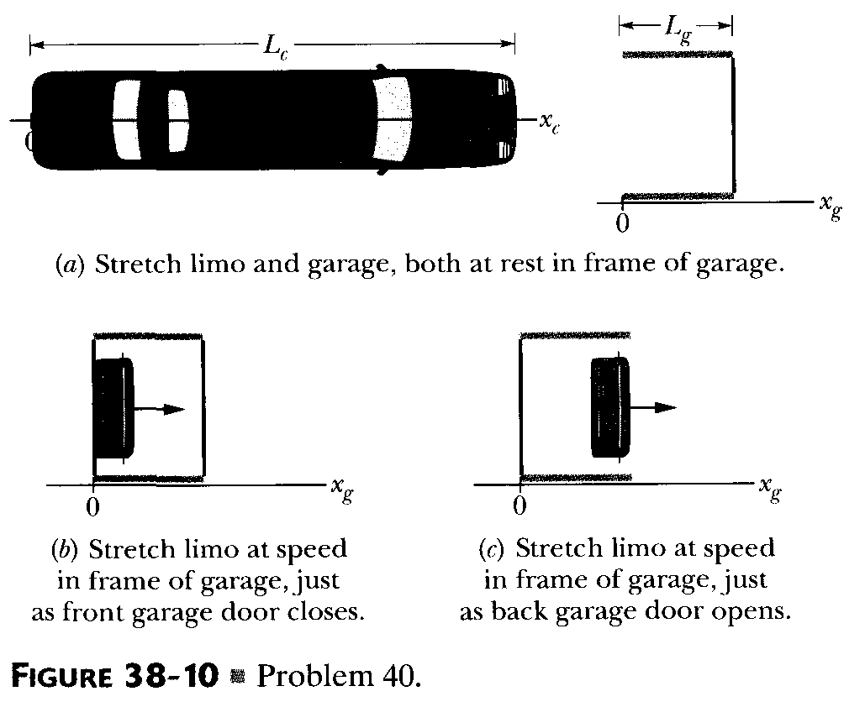

Solution
The limo, rest length 30 meters, must be contracted to 6/3 = 2 meters at speed. The required Lorentz contraction factor is therefore (using Eq. 38-28):
from which

SEC 38-13 RELETIVITY OF VELOCITIES

42. Separating Galaxies.
Galaxy A is measured to be receding from us on Earth with a speed of 0.3c. Galaxy B, located in precisely the opposite direction, is also receding from us at the same speed. What recessional velocity will an observer on galaxy A measure (a) for our galaxy, and (b) for galaxy B?

Solution
(a) The observer on Galaxy A will observe our galaxy to be receding with speed 0.3c.

(b) The formal analysis of this part is identical to that of problem 41. Choose the positive x direction as the direction of motion of Galaxy A, and its speed with respect to us is
v^{rel} = + 0.3c. We measure Galaxy B to be moving in the negative x direction with velocity u = – 0.3c. Then the final formula in the solution problem 41 is adapted to give the velocity of Galaxy B with respect to Galaxy A

44. Transit Time
An unpowered spaceship whose rest length 350 meters has a speed 0.82c with respect to Earth. A micrometeorite, also with speed of 0.82c with respect to Earth, passes spaceship on an antiparallel track that is moving in the opposite direction. How long does it take the micrometeorite to pass spaceship as measured on the ship?

Solution
Assume that with respect to the Earth frame the spaceship moves in the positive x direction and the micrometeorite moves in the negative x direction. Then we can solve this exercise the same way we solved problem 41. Substituting values from the present exercise into the second equation of the solution to problem 41, we have velocity of the rocket with respect to Earth = v^{rel} = 0.82c, velocity of micrometeorite with respect to Earth = u = – 0.82c. The result is:
Now we know that the micrometeorite is moving at a speed of 0.98c with respect to the spaceship in the spaceship rest frame. We know that the ship is 350 meters long in its rest frame, so that the time Δt’ it takes for the micrometeorite to pass in the spaceship frame is:

48. Receding Galaxy
Figure 38-11 shows a graph of intensity versus wavelength for light reaching Earth from galaxy NGC 7319, which is about 3 X l0 light-years away. The most intense light is emitted by the oxygen in that galaxy. In a laboratory, that emission is at wavelength A = 513 nm, but in the light from NGC 7319 it has been shifted to 525 nm due to the Doppler effect. (Indeed, all the emissions from that galaxy have been shifted.) (a) According to special relativity Doppler shift theory, what is the radial speed of galaxy NGC 7319 relative to Earth? (b) Is the relative motion to ward or away from Earth?

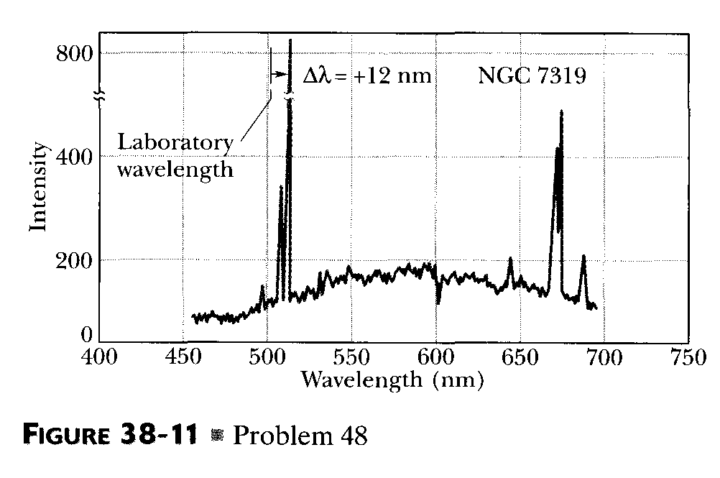

Solution
The wavelength is increased, so the frequency is decreased. This means that the galaxy is moving away from us (answer to part b).

(a) Because of the inverse relation f = c/ λ between frequency and wavelength, we can rewrite Equation 38-33 as:
Square both sides of this equation
Solve for v^{rel}/c:
This is the speed of recession of the galaxy, according to special relativity.

