TUTORIAL 2

Black Body, Photoelectricity, Compton Scattering, X-rays, Pair-production/annihilation

The total intensity I(T) radiated from a blackbody (at all wavelengths λ) is equal to the integral over all wavelengths. 0 < λ < ∞, of the Planck distribution . (a) By changing variables to x = hc/λkT, show that I(T) has the form I(T) = , where σ is a constant independent of temperature. This result is called Stefan’s fourth-power law, after the Austrian physicist Josef Stefan. (b) Given that =, show that the Stefan-Boltzmann Constant σ is . (c) Evaluate σ numerically, and find the total power radiated from a red-hot (T = 1000 K) steel hail of radius 1 cm. (Such a ball is well approximated as a blackbody.) (Taylor, Problem 4.4, pg. 141,)
Solution
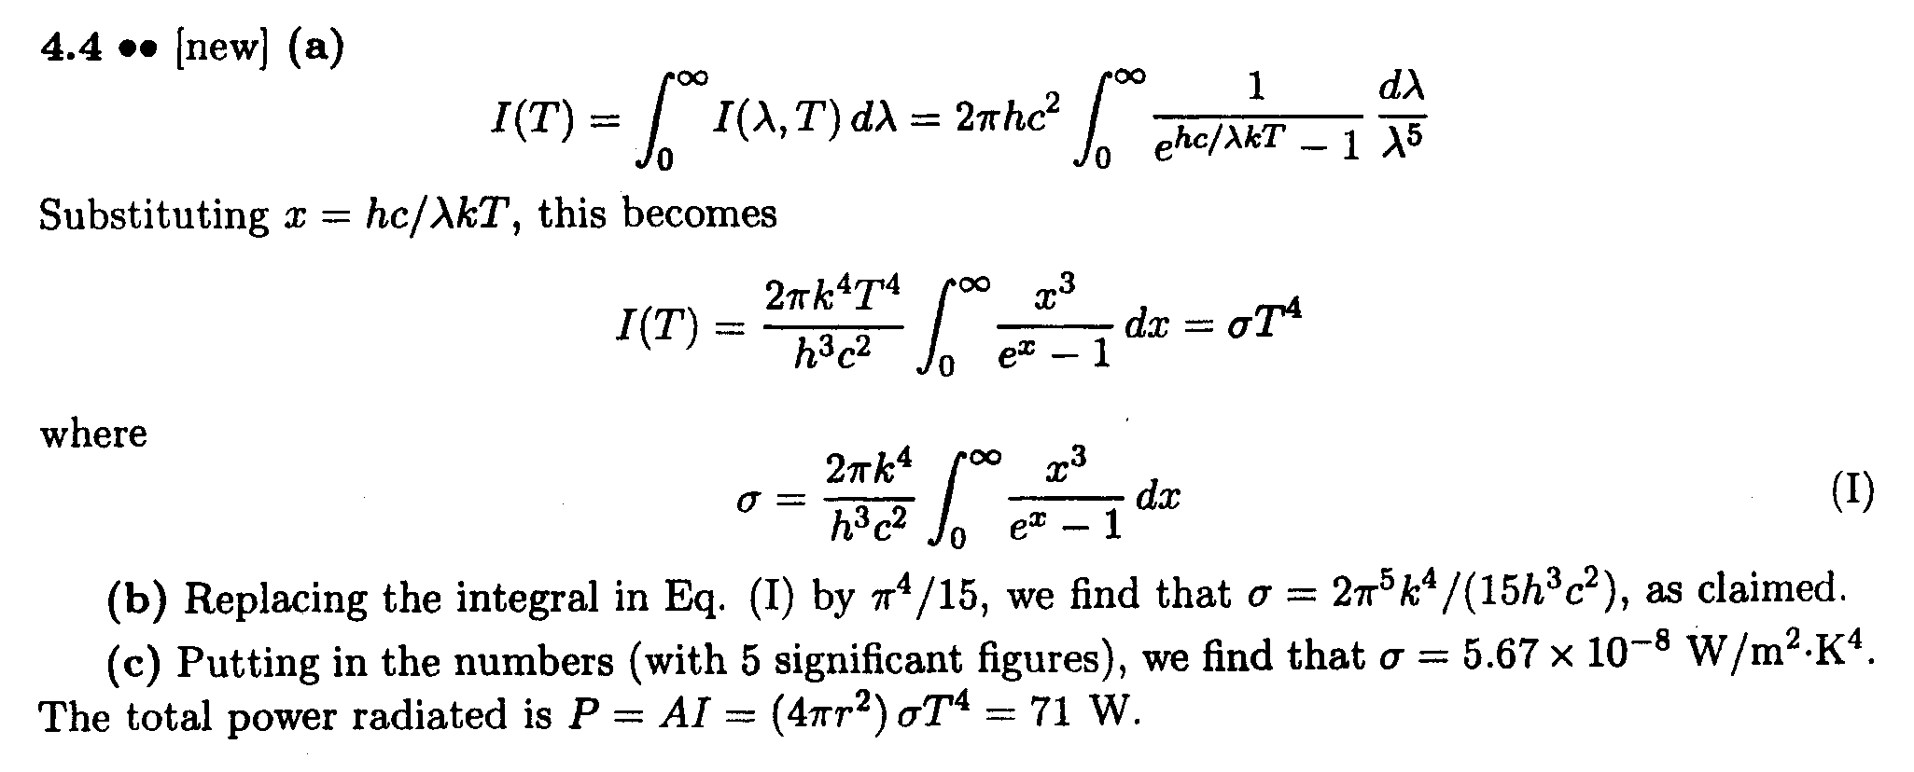

- If Planck constant were smaller than it is, would quantum phenomena be more or less conspicuous than they are now? (Beiser, Ex. 1, pg. 89)

Solution
Planck’s constant gives a measure of the energy at which quantum effects are observed. If Planck’s constant had a smaller value, while all other physical quantities, such as the speed of light, remained the same, quantum effects would be seen for phenomena that occur at higher frequncies or shorter wavelengths. That is, quantum phenomena would be less conspicuous than they are now.

- The diameter of an atomic nucleus is about m. Suppose you wanted to study the diffraction of photons by nuclei. What energy of photons would you choose? (Krane, Q.1, pg. 94)

Solution

- Electric current is charge flowing per unit time. If we increase the kinetic energy of the electron by increasing the energy of the photons, shouldn’t the current increase, because the charge flows more rapidly? Why doesn’t it? (Krane, Q.6, pg. 94)

Solution

- What would be the effects on a photoelectric effect if we were to double the frequency of the incident light? If we were to double the wavelength? If we were to double the intensity? (Krane, Q.7, pg. 94)

Solution

- The Compton-scattering formula suggests that objects viewed from different angles should reflect light of different wavelengths. Why don’t we observe a change in colour of objects as we change the viewing angle? (Krane, Q.16, pg. 95)

Solution

- You have a monoenergetic source of X-rays of energy 84 keV, but for an experiment you need 70 keV X-rays. How would you convert the X-ray energy from 84 to 70 keV? (Krane, Q.16, pg. 95)

Solution

- Show that a photon cannot transfer all of its energy to a free electron. (Hint: Note that energy and linear momentum must be conserved.) (Serway, Moses and Moyer, P27. pg. 103)

Solution
Conservation of energy yields (Equation A). Conservation of momentum yields . Using there results (Equation B). If the photon transfers all of its energy, and Equations A and B become and respectively. Note that in general, . Finally, substituting and into , yields (Equation C). As Equation C is true only if h, or f, or , or c is zero and all are non-zero this contradiction means that cannot equal zero and conserve both relativistic energy and momentum.

- The determination of Avogadro’s number with x—rays. X-rays. X-rays from a molybdenum (0.626 A) are incident on a NaCl crystal, which has the atomic arrangement shown in Figure below. If NaCl has a density of 2.17 g/cm³ and the n= 1 diffraction maximum from planes separated by d is found at θ = 6.41°, compute Avogadro’s number. (Hint: First determine d. Using Figure P3.39, determine the number of NaCl molecules per primitive cell and set the mass per unit volume of the primitive cell equal to the density. (Serway, Moses and Moyer, P39, pg./ 104)

Solution
The first x-ray intensity maximum in the diffraction pattern occurs at . To determine d use the Bragg diffraction condition for .
.
From the figure there are and ions per primitive cell. This works out to half a NaCl formula unit per primitive cell. The formula weight of NaCl is 58.4 g/mole. Setting the mass per unit volume of the primitive cell equal to the density we have where is the number of formula units per mole (Avogadro’s number). So

- Two light sources are used in a photoelectric experiment to determine the work function for a particular metal surface. When green light from a mercury lamp (λ= 546.1 nm) is used, a retarding potential of 1.70 V reduces the photocurrent to zero. (a) Based on this measurement, what is the work function for this metal? (b) What stopping potential would be observed when using the yellow light from a helium discharge tube (λ = 587.5 nm)? (Serway, Moses and Moyer. P42, pg 104)
Solution
(a)
(b)

- Monochromatic X rays are incident on a crystal in the geometry of Figure below. The first-order Bragg peak is observed when the angle of incidence is 34.0°. The crystal spacing is known to be 0.347 nm. (a) What is the wavelength of the X rays? (b) Now consider a set of crystal planes that makes an angle of 45° with the surface of the crystal (as in the Figure). For X rays of the same wavelength, find the angle of incidence measured from the surface of the crystal that produces the first-order Bragg peak. At what angle from the surface does the emerging beam appear in this case? (Krane, P3, pg 95)

Solution

- The universe is filled with thermal radiation, which has a bla at an effective temperature of 2.7 K. What is the peak wavelength of this radiation? What is the energy (in eV) of a quanta at the peak wavelength? In what region of the electromagnetic spectrum is this peak wavelength? (Krane. P 20, pg 96)
Solution

- Light from the sun arrives at the earth an average of 1.5×10¹¹ m away, at the rate of 1.4×10¹³ W/m of area perpendicular to the direction of the light. Assume that sunlight is monochromatic with a frequency of 5×10¹⁴ Hz. (a) How many photons fall per second on each square meter of Earth’s surface directly facing the sun? (b) What is the power output of the sun, and how many photons per second does it emit? (c) How many photons per cubic meter are there near the earth? (Beiser, Ex. 9, pg. 90)

Solution
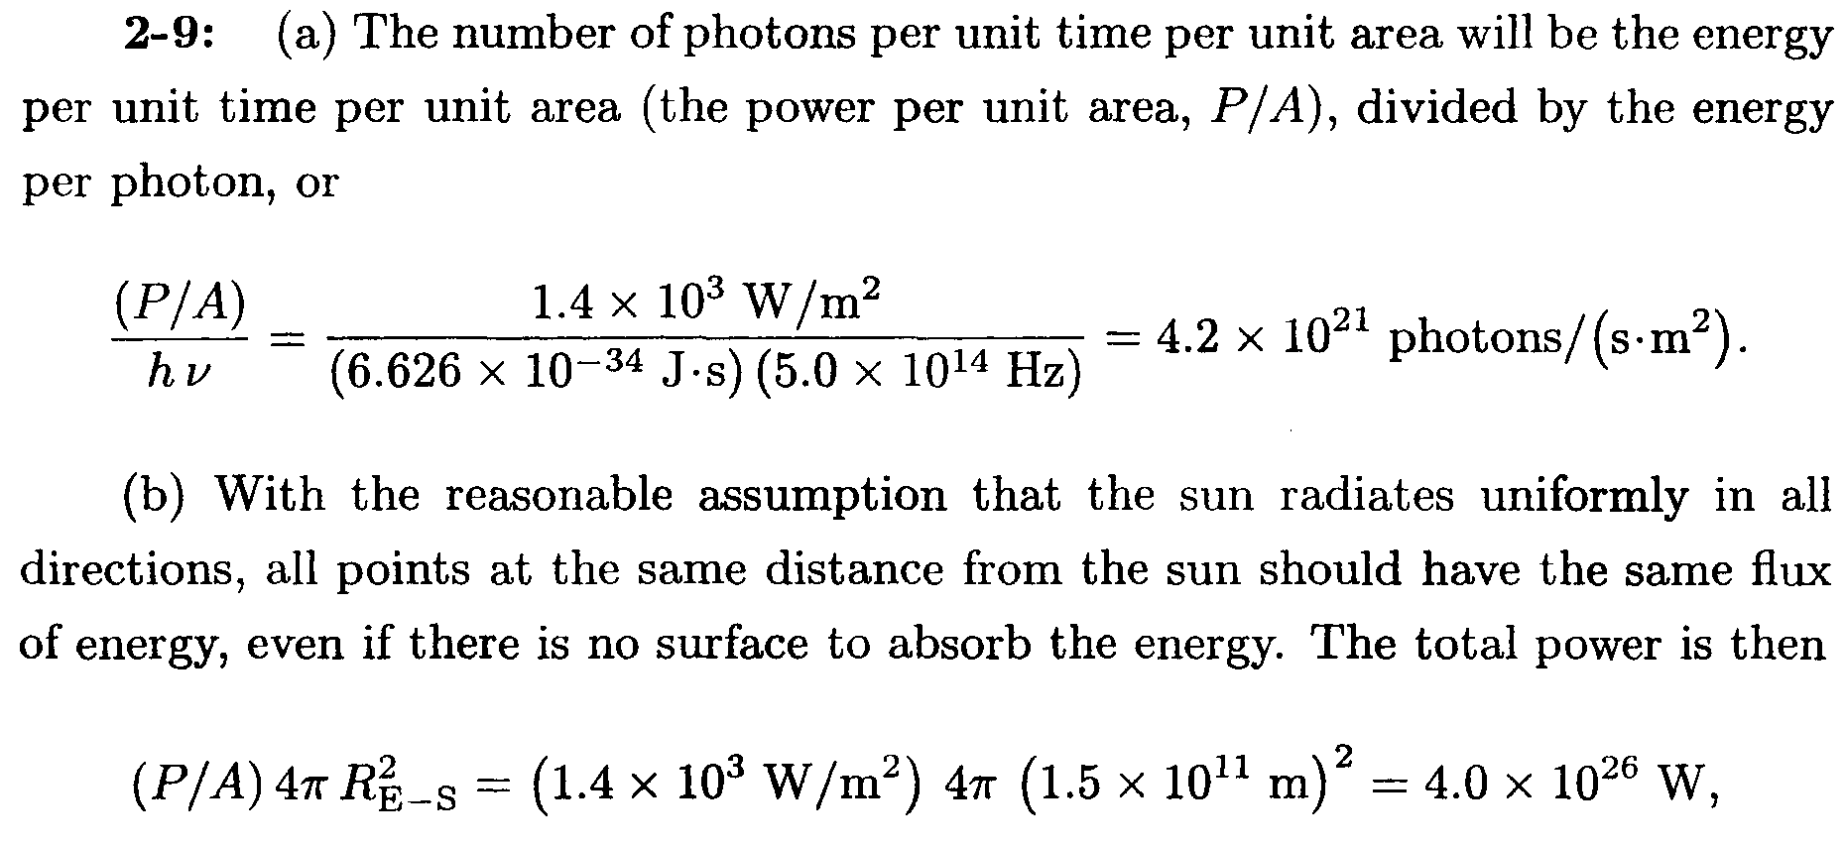

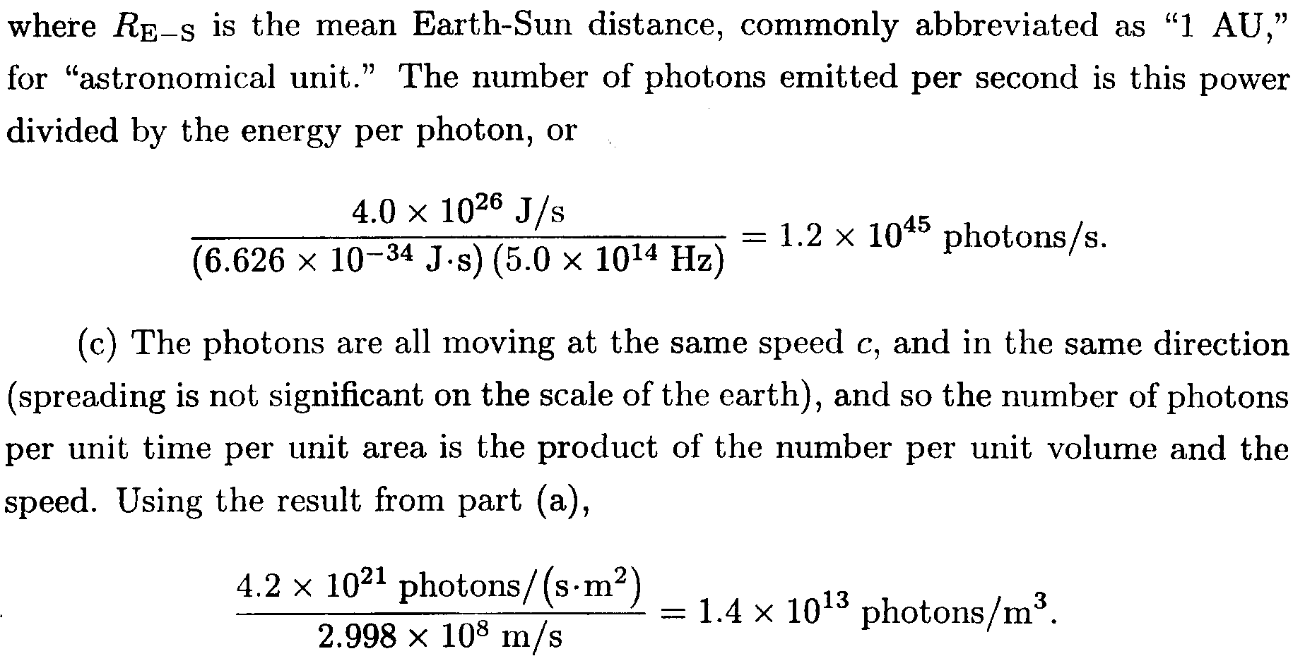

- 1.5 mW of 400-nm light is directed at a photoelectric cell. If 0.10 percent of the incident photons produce photoelectrons, find the current in the cell. (Beiser, Ex. 15, pg. 90)

Solution
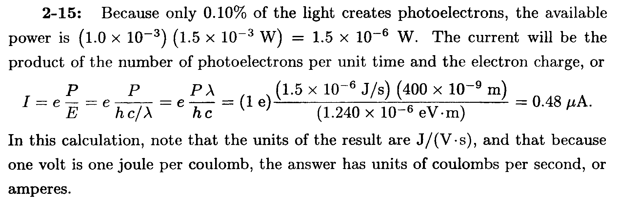

- (a) Find the change in wavelength of 80-pm x-rays that are scattered 120° by a target, (b) Find the angle between the directions of the recoil electron and the incident photon. (c) Find the energy of the recoil electron. (Beiser, Ex. 34, pg. 90)

Solution
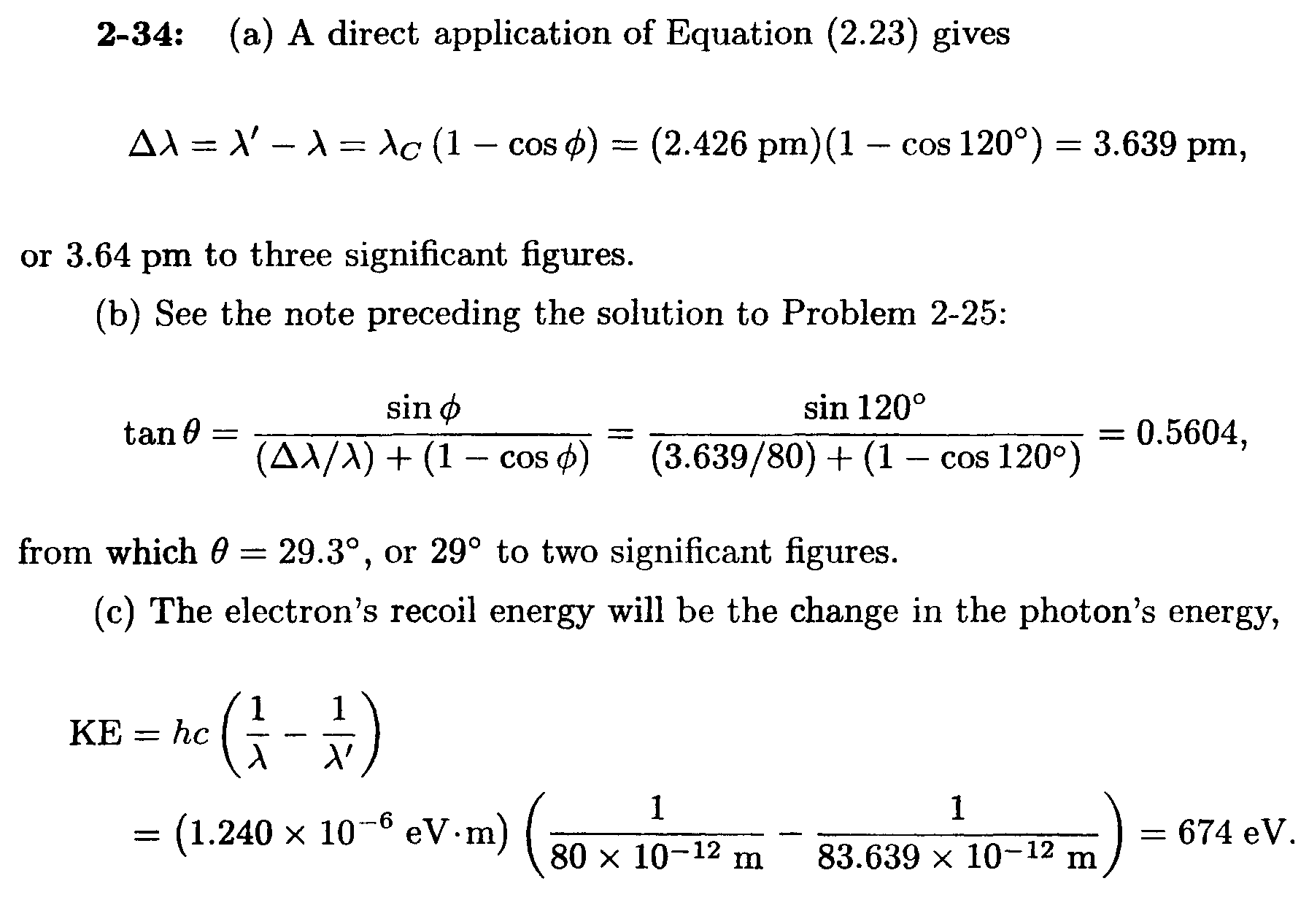

- A photon of frequency v is scattered by an electron initially at rest. Verify that the maximum kinetic energy of the recoil electron is KE_{max} = (2h²v²/mc²) / (1+ 2hv/mc²) (Beiser, Ex. 35, pg. 90)
Solution
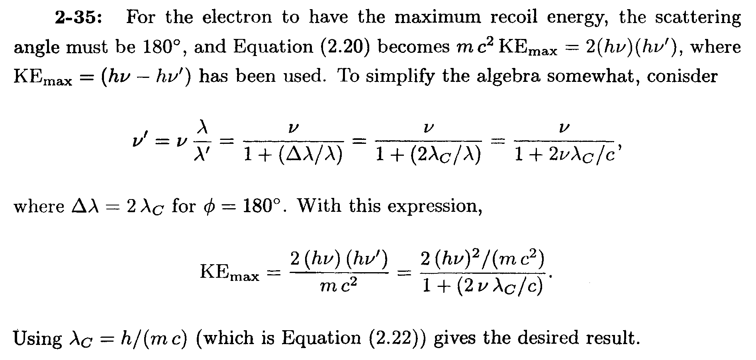

- Show that, regardless of its initial energy, a photon cannot undergo Compton scattering through an angle of more than 60° and still be able to produce an electron-positron pair. (Hint: Start by expressing the Compton wavelength of the electron in terms of the maximum photon wavelength needed for pair production.) (Beiser, Ex. 41, pg. 91)

Solution

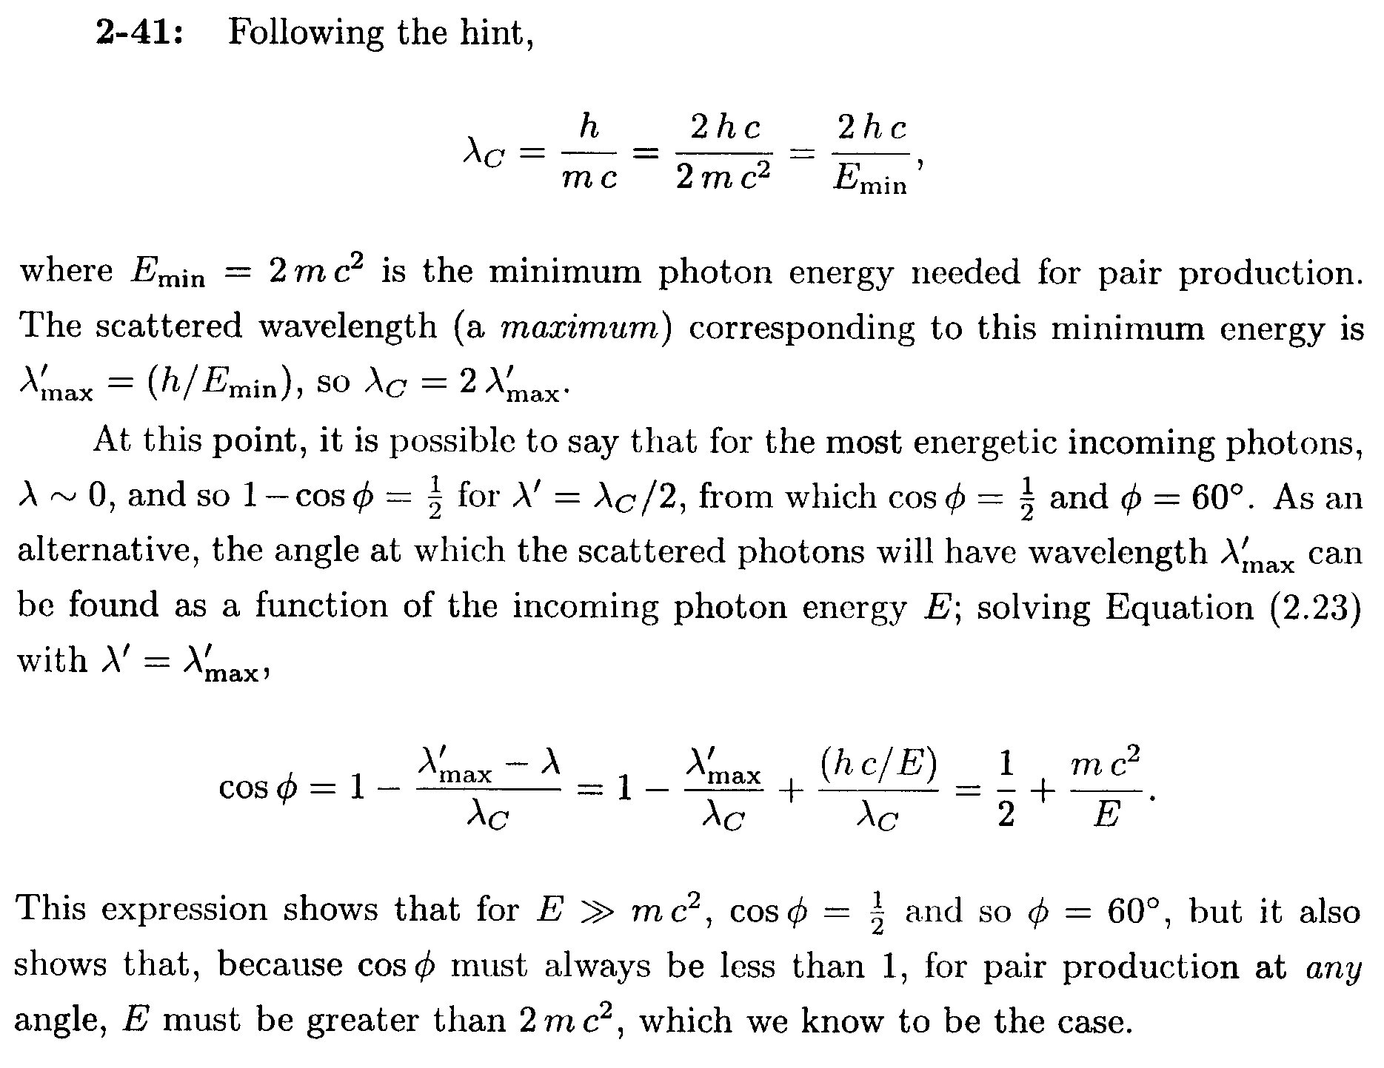

- (a) Verily that the minimum energy a photon must have to create an electron-positron pair in the presence of a stationary nucleus of mass M is 2mc²/(l + m/M), where m is the electron rest mass. (b) Find the minimum energy needed for pair production in the presence of a proton. (Beiser, Ex. 42, pg. 91)

Solution
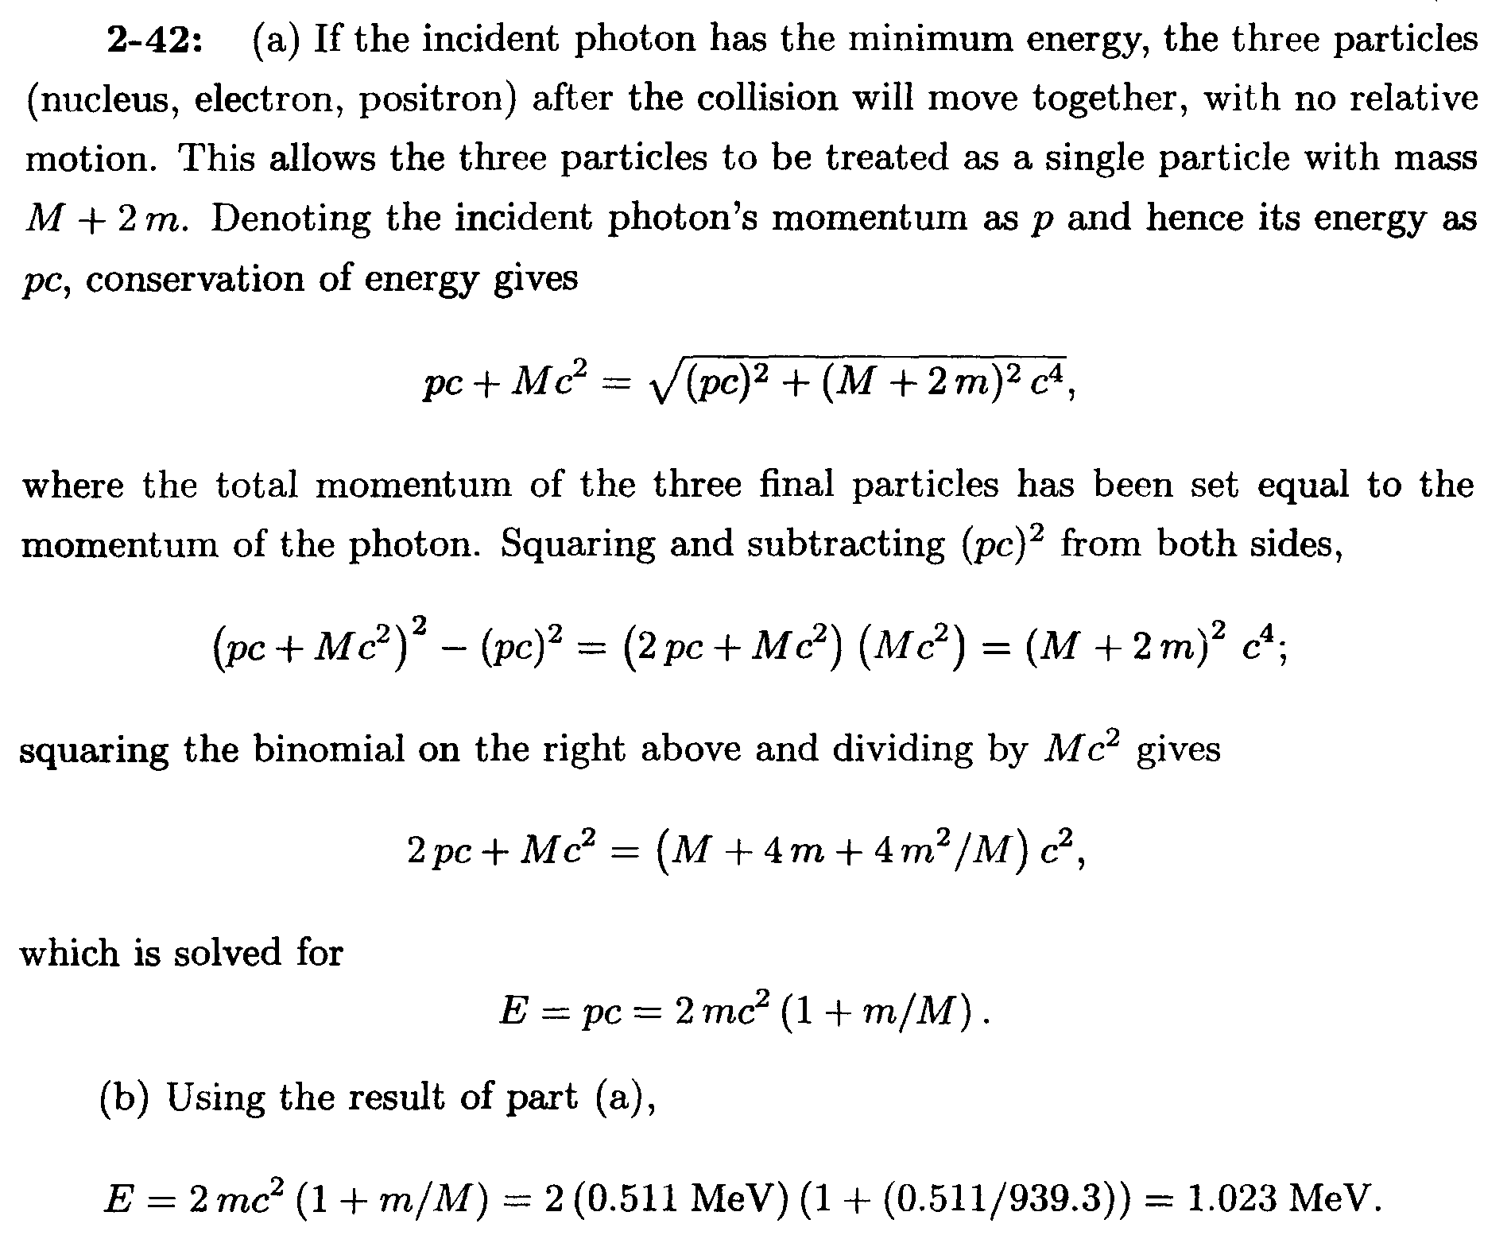

- Why is it in a pair annihilation the resultant photons cannot be singly produced?

Solution

It is the conservation of linear momentum that prohibits such a singly photon production after pair annihilation. Consider in a CM frame where the total linear momentum of the electron-positron pair is zero. If only a single photon is produced, then the total linear momentum in the CM frame after the annihilation will no more be zero. The linear momentum of a single photon shall not be cancelled off unless there is another photon being produced simultaneously (in an back-to-back manner) after the annihilation. Since such a process cannot happen in a CM frame it could also no happen in any other frame of reference due to postulate of Special Relativity.

