TUTORIAL 3
Wave properties of particles

Suppose we cover one slit in the two-slit experiment with a very thin sheet of fluorescent material that emits a photon of light whenever an electron passes through. We then fire electrons one at a time at the double slit; whether or not we see a flash of light tells us which slit the electron went through. What effect does this have on the interference pattern? Why? (Suggestion: Read Chap. 1, Feynman Lectures on Physics Vol. 3) (Krane, Q13, pg. 131,)
Solution

- The speed of an electron is measured to within an uncertainty of 2.0×10⁴ m/s. What is the size of the smallest region of space in which the electron can be confined? (Krane, P14, pg. 133)
Solution

- A pi meson (pion) and a proton can briefly join together to form a Δ particle. A measurement of the energy of the πp system (see Figure) shows a peak at 1236 MeV, corresponding to the rest energy of the Δ particle, with an experimental spread of 120 MeV. What is the lifetime of the Δ? (Krane, P17, pg. 133)
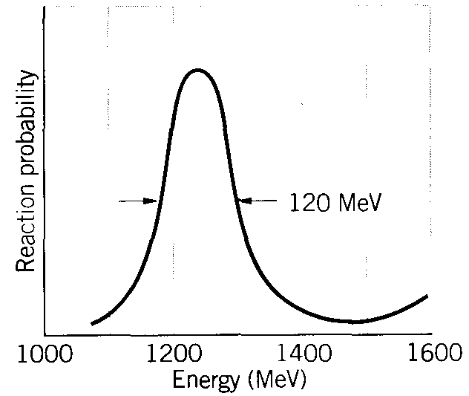

Solution

- A proton or a neutron can sometimes “violate” conservation of energy emitting and then reabsorbing a pi meson, which has a mass of 135 MeV/c². This is possible as long as the pi meson is reabsorbed within a short enough time Δt consistent with the uncertainty principle. (a) Consider pà p + π. By what amount ΔE is energy conservation violated? (ignore any kinetic energies.) (b) For how long a time Δt can the pi meson exist? (c) Assuming pi meson to travel at very nearly the speed of light, how far from the proton can it go? (This procedure gives us an estimate of the range of the nuclear force, because we believe that protons and neutron are held together in the nucleus by exchanging pi mesons.) (Krane, P22, pg. 133)
Solution

- Show that the formula for low-energy electron diffraction (LEED), when electrons are incident perpendicular to a crystal surface, may be written as , where n is the order of the maximum, d is the atomic spacing, m_{e} is the electron mass, K is the electron's kinetic energy, and φ is the angle between the incident and diffracted beams, (b) Calculate the atomic spacing in a crystal that has consecutive diffraction maxima at φ = 24.1° and φ = 54.9° for 100-eV electrons. (Serway, M & M, P 14, pg. 188)

Solution
(a) or
(b)
As we obtain the same spacing in both cases, must correspond to and to .

- A woman on a ladder drops small pellets toward a spot on the floor, (a) Show that, according to the uncertainty principle, the miss distance must be at least , where H is the initial height of each pellet above the floor and m is the mass of each pellet, (b) If H = 2.0 m and m = 0.50 g, what is Δx? (Serway & M & M, P 21, pg. 188)

Solution
(a) The woman tries to hold a pellet within some horizontal region and directly above the spot on the floor. The uncertainty principle requires her to give a pellet some x velocity at least as large as . When the pellet hits the floor at time t, the total miss distance is . The minimum value of the function occurs for or .

We find .

(b) For , , .

- An excited nucleus with a lifetime of 0.100 ns emits a γ ray of energy 2.00 MeV. Can the energy width (uncertainty in energy, ΔE) of this 2.00-MeV γ emission line be directly measured if the best gamma detectors can measure energies to ±5 eV? (Serway & M & M, P 25, pg. 188)

Solution
To find the energy width of the -ray use or
.
As the intrinsic energy width of is so much less than the experimental resolution of , the intrinsic width can’t be measured using this method.

- Find the de Broglie wavelength of a 1.00-MeV proton. Is a relativistic calculation needed? (Beiser, Ex. 6, pg. 117)

Solution
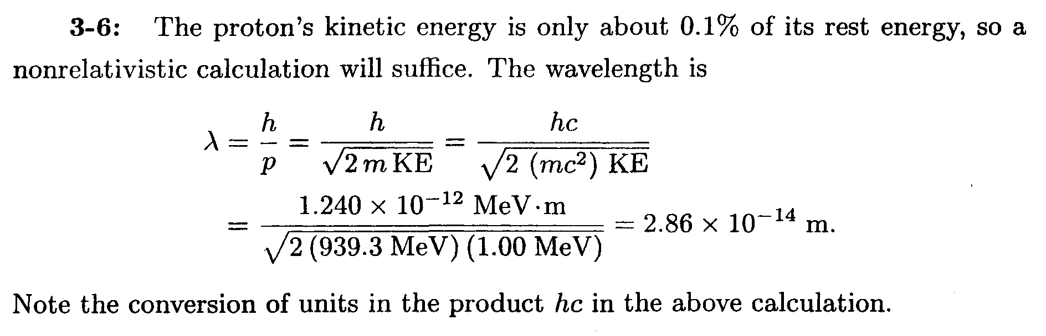

- Show that the de Broglie wavelength of a particle of mass m and kinetic energy KE is given by (Beiser, Ex. 10, pg. 117)
Solution
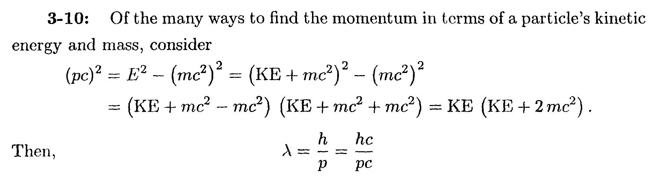

- What effect on the scattering angle in the Davisson-Germer experiment does increasing the electron energy have? (Beiser, Ex. 23, pg. 117)
Solution
Increasing the electron energy increases the electron’s momentum, and hence decrease the electron’s de Broglie wavelength. A smaller dB wavelength results in a smaller scattering angle.

- A beam of 50-keV electrons is directed at a crystal and diffracted electrons are found at an angle of 50° relative to the original beam. What is the spacing of the atomic planes of the crystal? A relativistic calculation is needed for λ. (Beiser, Ex. 26, pg. 117)
Solution
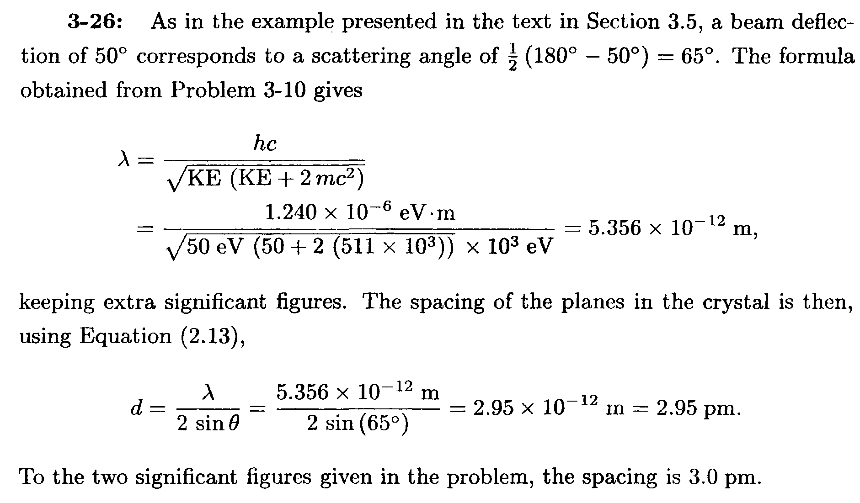

- The lowest energy possible for a certain particle trapped in a certain box is 1.00 eV. (a) What are the next two higher energies the particle can have? (b) If the particle is an electron, how wide is the box? (Beiser, Ex. 29, pg. 118)
Solution
(a) The energies of the stationary states are given by , E_{n} is proportional to n². Hence, (1.00 eV). The first and second excited state corresponds to n = 2 and n = 3.
eV; eV;
(b) Solving for L, the width of the box is
. Let n = 2,

- Discuss the prohibition of E = 0 for a particle trapped in a box L wide in terms of the uncertainty principle. How does the minimum momentum of such a particle compare with the momentum uncertainty required by the uncertainty principle if we take Δx = L? (Beiser, Ex. 30, pg. 118)
Solution
For a “trapped” particle, the uncertainty in position cannot be larger than the size of the box, and so the uncertainty in the particle’s momentum must be finite, and the particle cannot have zero kinetic energy. If Δx = L, the uncertainty principle as given in states that. The magnitude of the momentum of the particle in the lowest energy state for a particle in a box of width L is, from . Thus, p₁ is greater than the minimum value of Δp.

- How much time is needed to measure the kinetic energy of an electron whose speed is 10.0 m/s with an uncertainty of no more than 0.100 percent? How far will the electron have travelled in this period of time? (b) Make the same calculations for a 1.00-g insect whose speed is the same. What do these sets of figures indicate? (Beiser, Ex. 34, pg. 118)
Solution
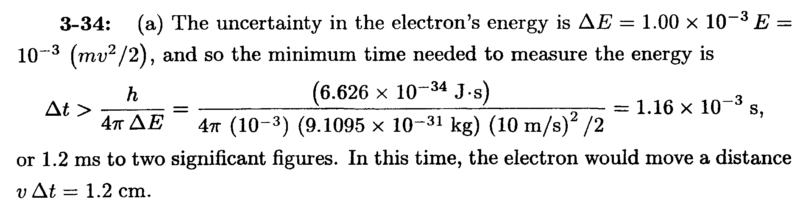

(b) ΔE= 10⁻³E= 10⁻³(mv²/2); Δt > h/4πΔE = 10³h/(2πmv²) = 9.5 x 10⁻²⁹ s. Distance moved is
vΔt = 9.5 x 10⁻²⁸ m.

- How accurately can the position of a proton with v << c. be determined without giving it more than 1.00 keV of kinetic energy? (Beiser, Ex. 35, pg. 118)

Solution
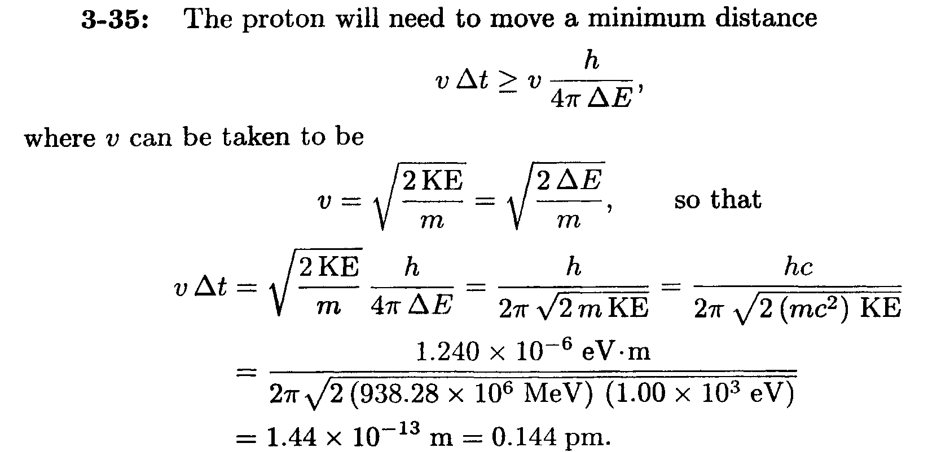
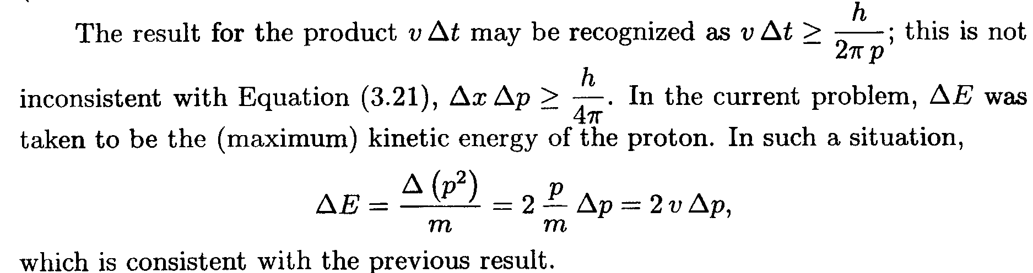

- (a) Find the magnitude of the momentum of a particle in a box in its nth state. (b) The minimum change in the particles momentum that a measurement can cause corresponds to a change of ±1 in the quantum number n. If Δx = L. show that Δp Δx. (Beiser, Ex. 36, pg. 118)
Solution
K.E
