TUTORIAL 4
Atomic models

- How is the quantization of the energy in the hydrogen atom similar to the quantization of the systems discussed in the 1-D infinite quantum well? How is it different? Do the quantizations originate from similar causes? (Krane, Q8, pg. 201)
Solution

- In both the Rutherford theory and the Bohr theory, we used the classical expression for the kinetic energy. Estimate the velocity of an electron in the Bohr atom and of an alpha particle in a typical scattering experiment, and decide if the use of the classical formula is justified. (Krane, Q14, pg. 201)
Solution

- The lifetimes of the levels in a hydrogen atom are of the order of 10⁻⁸ s. Find the energy uncertainty of the first excited state and compare it with the energy of the state. (Krane, P29, pg. 204)
Solution

- A long time ago, in a galaxy far, far away, electric charge had not yet been invented, and atoms were held together by gravitational forces. Compute the Bohr radius and the n=2 to n = 1 transition energy in a gravitationally hound hydrogen atom. (Krane, P33, pg. 204)
Solution

- The fine structure constant is defined as α = e²/2ε_{o}hc. This quantity got its name because it first appeared in a theory by the German physicist Arnold Sommerfeld that tried to explain the line structure in spectral lines (multiple lines close together instead of single lines) by assuming that elliptical as well as circular orbits are possible in the Bohr model. Sommerfeld’s approach was on the wrong track, but α has nevertheless turned out to be a useful quantity in atomic physics, (a) Show that α = v₁/c, where v₁ is the velocity of the electron in the ground state of the Bohr atom, (b) Show that the value of α is very close to 1/137 and is a pure number with no dimensions. Because the magnetic behavior of a moving charge depends on its velocity, the small value of α is representative of the relative magnitudes of the magnetic and electric aspects of electron behavior in an atom (c) Show that α a₀ = λ_{c} / 2π, where a₀ is the radius of the ground-state Bohr orbit and λ_{c} is the Compton wavelength of the electron. (Beiser Ex. 9, pg. 158)

Solution
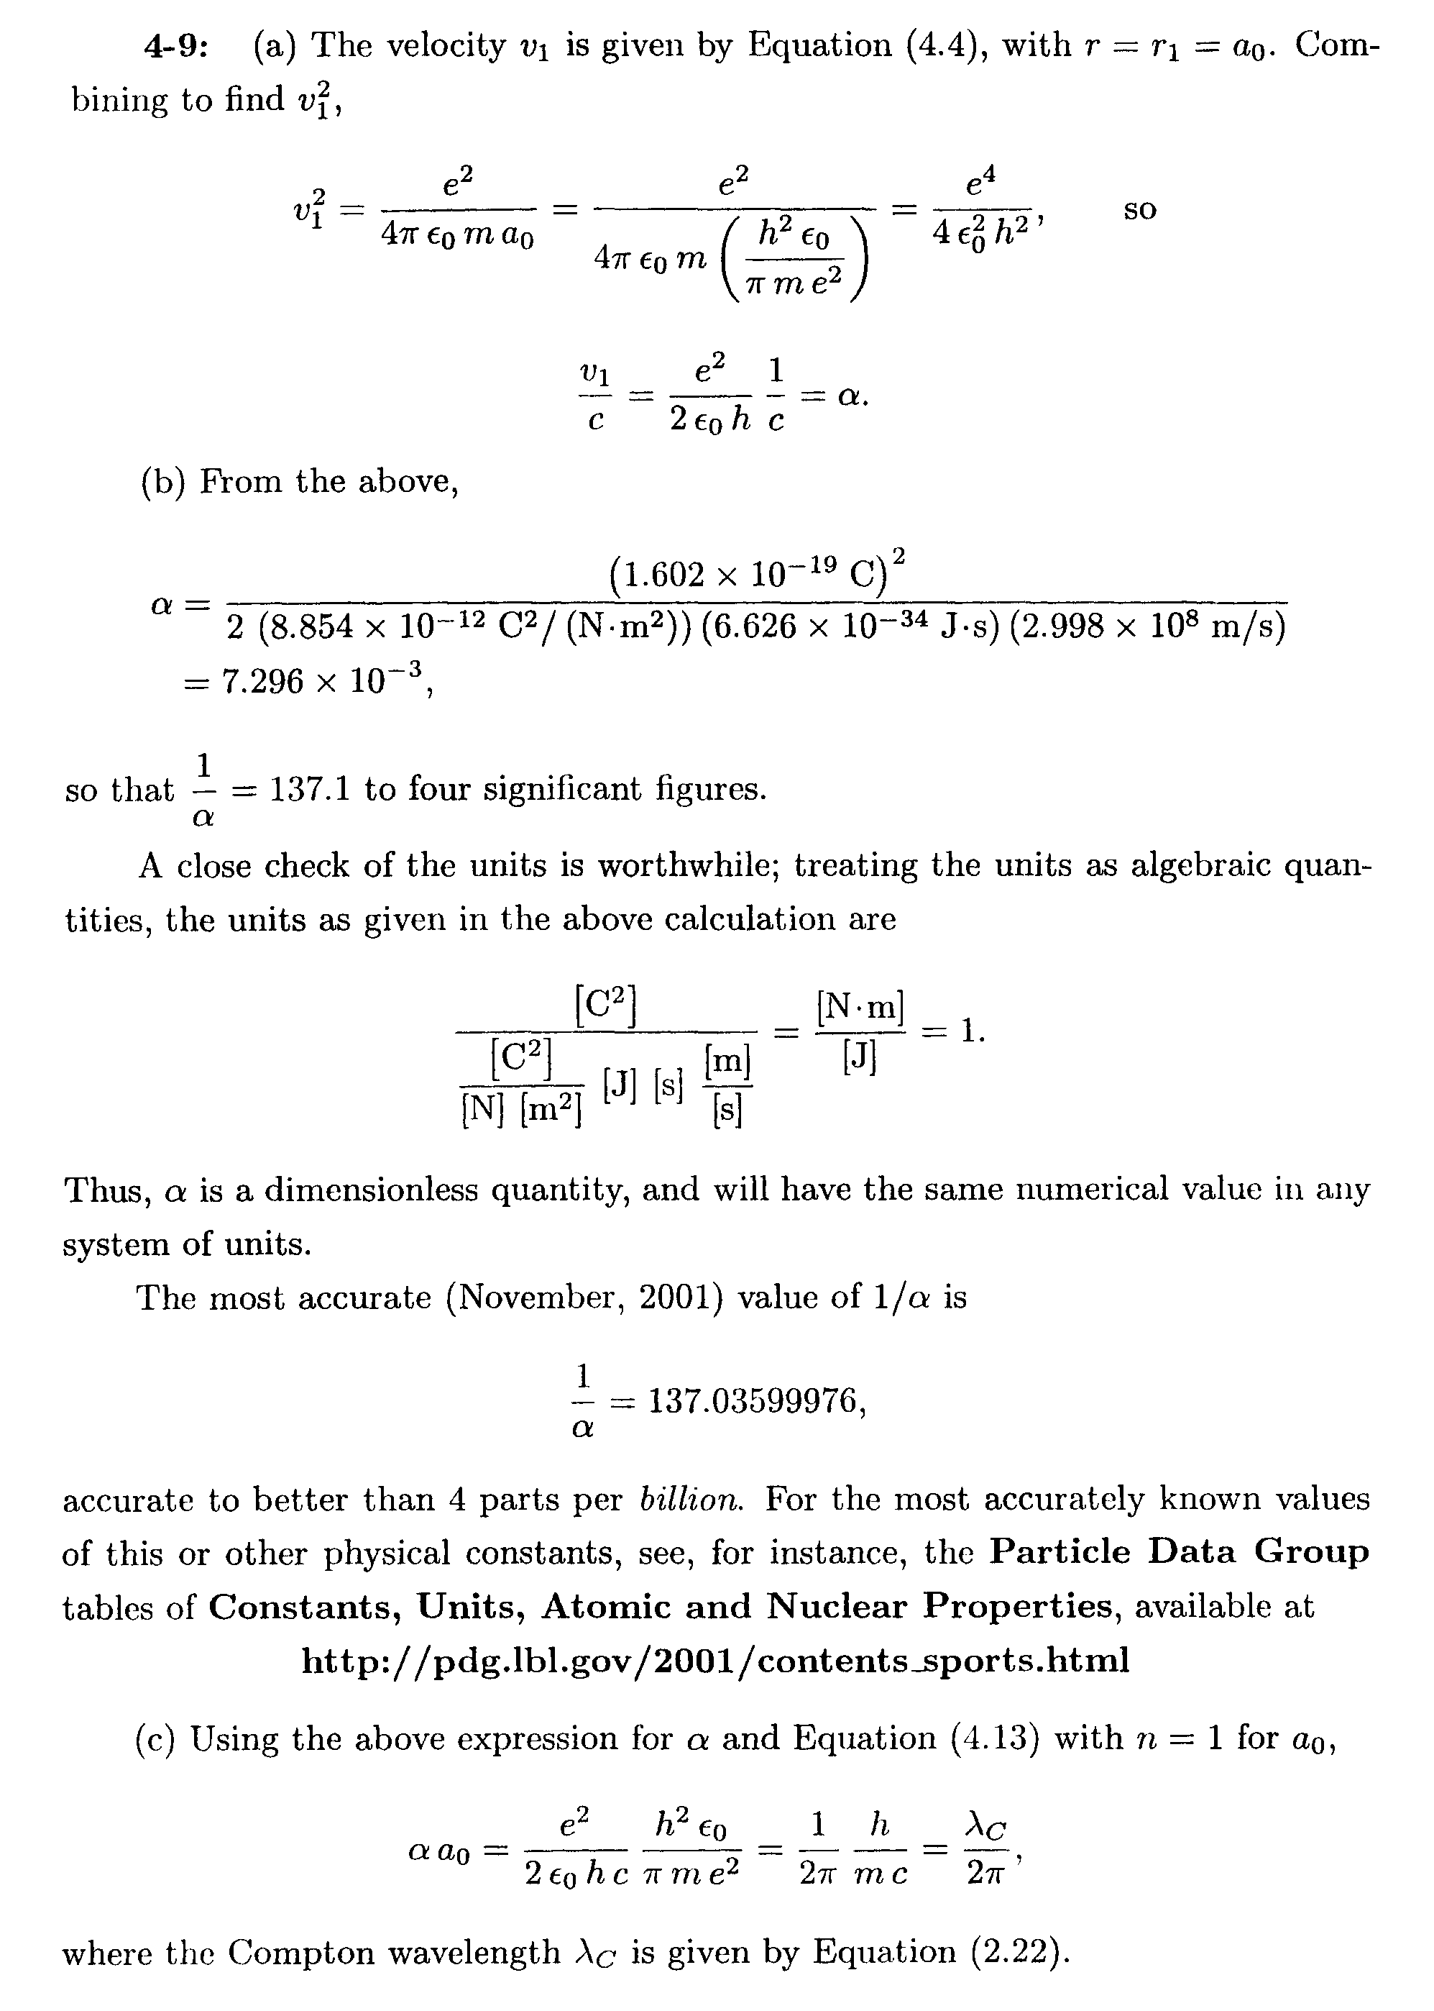
- Show that the energy of the photon emitted when a hydrogen atom makes a transition from state n to state n - 1 is, when n is very large, ΔE α²(mc²/n³) where α is the fine structure constant. (Krane, P38, pg. 205)
Solution

- Can the electron in the ground state of the hydrogen atom absorb a photon of energy (a) less than 13.6 eV and (b) greater than 13.6 eV? (c) What is the minimum photon energy that can be absorbed by the ground state of the hydrogen atom? (Serway, M & M, Q3, pg. 145)
Solution
(a) Yes (b) No (c) 13.6 eV×(1/1² - 1/2²) = 13.6 eV× (3/4) = 10.2 eV

- Four possible transitions for a hydrogen atom are listed here.
(A) n_{i} = 2; n_{f} = 5 (B) n_{i} = 5; n_{f} = 3 (C) n_{i} = 7; n_{f} = 4 (D) n_{i} = 4; n_{f} = 7
(a) Which transition emits the photons having the shortest wavelength?
(b) For which transition does the atom gain the most energy? (c) For which transition(s; does the atom lose energy? (Serway, M & M. Q11, pg. 145)
Solution

- An electron initially in the n = 3 state of a one-electron atom of mass M at rest undergoes a transition to the n = 1 ground state. (a) Show that tile recoil speed of the atom from emission of a photon is given approximately by v=8hR/9M. (b) Calculate the percent of the 3 → 1 transition energy that is carried off by the recoiling atom if the atom is deuterium. (Serway, M & M. Q29, pg. 148)
Solution
(a) Both momentum and energy must be conserved. Momentum: , energy: where M is the atom’s mass, v is its recoil velocity, is the photon’s energy and E is the energy difference between the and states. Combining equations, and using the quadratic formula,
.
For , or , the second of which is non physical. Thus in general, . For the to transition in particular,
,
so .

(b)

- The Auger process. An electron in chromium makes a transition from the n = 2 state to the n = 1 state with out emitting a photon. Instead, the excess energy is transferred to an outer electron (in the n = 4 state), which is ejected by the atom. (This is called an Auger process, and the ejected electron is referred to as an Auger electron.) Use the Bohr theory to find the kinetic energy of the Auger electron. (Serway, M & M. Q28, pg. 148)
Solution
Call the energy available from the to transition :
.
The kinetic energy K of the Auger electron is equal to 5.875 keV minus the energy required to ionize an electron in the state, . Thus,
.

- In a hot star, a multiply ionized atom with a single remaining electron produces a series of spectral lines as described by the Bohr model. The series corresponds to electronic transitions that terminate in the same final state. The longest and shortest wavelengths of the series are 63.3 nm and 22.8 nm, respectively. (a) What is the ion? (b) Find the wave lengths of the next three spectral lines nearest to the line of longest wavelength. (Serway, M & M. Q44, pg. 150)
Solution
(a) . The shortest wavelength, , corresponds to , and the longest wavelength, , to .
(1)
(2)
Divide (1) and (2): , , . From (1): . Hence the ion is .

(b) , . Setting gives , 33.8 nm, 30.4 nm

- Find the frequency of revolution of the electron in the classical model of the hydrogen atom. In what region of the spectrum are electromagnetic waves of this frequency? (Beiser, Ex. 4, pg. 157)
Solution
For a classical particle attracted by the inverse-square Coulomb field, or . With r = a₀ = 0.5A the Bohr radius. ω = 4.13×10¹⁶ rad/s, f = ω/2π=6.6×10¹⁵ Hz, in ultraviolet part of the spectrum. What is the shortest wavelength present in the Bracken series of spectral lines? (Beiser, Ex.5, pg. 158)
Solution
The wavelengths in the Brackett series are given by, or ; the shortest wavelength (highest energy) corresponds to the largest value of n_{i}. For n→∞,
- What is the shortest wavelength present in the Bracken series of spectral lines? (Beiser, Ex.5, pg. 158)
Solution
The wavelengths in the Brackett series are given by, or ; the shortest wavelength (highest energy) corresponds to the largest value of n_{i}. For n→∞,

- A beam of 13.0-eV electrons is used to bombard gaseous hydrogen. What series of wavelengths will be emitted? (Beiser Ex. 16, pg. 158)

Solution
In terms of the ionization energy of 13.6 eV,
,
Thus, electrons may be excited to the n = 4 level but no higher. (Atoms that had electrons that were originally in higher orbits would be ionized.) The spectral series would be those with final states corresponding to n < 4; the Lyman, Balmer and Paschen series.

- The longest wavelength in the Lyman series is 121.5 nm and the shortest wavelength in the Balmer series is 364.6 nm. Use the figures to find the longest wavelength of light that could
ionize hydrogen. (Beiser, Ex. 23, pg. 158)

Solution
The energy needed to ionize hydrogen will be the energy needed to raise the energy from the ground state to the first excited state plus the energy needed to ionize an atom in the second excited state; these are the energies that correspond to the longest wavelength (least energetic photon) in the Lyman series and the shortest wavelength (most energetic photon) in the Balmer series. The energies are proportional to the reciprocals of the wavelengths, and so the wavelength of the photon needed to ionize hydrogen is

As a check, note that this wavelength is R⁻¹.

- When an excited atom emits a photon, the linear momentum of the photon must be balanced by the recoil momentum of the atom. As a result, some of the excitation energy of the atom goes into the kinetic energy of its recoil. (a) Modify E_{i} – E_{f} = hν to include this effect, (b) Find the ratio between the recoil energy and the photon energy for the n = 3 → n→ 2transition in hydrogen, for which E_{f} – E_{i} = 1.9 eV. Is the effect a major one? A nonrelativistic calculation is sufficient here. (Beiser, Ex. 27, pg. 158)

Solution
  - A relativistic calculation would necessarily involve the change in mass of the atom due to the change in energy of the system. rfhe fact that this mass change is too small to measure (that is, the change is measured indirectly by measuring the energies of the emitted photons) means that a nonrelativistic calculation should suffice. In this situation, the kinetic energy of the recoiling atom is
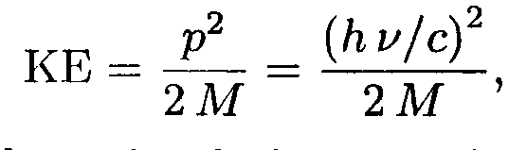
where ν is the frequency of the emitted photon and p = hν/c = hc/λ = is the magnitude of the momentum of both the photon and the recoiling atom. Then the photon energy is
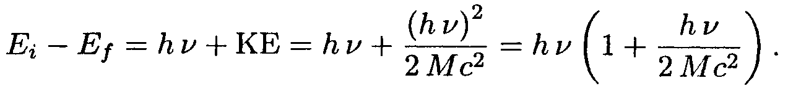
A relativistic calculation is managable; the result would be
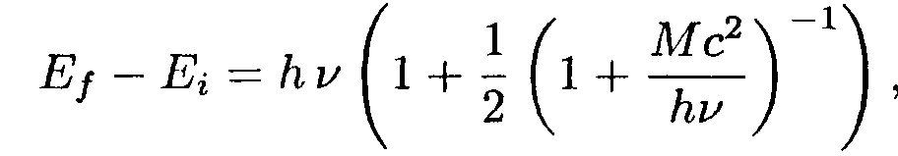
a form not often useful; see part (b).
(b) As indicated above and in the problem statement, a nonrelativistic calculation is sufficient. As in part (a),
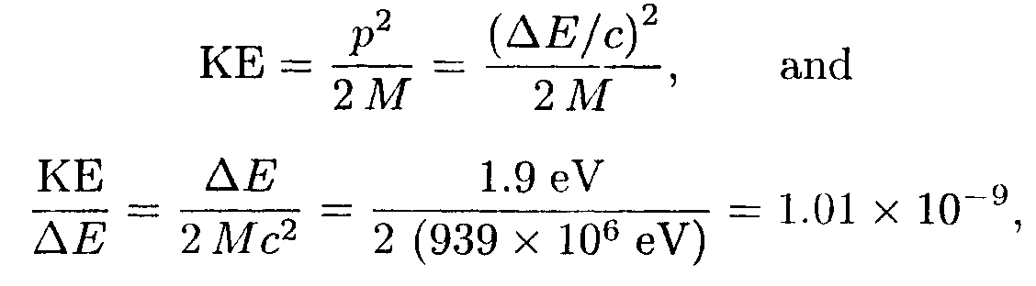
or 1.0 x 10⁻⁹ to two significant figures. In the above, the rest energy of the hydrogen atom M is taken to be the same as the mass of proton, about 939 MeV.

