TUTORIAL 5
Introductory Quantum Mechanics

- Which of the following wave functions cannot be solutions of Schrodinger's equation for all values of x? Why not? (a) ψ = A sec x; (b) ψ = A tan x; (c) ψ = A; (d) ψ = A(Beiser, Ex. 3, pg. 197)

Solution
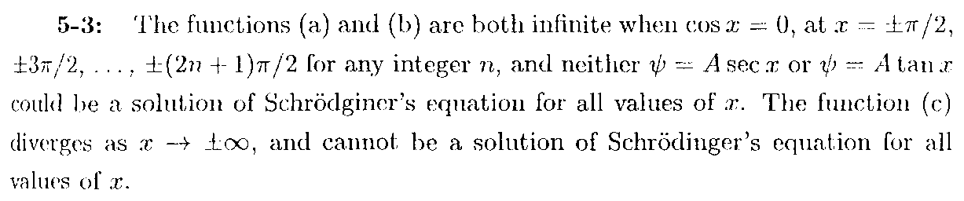
Only (d) is could be a solution as it contains no divergence. It also →0 when x→ ±∞.

- The wave function of a certain particle is ψ =A cos²x for π/2 <x <π/2. (a) Find the value of A. (b) Find the probability that the panicle be found between x = 0 and x = π/4 (Beiser, Ex. 5, pg. 197)

Solution
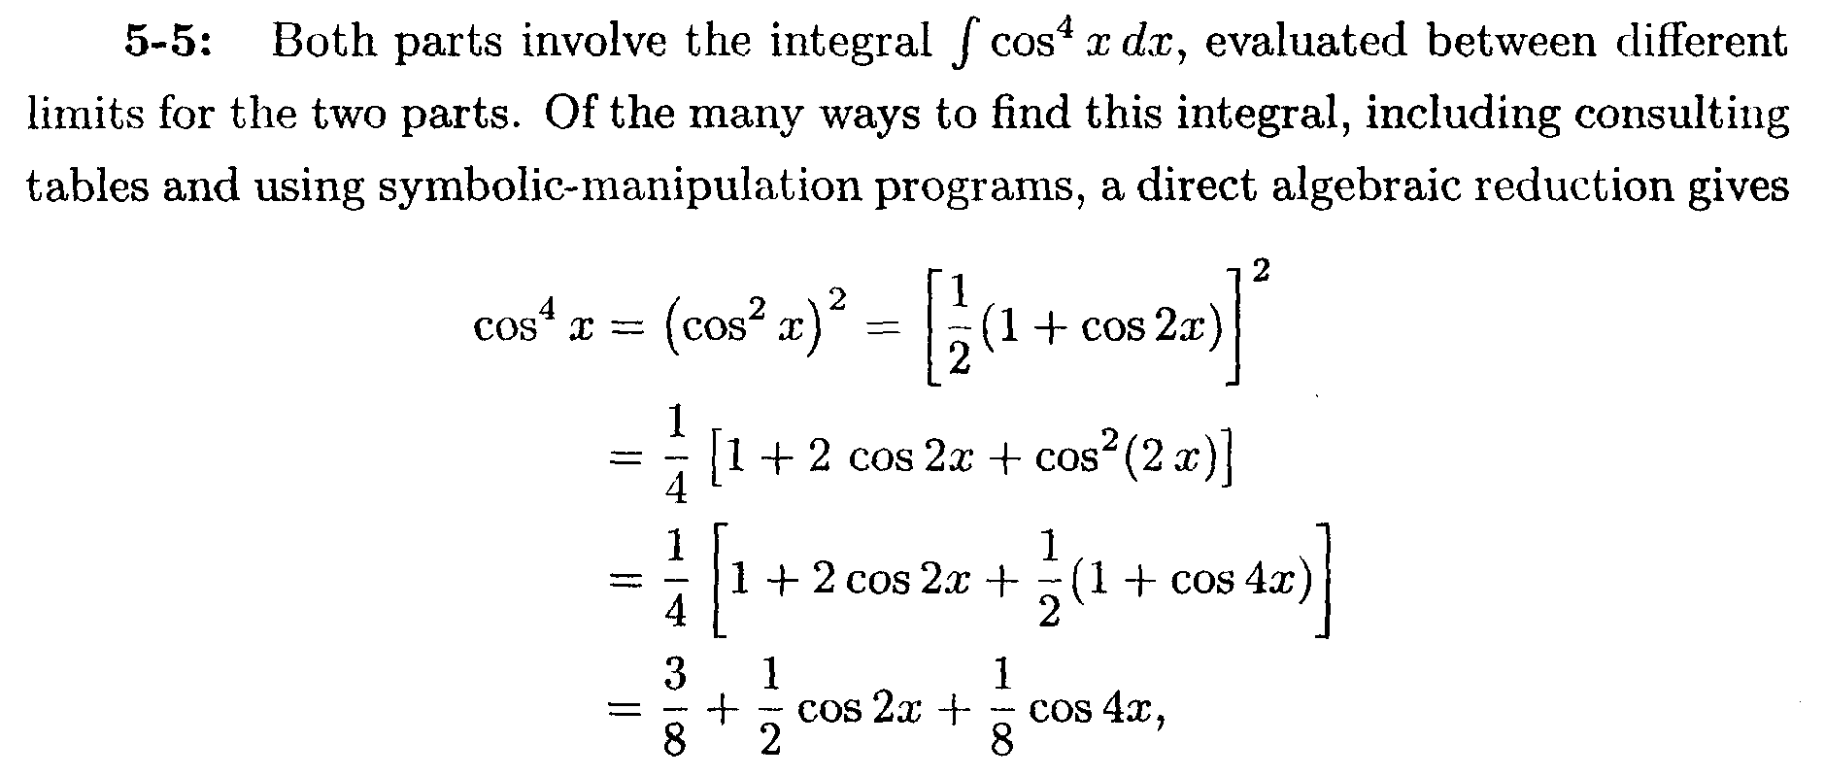

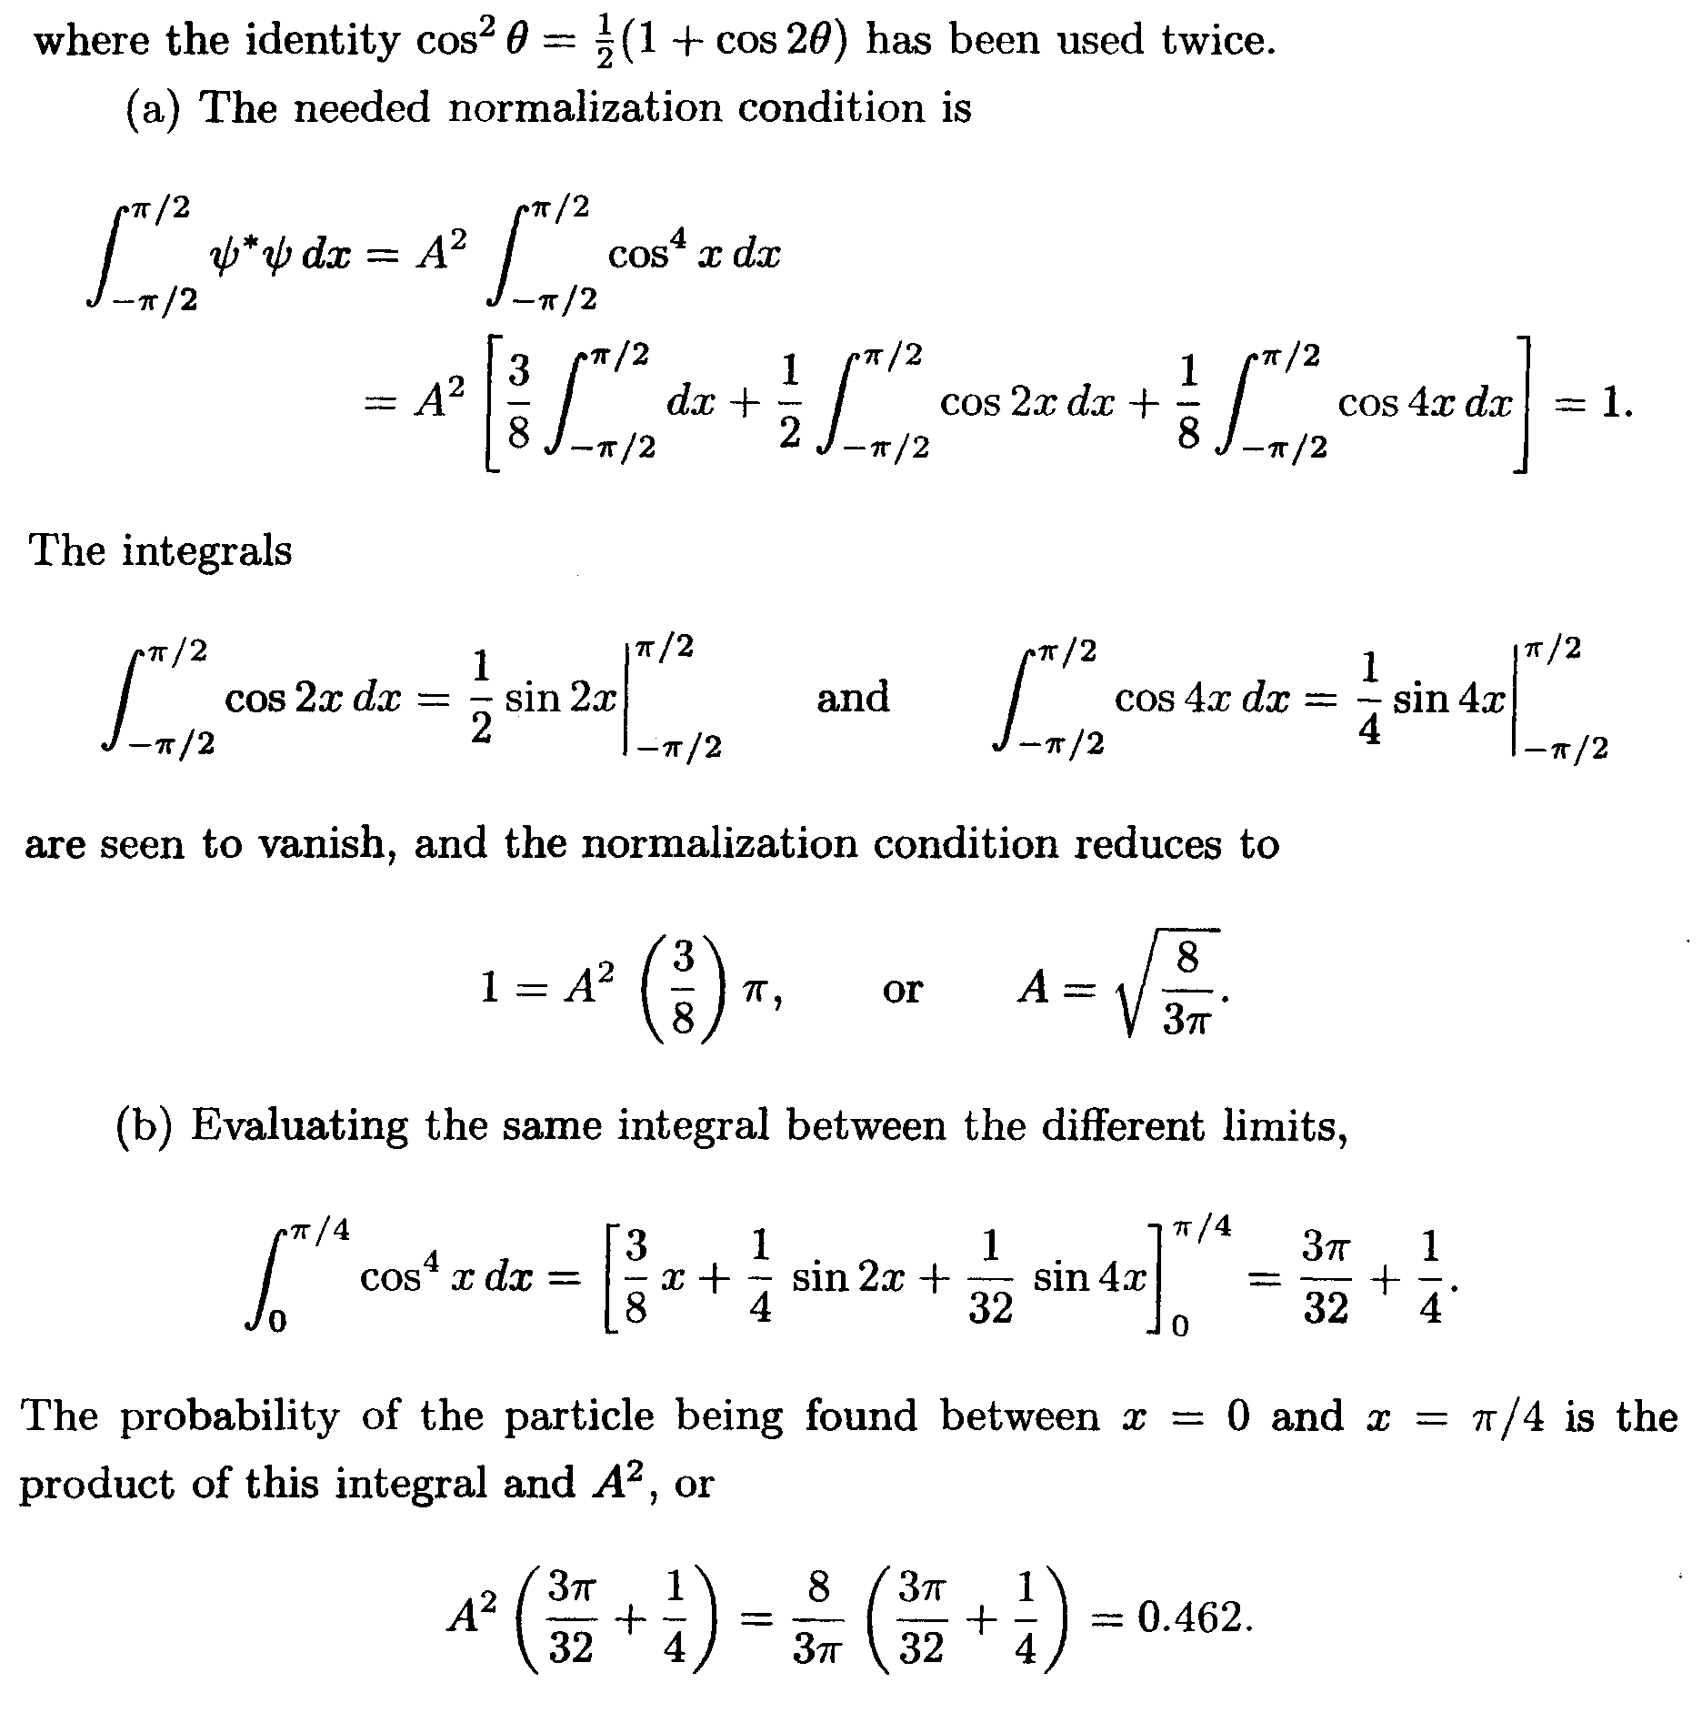

- The expectation value of a particle trapped in a box a wide is a/2 (0≤x≤a), which means that its average position is the middle of the box. Find the expectation value in the stationary state n. What is the behaviour of as n becomes infinity. Is this consistent with classical physics? (Beiser, Ex. 17, pg. 198)
Solution
The solution of the ground state wave function for a particle in an infinite box is.
, where we have used the substitution
. Using integration by parts,
.
As n→infinity, , which is the expectation value of in the classical limit, for which the probability distribution is independent of position in the box, and n-independent.

- Find the probability that a particle in a box L wide can be found between x = 0 and x = L/n when it is in the nth state. (Beiser, Ex. 19, pg. 198)

Solution
The probability density is given by, where the wave function of a particle in a box is
The probability to find the particle between x₂ and x₁ within the box is
. Here, set x₂ = L/n, x₁ = 0,

- What is the physical meaning of ψ dx = 1? (Krane, Q3, pg/ 168)
Solution
Due to the probabilistic interpretation of the wave function, the particle must be found within the region in which it exists. Statistically speaking, this means that the probability to find the particle in the region where it exists must be 1. Hence, the square of the wave function, which is interpreted as the probably density to find the particle at an intervals in space, integrated over all space must be one in accordance with this interpretation. Should the wave function is not normalised, that would lead to the consequence that the probability to find the particle associated with the wave function in the integrated region not being unity, which violates the probabilistic interpretation of the wave function.

- What are the dimensions of? (Krane, Q4, pg. 168)
Solution
From, []²[x] = []² ⋅L = 1, hence []² = 1/L, so that []=1/

- What happens to the probability density in the infinite well when n → ∞? Is this consistent with classical physics? (Krane, Q6, pg. 168)

Solution
Consider a particle moving with constant speed, bouncing back and forth between the walls in a box of length L. In classical mechanics the probability to find the particle between the interval x₁ and x₂ is simply the ratio of the interval to the length L, . The quantum probability of a particle in a box should reduce to this classical limit when n→∞.

The probability to locate the particle in a box between the intervals x₁ and x₂ in state n in general is given by
which is n-dependent in general. In the limit of n→∞, theterms vanish and, which is just the probability to locate a particle between the interval intervals x₁ and x₂ in classical mechanics.

- How would the solution to the one-dimensional infinite potential energy well be different if the potential energy were not zero for 0≤x≤L but instead had a constant value U₀. What would be the energies of the excited states? What would be the wavelengths of the standing de Broglie waves? Sketch the behavior of the lowest two wave functions. (Krane, Q6, pg. 168)

Solution
Be reminded that the energies of the excited states depend on possible the stationary modes constrained by the condition L = nλ_{n}/2, which in tern quantize the possible momentum of the particle in the box via
p_{n} = h/λ_{n} and this in terns quantize the energy states of the particle via .

In the case of zero potential, the energy of the particle in the box is equal the kinetic energy of the particle. However, if the potential U₀ is a constant, has a positive value, and assumed to be less than E₁, the kinetic energy of the particle will be reduced from E_{n} → E_{n}’ = E_{n} - U₀. The reduction in kinetic energy causes a reduction in the linear momentum from p_{n} = → p_{n}’=. A reduction in momentum means an increase on the particle’s wavelength in the box from such that. Hence, the energy states in the box is modified from, which means that the energy states is shifted from.

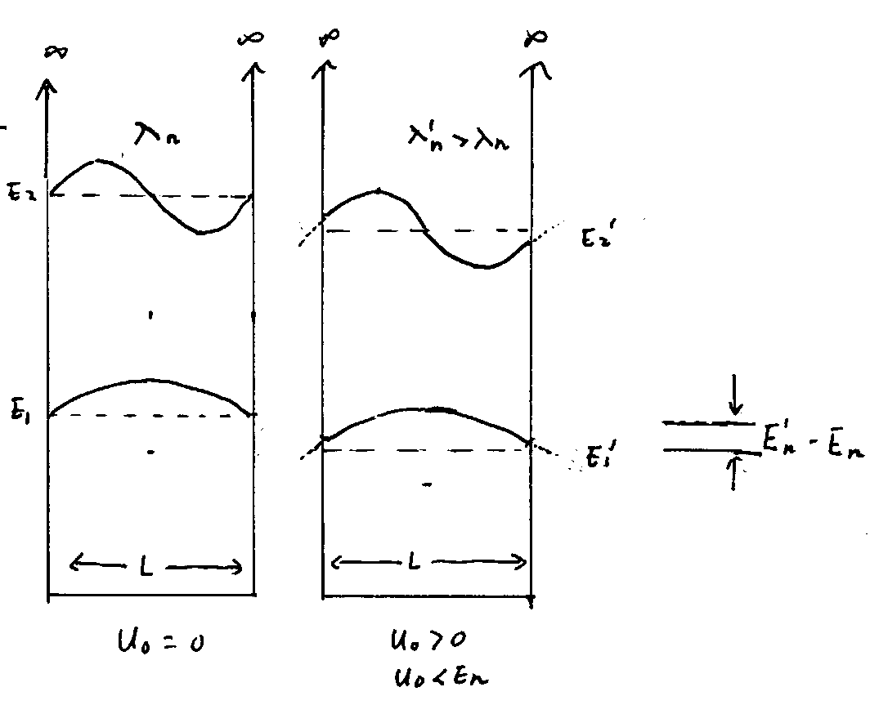

- A particle in an infinite well is in the ground state with an energy of 1.26 eV. How much energy must be added to the particle to reach the second excited state (n = 3)? The third excited state (n = 4)? (Krane, P4, pg. 170)

- An electron is trapped in a one-dimensional well of width 0.132 nm. The electron is in the n = 10 state. (a) What is the energy of the electron? (b) What is the uncertainty in its momentum? (c) What is the uncertainty in its position? How do these results change as n → ∞? Is this consistent with classical behavior? (Krane, P9, pg. 170)

- Consider a particle moving in a one-dimensional box with walls at x = -L/2 and x = +L/2. (a) Write the wave functions and probability densities for the states n = 1, n = 2, and n = 3. (b) Sketch the wave function and probability densities. (Hint: Make an analogy to the case of a particle in a box with walls at x = 0 and x = L) (Serway, M & M, P11, pg. 228)

Solution
By applying the boundary conditions that the solution must vanish at both ends, i.e. $ψ(x={−L}/2)=ψ(x=L/2)=0$, the solution takes the form
$ψ_{n}(x)=\left\{\begin{matrix}\sqrt{\frac{2}{L}}\text{cos}\frac{nπx}{L} (\text{odd} n) \\ \sqrt{\frac{2}{L}}\text{sin}\frac{nπx}{L} (\text{even} n)\end{matrix}\right.$ for $−\frac{L}{2}≤x\frac{L}{2}$
This question is tantamount to re-analyse the same physical system in a shifted coordinates, x $→$ x – L/2. The normalisation and energies shall remain unchanged under the shift of coordinate system x $→$ x – L/2. Both of these quantities depends only on the width of the well but not on the coordinate system used. We get for
;
;
;

- A particle of mass m is placed in a one-dimensional box of length L. The box is so small that the particle’s motion is relativistic, so that E = p²/2m is not valid. (a) Derive an expression for the energy levels of the particle using the relativistic energy- momentum relation and the quantization of momentum that derives from confinement. (b) If the particle is an electron in a box of length L = 1.00×10⁻¹²m, find its lowest possible kinetic energy. By what percent is the nonrelativistic formula for the energy in error? (Serway, M & M, P14, pg. 228)

Solution
(a) Still, so
(b) Taking , , and we find . The nonrelativistic result is
Comparing this with , we see that this value is too big by 29%.

