TUTORIAL 1
SPECIAL RELATIVITY
(BASED ON UNDERSTANDING PHYSICS, CUMMINGS et al, John Wiley and Sons)

SEC. 38-2 ORIGINS OF SPECIAL RELATIVITY

1. Chasing Light.
What fraction of the speed of light does each of the following speeds v represent? That is, what is the value of the ratio v/c? (a) A typical rate of continental drift, 3 cm/y. (b) A high way speed limit of 100 km/h. (c) A supersonic plane flying at Mach 2.5 = 3100 km/h. (d) The Earth in orbit around the Sun at 30 km/s. (e) What conclusion(s) do you draw about the need for special relativity to describe and analyze most everyday phenomena? (Note: Some everyday phenomena can be derived from relativity. For example, magnetism can be described as arising from electrostatics plus special relativity applied to the slow-moving charges in wires.) ( ; ; ; )

SEC. 38-3 . THE PRINCIPLE OF RELATIVITY

3. Examples of the Principles of Relativity
Identical experiments are carried out (1) in a high-speed train moving at constant speed along a horizontal track with the shades drawn and (2) in a closed freight container on the platform as the train passes. Copy the following list and mark with a “yes” quantities that will necessarily be the same as measured in the two frames. Mark with a “no” quantities that are not necessarily the same as measured in the two frames. (a) The time it takes for light to travel one meter in a vacuum; (b) the kinetic energy of an electron accelerated from rest through a voltage difference of one million volts; (c) the time for half the number of radioactive particles at rest to decay; (d) the mass of a proton; (e) the structure of DNA for an amoeba; (f) Newton’s Second Law of Motion: F = ma; (g) the value of the downward acceleration of gravity g.

SEC. 38-4. LOCATING EVENTS WITH AN INTELLIGENT OBSERVER

6. Eruption from the Sun
You see a sudden eruption on the surface of the Sun. From solar theory you predict that the eruption emitted a pulse of particles that is moving toward the Earth at one- eighth the speed of light. How long do you have to seek shelter from the radiation that will be emitted when the particle pulse hits the Earth? Take the light-travel time from the Sun to the Earth to be 8 minutes. (56 minutes)

SEC. 38-5 LABORATORY AND ROCKET LATTICEWORKS OF CLOCKS

7. Synchronizing a Clock
In a vast latticework of meter sticks and clocks, you stand next to a lattice clock whose coordinates are x = 8 km, y = 40 km, z = 44 km. When you receive the synchronizing flash, to what time do you quickly set your clock? ()

10. Where and When?
Two firecrackers explode at the same place in the laboratory and are separated by a time of 12 years. (a) What is the spatial distance between these two events in a rocket in which the events are separated in time by 13 years? (b) What is the relative speed of the rocket and laboratory frames? Express your answer as a fraction of the speed of light. (; a little more than one-third the speed of light)

13. Fast-Moving Muons

The half-life of stationary muons is mea sured to be 1.6 microseconds. Half of any initial number of station ary muons decays in one half-life. Cosmic rays colliding with atoms in the upper atmosphere of the Earth create muons, some of which move downward toward the Earth’s surface. The mean lifetime of high-speed muons in one such burst is measured to be 16 microseconds. (a) Find the speed of these muons relative to the Earth. (b) Moving at this speed, how far will the muons move in one half-life? (c) How far would this pulse move in one half-life if there were no relativistic time stretching? (d) In the relativistic case, how far will the pulse move in 10 half-lives? (e) An initial pulse consisting of 10⁸ muons is created at a distance above the Earth’s surface given in part (d). How many will remain at the Earth’s surface? Assume that the pulse moves vertically downward and none are lost to collisions. (Ninety-nine percent of the Earth’s atmosphere lies below 40 km altitude.)
(;; 480 meters; 48 kilom eters.; )

15. Living a Thousand Years in One Year
Living a Thousand Years in One Year. You wish to make a round trip from Earth in a spaceship, traveling at constant speed in a straight line for 6 months on your watch and then returning at the same constant speed. You wish, further, to find Earth to be 1000 years older on your return. (a) What is the value of your constant speed with respect to Earth? (b) How much do you age during the trip? (c) Does it matter whether or not you travel in a straight line? For example, could you travel in a huge circle that loops back to Earth? (; one year)

SEC 38-8 . CAUSE AND EFFECT

17. Relations between Events
The table shows the t and x coordinates of three events as observed in the laboratory frame.
Laboratory Coordinates of Three Events
t x
Event years light-years
Event 1 2 1
Event 2 7 4
Event 3 5 6

On a piece of paper list vertically every pair of these events: (1,2), (1, 3), (2, 3). (a) Next to each pair write “time-like,” “light-like,” or “space-like” for the relationship between those two events. (b) Next to each pair, write “Yes” if it is possible for one of the events to cause the other event and “No” if a cause and effect relation between them is not possible. (For full benefit of this exercise construct and analyze your own tables.)

ANS: (1,2) timelike yes; (1,3) spacelike no; (2,3) lightlike yes

22. Proton Crosses Galaxy
Find the energy of a proton that crosses our galaxy (diameter 100 000 light-years) in one minute of its own time.
()

38-10 MOMENTUM AND ENERGY

23. Converting Mass to Energy
The values of the masses in the reaction have been determined by a mass spectrometer to have the values: m(p) = 1.00782, m(F) = 18.998405u, m(α) = 4.002603u, m(O) = 15.994915u. Here u is the atomic mass unit (Section 1.7). How much energy is released in this reaction? Express your answer in both kilograms and MeV. (; )

27. Powerful Proton
A proton exits an accelerator with a kinetic energy equal to N times its rest energy. Find expressions for its (a) speed and (b) momentum. (;)

30. A Box of Light
Estimate the power in kilowatts used to light a city of 8 million inhabitants. If all this light generated during one hour in the evening could be captured and put in a box, how much would the mass of the box increase? (16 million kilowatts; 0.64 g)

SEC. 38-11 . THE LORENTZ TRANSFORMATION
32. Really Simultaneous?
(a) Two events occur at the same time in the laboratory frame and at the laboratory coordinates (x₁ = 10 km, y₁ = 4 km, z₁ = 6 km) and (x₂ = 10 km, y₂ = 7 km, z₂ = -10 km). Will these two events be simultaneous in a rocket frame moving with speed v= 0.8c in the x direction in the laboratory frame? Explain your answer. (b) Three events occur at the same time in the laboratory frame and at the laboratory coordinates (x₀,y₁, z₁), (x₀,y₂, z₂) and (x₀,y₁, z₃) where x₀ has the same value for all three events. Will these three events be simultaneous in a rocket frame moving with speed v in the laboratory x direction? Explain your answer. (c) Use your results of parts (a) and (b) to make a general statement about simultaneity of events in laboratory and rocket frames.

ANS: (a) simultaneous—in the rocket frame (Δt’ = 0); (b) events are simultaneous in both the laboratory and rocket frames for the pair of events in part (a) and for all three pair of events in part (b);

38-12 LORENTZ CONTRACTION

36. Electron Shrinks Distance
An evacuated tube at rest in the /laboratory has a length 3.00 m as measured in the laboratory. An electron moves at speed v = 0.999 987c in the laboratory along the axis of this evacuated tube. What is the length of the tube measured in the rest frame of the electron? (1.53 cm)

39. Traveling to the Galactic Center
(a) Can a person, in principle, /travel from Earth to the center of our galaxy, which is 23 000 ly distant, in one lifetime? Explain using either length contraction or time dilation arguments. (b) What constant speed with respect to the galaxy is required to make the trip in 30 y of the traveler’s life time? (Yes; )

40. Limo in the Garage
Carman has just purchased the world’s longest stretch limo, which has proper length L = 30.0 m. Part (a) of Figure 38-10 shows the limo parked at rest in front of a garage of proper length L_{g} = 6.00 m, which has front and back doors. Looking at the limo parked in front of the garage, Carman says there is no way that the limo can fit into the garage. “Au con traire!” shouts Garageman, “Under the right circumstances the limo can fit into the garage with both garage doors closed and room to spare!” Garageman envisions a fast-moving limo that takes up exactly one-third of the proper length of the garage. Part (b) of Figure 38-10 shows the speeding limo just as the front garage door closes behind it as recorded in the garage frame. Part (c) of Figure 38-10 shows the limo just as the back garage door opens in front of it as recorded in the garage frame. Find the sped of the limo with respect to the garage required for this scenario to take place. ()
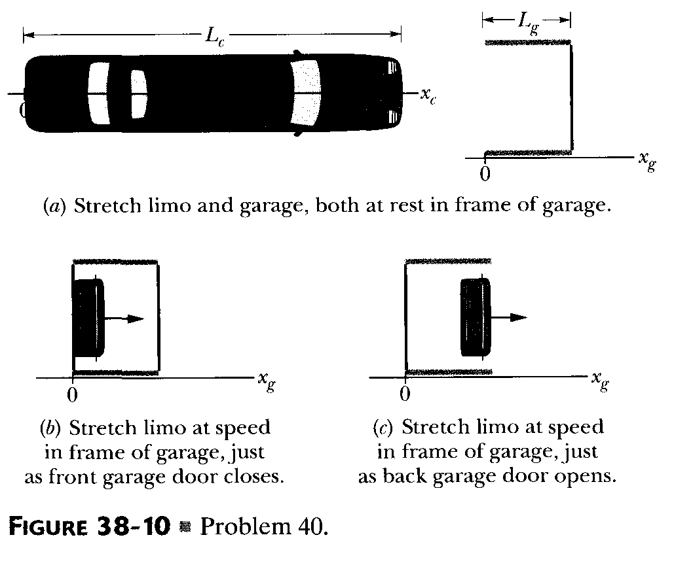
SEC 38-13 RELETIVITY OF VELOCITIES

42. Separating Galaxies.

Galaxy A is measured to be receding from us on Earth with a speed of 0.3c. Galaxy B, located in precisely the opposite direction, is also receding from us at the same speed. What recessional velocity will an observer on galaxy A measure (a) for our galaxy, and (b) for galaxy B? (0.3c., -0/55c)

44. Transit Time
An unpowered spaceship whose rest length 350 meters has a speed 0.82c with respect to Earth. A micrometeorite, also with speed of 0.82c with respect to Earth, passes spaceship on an antiparallel track that is moving in the opposite direction. How long does it take the micrometeorite to pass spaceship as measured on the ship? ()

